The Big Picture Grade Level
Unit 9: Reconstruction

Name: |  | Date: |  | Period:

Part I: Analyze an Image
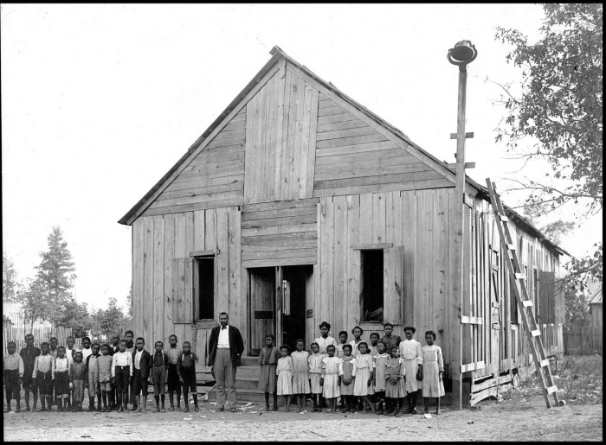  Figure 1: African American school house. The Portal to Texas History. | - What are two things you observe about the image?

- What is one thing you can infer about this era of Texas history based on the image?

- What do you predict we will see in this unit based on the image?

Part II: Essential Ideas Reading Passage

In the previous unit, the Civil War, the Northern states of the Union and the Southern states of the Confederacy fought in a deadly war over slavery. Eleven Southern states, including Texas, seceded from the Union to form the Confederate States of America. After four bloody years of fighting, the main armies of the Confederacy surrendered on April 9, 1865, and the Civil War came to an end. Cities, towns, land, and farms across the South were destroyed. Slavery, which had driven the South’s profitable plantation economy for two centuries, was abolished. As the Civil War ended, the United States faced three major questions.
First, the U.S. government needed to decide what to do with the former Confederates. These men had waged a war against the United States government, which was a serious crime. Should they be welcomed back into the U.S. with full citizenship? Should they be allowed to vote and hold office? Should they be imprisoned? What consequences, if any, should they face for their rebellion?
Second, the U.S. government needed to determine how to bring the Southern states of the Confederacy back into the Union. When the Southern states seceded, they withdrew Southern Congressmen and politicians from the United States government to form their own governments. Should these states be punished for seceding? Should they be welcomed back as though nothing had happened?
Third, what would happen to the four million newly freed Black Southerners? The formerly enslaved people were starting from scratch, with no property and no money. Under the system of slavery, Black Southerners could not receive education or take part in the government, and they had no rights under the law. Should the U.S. government provide services and assistance to the newly freed people? Would they be granted full rights as U.S. citizens? Should the government simply leave the future of the freed people up to each individual state? What role should the government play in the future of the freed people?
There were many different opinions on how to address these questions. Some favored a lenient approach to Reconstruction. This included pardoning the ex-Confederates, allowing Southern states to rejoin the Union without punishment, and doing very little to support the freed Black Southerners. Others believed the ex-Confederates should be punished and prohibited from political participation. This included strictly controlling the Southern states, and providing federal support to the freed people. Which point of view would succeed? How would these different opinions affect the people and government of Southern states like Texas during the era of Reconstruction?

Part III: Comprehension Questions
- Complete the graphic organizer below based on the information provided in the reading passage on the previous page.

Significant Questions facing the country after the Civil War: | What were some of the different opinions on how to address this question?
What should the U.S. government do with the ex-Confederates?
How should the U.S. government bring the Southern stats back into the Union?
What should happen to the newly freed Black Southerners?

- Make a prediction: Think about the different opinions on Reconstruction. Which method of reconstruction do you think the U.S. government should implement in the Southern states – a lenient policy that welcomes the South back into the country, or a stricter policy that focuses on punishment and control? Explain your answer.

I think the U.S. government should implement a lenient / strict policy of Reconstruction, because _________________________________________________________________ _____________________________________________________________________________________________ _____________________________________________________________________________________________ _____________________________________________________________________________________________ _____________________________________________________________________________________________

Lenient: relaxed, forgiving, merciful.

