Vocabulary Grade Level
Unit 9: Reconstruction

Name: |  | Date: |  | Period:

Directions: Use the vocabulary readings on the slideshow presentation to complete the chart below.
Reconstruction (n)
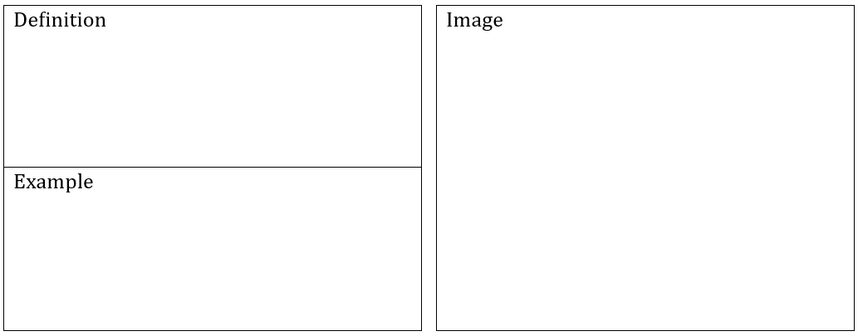
Sharecropper (n)

Amendment (n)
Ratify (v)
Franchise (n)
Martial Law (n)

Redemption (n)

