 Warm-up: The Council House Fight Extension
Unit 6: The Republic of Texas
Name: |  | Date: |  | Period:

- The shaded portion of the map is labeled Comanchería in the map key. What do you think this means?  - What effect do you think the Comanchería territory had on nearby towns like Austin and San Antonio? | 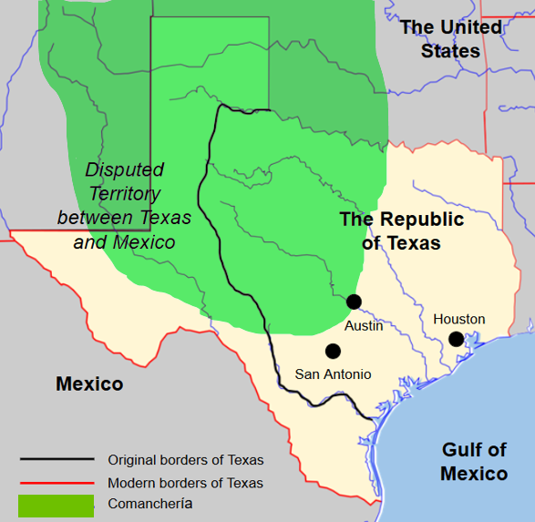

Warm-up: The Council House Fight Extension
Unit 6: The Republic of Texas
Name: |  | Date: |  | Period:

- The shaded portion of the map is labeled Comanchería in the map key. What do you think this means?

- What effect do you think the Comanchería territory had on nearby towns like Austin and San Antonio?

The Council House Fight Extension Exit Ticket

- Place a checkmark next to every statement that is TRUE about the Council House Fight.
  - The Republic of Texas government asked the Penateka Comanche tribe for a meeting to discuss a peace agreement.
  - The Republic of Texas government would only agree to a meeting with the Penateka Comanches if they returned all of the Anglos they had captured during their raids.
  - The Comanches only brought about 5 of their peace chiefs to the meeting at the San Antonio Council House because their numbers had been dramatically reduced.
  - The Comanches only brought a few captives, and only one Anglo captive – a girl named Matilda Lockhart who had been tortured.
  - A fight broke out when the Anglos at the meeting stated they would hold the Comanches as prisoners until they returned the rest of the Anglo captives.
  - Most of the Comanches escaped the fight and the rangers, military, and townspeople suffered casualties in the hundreds.
  - In response to the Council House Fight, the Comanches later mounted a large raid and attack on the Texan towns of Victoria and Linnville.

The Council House Fight Extension Exit Ticket

- Place a checkmark next to every statement that is TRUE about the Council House Fight.
  - The Republic of Texas government asked the Penateka Comanche tribe for a meeting to discuss a peace agreement.
  - The Republic of Texas government would only agree to a meeting with the Penateka Comanches if they returned all of the Anglos they had captured during their raids.
  - The Comanches only brought about 5 of their peace chiefs to the meeting at the San Antonio Council House because their numbers had been dramatically reduced.
  - The Comanches only brought a few captives, and only one Anglo captive – a girl named Matilda Lockhart who had been tortured.
  - A fight broke out when the Anglos at the meeting stated they would hold the Comanches as prisoners until they returned the rest of the Anglo captives.
  - Most of the Comanches escaped the fight and the rangers, military, and townspeople suffered casualties in the hundreds.
  - In response to the Council House Fight, the Comanches later mounted a large raid and attack on the Texan towns of Victoria and Linnville.

