Events of the Republic of Texas Advanced
Unit 6: The Republic of Texas

Name: |  | Date: |  | Period:

Directions: Use the information in the slideshow to complete this worksheet.
Sam Houston’s Administration
Oct. 22, 1836 – Dec. 10, 1838

Goals

The Córdova Rebellion

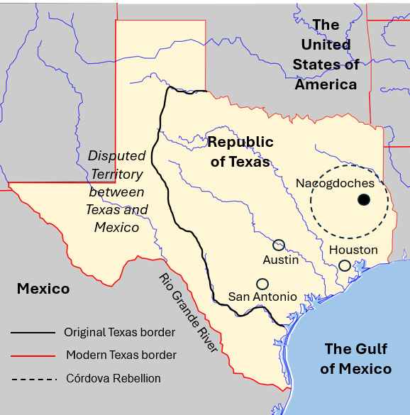

Significance of Houston’s Administration

Mirabeau Lamar’s Administration
Dec. 10, 1838 – Dec. 13, 1841

Goals

The “War of Extermination”

The Santa Fe Expedition

Significance of Lamar’s Administration

Houston’s Second Administration
Dec. 13, 1841 – Dec. 9, 1844

Goals

Mexico’s Invasions

Texas’ Response

Significance of Houston’s Second Administration

Anson Jones’ Administration
Dec. 9, 1844 – Dec. 19, 1846

Goals

The Annexation of Texas

