Events of the Republic of Texas Foundations
Unit 6: The Republic of Texas

Name: |  | Date: |  | Period:

Directions: Use the information in the slideshow to complete this worksheet.
Sam Houston’s Administration
Oct. 22, 1836 – Dec. 10, 1838

Goals | - Establish ____________________ agreements with Texas Indian tribes  - Gain _____________________________ recognition from other countries  - Establish _________________________ relationships with other countries  - Save money and improve the ___________________________________________

The Córdova Rebellion  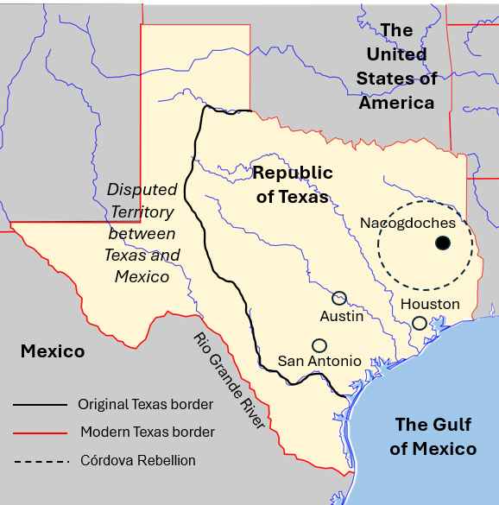 | - August – October 1838  - Nacogdoches  - Vicente Córdova led a ____________________________ of Tejanos and Indians against Texas.  - Thomas J. Rusk led a ____________________________ to end the rebellion and force the Caddo out of Texas.  - Increased __________________________ between Anglos, Tejanos, and Indians.

Significance of Houston’s Administration | - Established peace agreements with most Indian tribes  - Diplomatic recognition only from the ______________________  - _________________ increased to approximately $3 million  - Disbanded the army to save money  - Relocated capital to __________________________________________  - Passed high ________________

Mirabeau Lamar’s Administration
Dec. 10, 1838 – Dec. 13, 1841

Goals | - Maintain Texas’ _____________________________________________  - Remove ____________________ from Texas: “War of Extermination”  - Gain diplomatic recognition from other countries  - Establish commercial relationships with other countries  - Establish new __________________________________ city

The “War of Extermination” | - Battle of the Neches: Drove the ______________________________ out of Texas  - Council House Fight: Killed or captured 60 _____________________________ in San Antonio, Mar. 19, 1840  - Comanche ______________________ Linnville and Victoria in retaliation  - Wars against Texas Indians significantly increased __________________.

The Santa Fe Expedition | - June – October 1841  - An expedition to establish _____________________________ with Santa Fe and ask New Mexico to _________________________ the Republic of Texas.  - Expedition members ________________________________ and imprisoned on arrival.  - National embarrassment for __________________________ of Texas.

Significance of Lamar’s Administration | - Debt increased to $_______________ million due to:  - ____________________ against Texas Indians  - Relocation of the capital to ___________________________  - Purchase of navy __________________________  - Gained French and Dutch diplomatic recognition

Houston’s Second Administration
Dec. 13, 1841 – Dec. 9, 1844

Goals | - Reduce spending  - Re-establish ______________________________ with Texas Indians  - Establish ___________________________________________ and diplomatic relationships  - ________________________________________ with the U.S.

Mexico’s Invasions | - March & September 1842  - Mexican military invaded and occupied __________________________ ________________________________________________________________________  - Battle of Salado Creek: Sept. 1842 - Texas _____________________ chased the Mexican _________________________________ out of Texas.

Texas’ Response | - Somervell Expedition: Nov. – Dec. 1842, Alexander Somervell led a _______________________ that captured Laredo and Guerrero.  - Mier Fight: Dec. 1842, Some Texans under William S. Fisher continued to Mier, Mexico, and fought the Mexican army. They were _____________________________, ____________________________, and imprisoned in _______________________________.

Significance of Houston’s Second Administration | - Houston attempted to relocate the ____________________________ again = unpopular  - Sold the Texas ____________________________  - Gained British diplomatic recognition  - U.S. denied Texas 2nd ______________________________ application.  - Debt grew to $______________ million

Anson Jones’ Administration
Dec. 9, 1844 – Dec. 19, 1846

Goals | - Reduce __________________________________  - Maintain ______________________ with Texas __________________________  - Diplomatic relationship with Mexico and Britain OR ____________________________________ with the U.S.

The Annexation of Texas | - Officially _______________________________ on Dec. 29, 1845  - TX became a U.S. _____________________________ (not a territory)  - TX kept ownership of its public __________________________________  - TX gave its public buildings and military property to U.S. government  - U.S. supported TX __________________________________ disputes with Mexico  - TX can divide into 5 total states

