Events of the Republic of Texas Grade Level
Unit 6: The Republic of Texas

Name: |  | Date: |  | Period:

Directions: Use the information in the slideshow to complete this worksheet.
Sam Houston’s Administration
Oct. 22, 1836 – Dec. 10, 1838

Goals | - Establish peace agreements with __________________________________________  - Gain diplomatic recognition from __________________________________________  - Establish _____________________________________________ with other countries  - Save money and ____________________________________________________________

The Córdova Rebellion  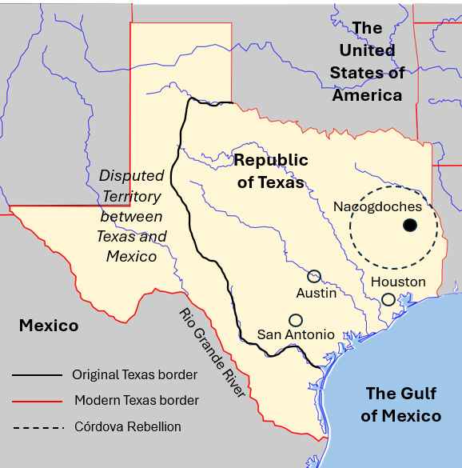 | - August – October 1838  - Nacogdoches  - ____________________________________ led a rebellion of __________________________________________________.  - ________________________________ led a militia to end the rebellion and force ___________________________ ___________________________________________________.  - Increased __________________________ between the ____________________________________________________.

Significance of Houston’s Administration | - Established _____________________________________________________ with most _______________________________________________________  - Diplomatic recognition ________________________________________  - ____________ increased to approximately _______________________  - _______________________________________________ to save money  - Relocated capital to ____________________________________________  - Passed ___________________________________________________________

Mirabeau Lamar’s Administration
Dec. 10, 1838 – Dec. 13, 1841

Goals | - Maintain Texas’ ____________________________________________________________  - Remove Indians from Texas: “_____________________________________________”  - Gain _________________________________________________ from other countries  - Establish _____________________________________________ with other countries  - Establish new _______________________________________________________________

The “War of Extermination” | - Battle of the Neches: _________________________________________ ___________________________________________________________________  - Council House Fight: _________________________________________ ________________________________ in San Antonio, Mar. 19, 1840  - Comanche _______________ Linnville and Victoria in retaliation  - Wars against Texas Indians ___________________________________ __________________________________________________________________.

The Santa Fe Expedition | - June – October 1841  - An expedition to __________________________________________________ and ask New Mexico to ___________________________________________.  - Expedition members ______________________________________________ __________________________________________________________on arrival.  - _____________________________________________________________________ for Republic of Texas.

Significance of Lamar’s Administration | - Debt increased to ____________________________________ due to:  - Wars against ____________________________________________  - Relocation of the _______________________________________  - Purchase of _____________________________________________  - Gained French and Dutch ______________________________________

Houston’s Second Administration
Dec. 13, 1841 – Dec. 9, 1844

Goals | - Reduce ______________________________________________________________  - Re-establish peace _________________________________________________  - Establish _____________________________________________________________  - __________________________________________________________ with the U.S

Mexico’s Invasions | - March & September 1842  - Mexican military ____________________________________________________ ________________________________________________________________________  - Battle of Salado Creek: Sept. 1842 - Texas Rangers ____________ _________________________________________________________________________

Texas’ Response | - Somervell Expedition: Nov. – Dec. 1842, Alexander Somervell led a militia that ______________________________________________________  - Mier Fight: Dec. 1842, Some Texans under William S. Fisher continued to Mier, Mexico, and _____________________________________. They were ____________________________________________________________ ___________________________________________________________ in Mexico.

Significance of Houston’s Second Administration | - Houston attempted to __________________________________________ ______________________________________________again = unpopular  - Sold the _________________________________________________________  - Gained British __________________________________________________  - U.S. _____________ Texas 2nd _________________________ application.  - Debt grew to ___________________________________________________

Anson Jones’ Administration
Dec. 9, 1844 – Dec. 19, 1846

Goals | - Reduce ______________________________________________________________  - _________________________________________________ with Texas Indians  - Diplomatic relationship with _______________________________________ __________________________________ OR _________________________________ ________________________________________________________________________

The Annexation of Texas | - Officially ____________________________________ on Dec. 29, 1845  - TX became a ______________________________________ (not a territory)  - TX kept ownership of its ___________________________________________  - TX gave its __________________________________ and ___________________ ____________________________________ to U.S. government  - U.S. supported TX __________________________ disputes with Mexico  - TX can divide into ___________________________________________________

