 Warm-up: Mind Map Review
Unit 6: The Republic of Texas
Name: |  | Date: |  | Period:

Look at the word bank below. Complete the mind map diagram by putting each term where you think it fits best.

- Annexation to the U.S.  - Challenge  - The Republic of Texas  - Goal  - Increasing debt | 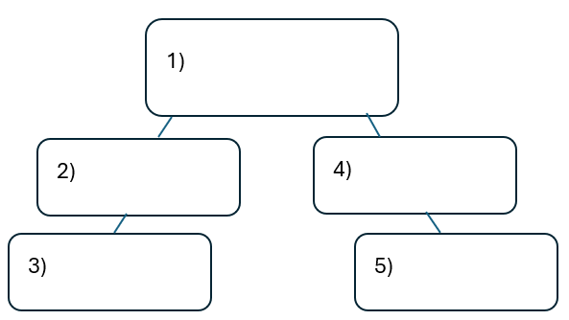

Warm-up: Mind Map Review
Unit 6: The Republic of Texas
Name: |  | Date: |  | Period:

Look at the word bank below. Complete the mind map diagram by putting each term where you think it fits best.

- Annexation to the U.S.
- Challenge
- The Republic of Texas
- Goal
- Increasing debt


Mind Map Review Exit Ticket

Directions: Complete the sentence by choosing the best answer for each blank from the chart below.

The (1)____________ is primarily characterized by (2)____________

Answer choices for blank (1)  Circle the best answer | Answer choices for blank (2)  Circle the best answer

- Administration of Sam Houston  - Primary effect of the Indian Wars  - Republic of Texas era  - Response to Texas annexation | - Texas’ attempts at establishing commercial and diplomatic relationships with prominent European powers like Britain.  - Texas’ struggle to address the many political, economic, and diplomatic challenges it faced as an independent nation.  - Texas’ goal of expanding its territory west into the Mexican states of New Mexico and California.  - Texas’ struggle to protect its borders for American Indian raids, a flood of U.S. immigration, and Mexican invasions.

Mind Map Review Exit Ticket

Directions: Complete the sentence by choosing the best answer for each blank from the chart below.

The (1)____________ is primarily characterized by (2)____________

Answer choices for blank (1)  Circle the best answer | Answer choices for blank (2)  Circle the best answer

- Administration of Sam Houston  - Primary effect of the Indian Wars  - Republic of Texas era  - Response to Texas annexation | - Texas’ attempts at establishing commercial and diplomatic relationships with prominent European powers like Britain.  - Texas’ struggle to address the many political, economic, and diplomatic challenges it faced as an independent nation.  - Texas’ goal of expanding its territory west into the Mexican states of New Mexico and California.  - Texas’ struggle to protect its borders for American Indian raids, a flood of U.S. immigration, and Mexican invasions.

