
Warm-up: The Santa Fe Expedition Extension
Unit 6: The Republic of Texas
Name: |  | Date: |  | Period:

Directions: Think back to the four geographic regions of Texas: the Coastal Plains, the North Central Plains, the Great Plains, and the Mountains and Basins. Answer the question based on your knowledge of these regions.
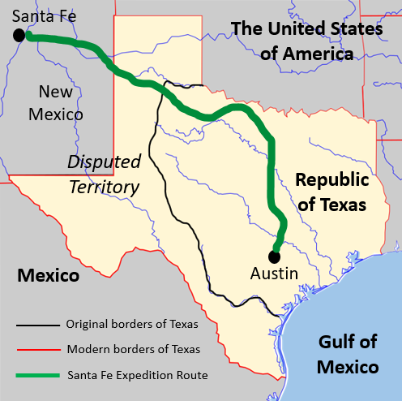 | Which regions did the Santa Fe Expedition travel through? What kind of geography, climate, plants, animals, and Indian tribes might the expedition have encountered on their journey?

Warm-up: The Santa Fe Expedition Extension
Unit 6: The Republic of Texas
Name: |  | Date: |  | Period:

Directions: Think back to the four geographic regions of Texas: the Coastal Plains, the North Central Plains, the Great Plains, and the Mountains and Basins. Answer the question based on your knowledge of these regions.
Which regions did the Santa Fe Expedition travel through? What kind of geography, climate, plants, animals, and Indian tribes might the expedition have encountered on their journey?


The Santa Fe Expedition Extension Exit Ticket

Directions: Imagine you were one of the members of the Santa Fe Expedition. Write a short, 3- to 5- sentence journal entry on the scrap of paper below about an experience you might have had on the journey. Include a date at the beginning of your entry (the expedition left Austin on June 19, 1841, and arrived in Santa Fe in mid-September 1841.) Sign your name at the end of your journal entry.


The Santa Fe Expedition Extension Exit Ticket

Directions: Imagine you were one of the members of the Santa Fe Expedition. Write a short, 3- to 5- sentence journal entry on the scrap of paper below about an experience you might have had on the journey. Include a date at the beginning of your entry (the expedition left Austin on June 19, 1841, and arrived in Santa Fe in mid-September 1841.) Sign your name at the end of your journal entry.

