The Somervell Expedition & the Mier Fight Extension Timeline of Events
Unit 6: The Republic of Texas

Name: |  | Date: |  | Period:

Directions: Read the chronological sequence of events of the Somervell Expedition and the Mier fight and use the information provided to complete this assignment.
March 1842  September 1842  October 3, 1842  November 25, 1842  December 8, 1842  December 10, 1842  December 19, 1842  December 20, 1842  December 22, 1842  December 24, 1842  December 25, 1842  December 26, 1842  December 27, 1842  February 11, 1843  February 18, 1843  March 25, 1843  June – August 1843  September 1843  September 16, 1843 | General Rafael Vásquez led a Mexican army in an invasion of Texas, briefly occupying San Antonio with 700 soldiers.  General Adrián Woll led a Mexican army in a second invasion of Texas, briefly occupying San Antonio with 1,200 soldiers.  President Sam Houston authorized Alexander Somervell to organize a group of volunteers and march to Mexico in response to the two invasions. Somervell was authorized to invade Mexico if he believed there was a reasonable chance of success.  Volunteers poured into San Antonio to join Somervell’s expedition to Mexico. On this date, Somervell and about 700 volunteers marched out of San Antonio bound for Mexico.  Somervell’s expedition reached the Texas border town of Laredo on the Rio Grande. Somervell’s men raided and captured Laredo.  By this point, 185 of Somervell’s men had returned to their Texas homes. The rest continued south along the Rio Grande with Somervell to the Mexican border town of Guerrero. Somervell captured Guerrero with approximately 500 men.  Having captured Laredo and Guerrero, Somervell believed the Texans had accomplished their goal of retaliation for the two Mexican invasions of Texas. He ordered the rest of his men to return to Texas, however only 189 men obeyed the order. Somervell and those 189 men returned to Texas.  The remaining force of 308 men continued south along the Rio Grande under the direction of William S. Fisher.  Fisher and the 308 Texans reached the Mexican town of Mier on the Rio Grande. Fisher and his men camped on the north side of the Rio Grande across from Mier.  Fisher and some of his men crossed the river into the town of Mier, captured the alcalde of the town, and demanded that he order the town to provide the Texans with much-needed supplies.  Fisher learned that Mexican General Pedro de Ampudia had arrived in Mier with a military force and was preventing the delivery of the supplies Fisher had demanded. Fisher ordered 42 men to guard the camp. The remaining 261 men crossed the Rio Grande and attacked Ampudia’s men in Mier. The fight continued until the afternoon of the following day. The Texans were outnumbered 10 to 1.  General Ampudia’s men had suffered heavy casualties; however, the Texans were badly outnumbered and ran out of ammunition. The Texans surrendered to Ampudia. Two of the Texans managed to escape and made it back to their camp across the Rio Grande to warn the 42 guards, who all retreated back to Texas.  Mexican President Santa Anna ordered the prisoners of war to be executed. General Ampudia managed to get the order reversed and marched the prisoners south along the Rio Grande to Matamoros and then on to Mexico City. During the long, challenging march the Texans worked on plans to escape.  The Texans escaped their captors at the town of Salado and were on the run for 7 days. During that time, they became lost and separated. The Mexican troops pursued them, recapturing all but three of the escaped men.  The Mexican army returned the 176 men they had captured to Salado.  When President Santa Anna learned of the Texans’ escape, he ordered the men to be executed. The governor of the state of Coahuila, Francisco Mexía, refused to carry out the execution and the foreign ministers in Mexico managed to get the order modified.  The new orders stated that Texans were ordered to be “decimated,” a Latin term that meant one out of every ten Texans would be executed.  “The Black Bean Episode”  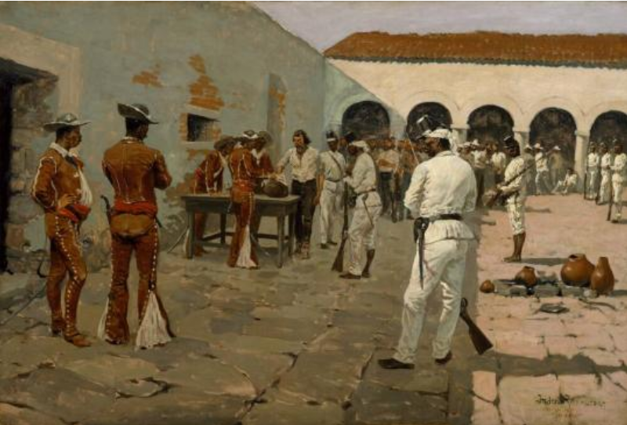  Figure 1: Painting by Frederic Remington titled "The Mier Expedition: Drawing the Black Bean" The Museum of Fine Arts Houston  In order to determine which of the Texan prisoners would be executed, the Mexican military leader Colonel Domingo Huerta decided to place 176 beans in a jar. There were 159 white beans and 17 black beans.  The Texan prisoners were then blindfolded and ordered to take turns drawing beans from the jar. The men who drew the white beans were safe. Those who drew the black beans were to be executed.  When the men were finished drawing their beans, those who had drawn black beans were unshackled, placed in a separate courtyard, and executed by firing squad at dusk.  The survivors continued their march to Mexico City.  When the prisoners arrived in Mexico City, they spent three months being forced to work on building roads in the city.  The prisoners were transferred to Perote prison in Veracruz. Many prisoners died in prison from disease or starvation. Some managed to escape by bribing prison guards or tunneling out of the prison. Some prisoners were released at the request of the United States government.  The last of the Texas prisoners from the Mier Fight were released by Santa Anna.

