 Warm-up: Texas Annexation
Unit 6: The Republic of Texas
Name: |  | Date: |  | Period:

Directions: Read the excerpt from an article published on April 9, 1845 in the Telegraph and Texas Register newspaper of Houston. Use the excerpt to answer the question that follows.

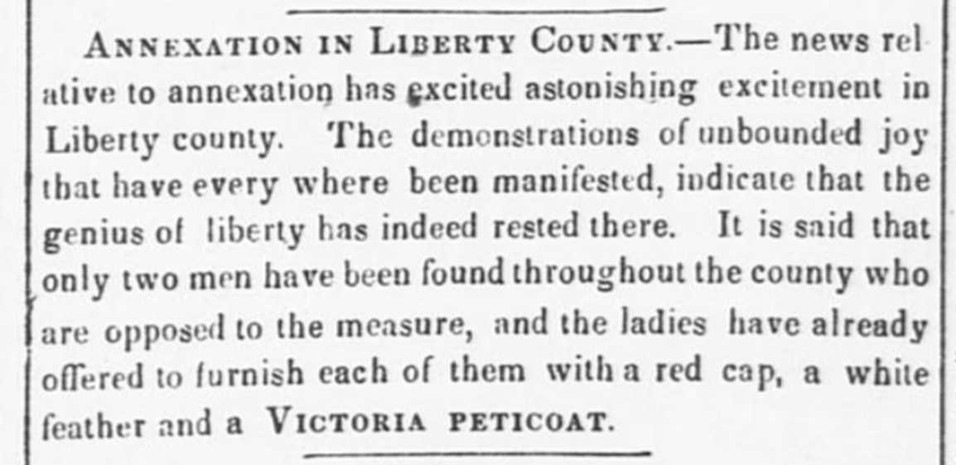 | According to the article, how did most people of Liberty County feel about annexation? Provide evidence from the article that supports your claim.

Warm-up: Texas Annexation
Unit 6: The Republic of Texas
Name: |  | Date: |  | Period:

Directions: Read the excerpt from an article published on April 9, 1845 in the Telegraph and Texas Register newspaper of Houston. Use the excerpt to answer the question that follows.

According to the article, how did most people of Liberty County feel about annexation? Provide evidence from the article that supports your claim.


Texas Annexation Exit Ticket

Directions: Consider the terms of annexation that we learned about in today’s lesson. Choose ONE term from the lesson and explain if you think the majority of Texans supported or opposed the term. Provide an explanation for your claim.
I think the people of Texas probably supported / opposed the term that stated __________________________ ______________________________________________________________________________________________________________________ because _____________________________________________________________________________________________________________ ______________________________________________________________________________________________________________________

Texas Annexation Exit Ticket

Directions: Consider the terms of annexation that we learned about in today’s lesson. Choose ONE term from the lesson and explain if you think the majority of Texans supported or opposed the term. Provide an explanation for your claim.
I think the people of Texas probably supported / opposed the term that stated __________________________ ______________________________________________________________________________________________________________________ because _____________________________________________________________________________________________________________ ______________________________________________________________________________________________________________________

