**Texas Today *Advanced***

*Unit 6: The Republic of Texas*

|  |  |  |  |  |  |
| --- | --- | --- | --- | --- | --- |
| Name: |  | Date: |  | Period: |  |

**The Importance of Public Land in Texas**

|  |
| --- |
| “Understanding the importance of land in the history of Texas is essential to understanding Texas. Few Texans, however, are aware of the role that public land has played in our state's development. Land has not only furnished us valuable natural resources, it has been used to finance government operations, reward veterans, provide internal improvements and fund public education.”   * “Understanding the Importance of Land in the History of Texas” Texas General Land Office, 2015 |

1. According to the passage from the Texas General Land Office, how has public land helped the development of Texas?
2. How did the terms of Texas’ annexation to the United States contribute to this development?

**Texas’s Public Lands: The Gift that Keeps on Giving**

When Texas was annexed to the United States in 1845, one of the terms of annexation was that the state of Texas was able to maintain ownership of its public lands, rather than **relinquish** those lands to the United States government. Texas’ ability to maintain and manage its public land has benefited Texas and Texans in numerous ways.

1. In 1854, the Permanent School Fund was established to provide financial support for Texas public schools based largely on **revenue** created from public lands. More than twelve million acres of Texas public land has been dedicated to the Texas’ Permanent School Fund. The value of the Permanent School Fund in 2025 was nearly $62.5 billion. The PSF provides approximately $2.5 billion to public schools across the state of Texas every year. Many other states have established their own Permanent School Funds; however, Texas’ fund is the largest in the nation. This is a direct result of the fact that Texas was allowed to keep ownership of its public lands when it joined the United States.
2. In addition to the Permanent School Fund for primary and secondary public schools, Texas also established a Permanent University Fund in 1876. The Permanent University Fund is **financed** by revenue from 2.1 million acres of public land in west Texas. Today, the Permanent University Fund is **valued at** $36.5 billion, largely due to **profits** from oil and natural gas located on the **designated** land. The revenue from this fund helps support several Texas universities including the University of Texas, Texas A&M University, and the University of North Texas.
3. The government of Texas created the Texas Veterans Land Board after World War II to help support Texas **veterans**. The Texas Veterans Land Board helps Texan veterans purchase or improve their own property by granting them **low-interest loans,** making land ownership more affordable for many veterans.
4. In 1901, oil was discovered at a place called Spindletop near Beaumont, Texas. This discovery led to an oil boom as people began discovering oil all across the state. In 1919, the **Texas land commissioner** was authorized to **lease** designated public land for oil and gas production. That meant that individuals or companies could now get permission to drill for oil on public lands by renting the land from the government and paying a percentage of the profits from any oil or natural gas discoveries to the Texas government. Today, the majority of revenue from public lands comes from oil and natural gas. This revenue is used to support public schools, universities, building and maintaining roads, and paying first responders like police, fire departments, and emergency services.

**Vocabulary Matching**

1. Relinquish
2. Revenue
3. Natural Resources
4. Financed
5. Valued at
6. Profit
7. Designated
8. Low-interest loans
9. Land Commissioner
10. Lease
11. Materials produced by the earth that serve an economic purpose to people
12. The excess money produced after subtracting initial expenses
13. To rent property
14. All the money made from doing business
15. Paid for
16. An elected government position in charge of the General Land Office in Texas
17. To give up ownership
18. Worth
19. Borrowing money with a small repayment fee
20. Set aside for a specific purpose

**Preparing to Write a Short Answer Response**

**Directions:** On the next page, you will write a one-paragraph essay based on the following writing prompt: ***How has Texas’ ownership of its public lands benefited the development of Texas?***

Follow the steps below to organize your information and prepare to write.

1. Which statement below would make the best topic sentence for your essay based on the writing prompt?
   1. Texas’ ownership of its public lands has played an important role in the development of the state since its annexation in 1845.
   2. One of the terms of Texas annexation in 1845 allowed the state government of Texas to maintain ownership of its public lands, which was unusual.
   3. The government of Texas is able to provide funding for public schools, universities, veterans who want to buy property, and emergency services.
   4. When Texas was annexed to the United States in 1845, there were several terms of annexation which allowed Texas to develop financially.
2. Use the graphic organizer below to plan out and organize the information you need to include in your essay.

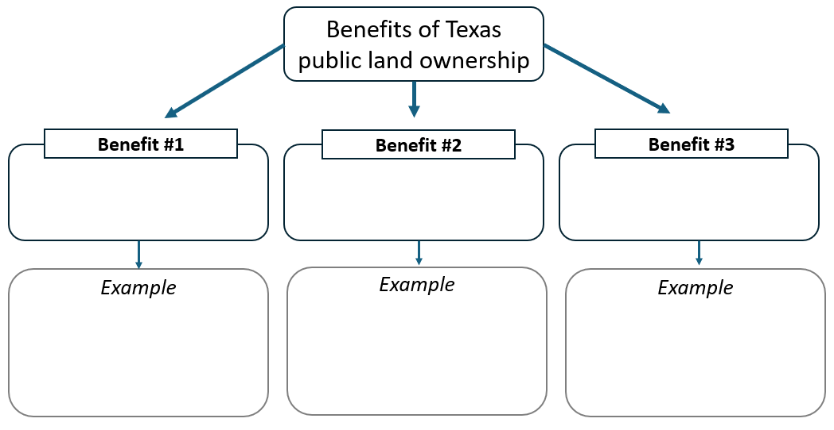

**Writing: Short Answer Response**

1. Using the information from the previous step: Preparing to Write a Short Answer Response, write 7 – 10 complete sentences, including a topic sentence and conclusion, in response to the following prompt:

How has Texas ownership of its public lands benefited the development of Texas?