 Warm-up: Texas Today
Unit 6: The Republic of Texas
Name: |  | Date: |  | Period:

Directions: Answer as many of the questions as you can based on the information provided.
What do you observe about this map?  What do you think is the purpose of the map?  What inferences can you make based on this map?  How might this map relate to our unit? | 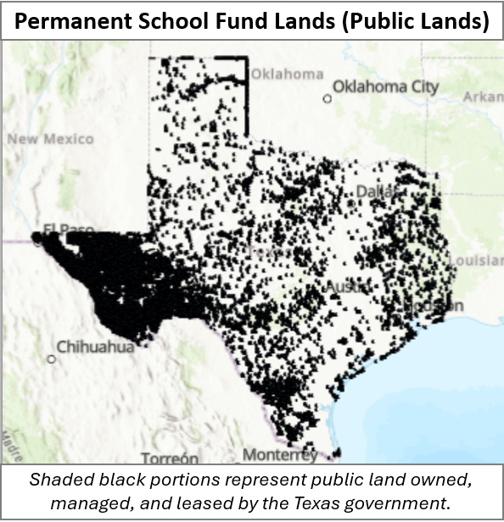

Warm-up: Texas Today
Unit 6: The Republic of Texas
Name: |  | Date: |  | Period:

Directions: Answer as many of the questions as you can based on the information provided.
What do you observe about this map?
What do you think is the purpose of the map?
What inferences can you make based on this map?
How might this map relate to our unit?


Texas Today Exit Ticket
“In 1844, Texas submitted a treaty of annexation to the United States Congress. Under its terms, Texas would have given 175,000,000 acres of public land to the United States government and the United States would have assumed Texas's debts of $10,000,000. The United States Congress rejected the treaty on grounds that the Texas public domain was not worth $10,000,000.”

- “Understanding the Importance of Land in the History of Texas” Texas General Land Office, 2015

Directions: Circle or highlight the correct option in underlined in bold to complete the statement based on the excerpt above.
- According to the excerpt above, the U.S. rejected / accepted Texas’ 1844 application for annexation because the U.S. government wanted / did not want to take responsibility for Texas debt. The U.S. government believed / did not believe that the millions of acres of Texas public land it would get would be worth enough to pay off Texas’ $10 million in debt.

Texas Today Exit Ticket
“In 1844, Texas submitted a treaty of annexation to the United States Congress. Under its terms, Texas would have given 175,000,000 acres of public land to the United States government and the United States would have assumed Texas's debts of $10,000,000. The United States Congress rejected the treaty on grounds that the Texas public domain was not worth $10,000,000.”

- “Understanding the Importance of Land in the History of Texas” Texas General Land Office, 2015

Directions: Circle or highlight the correct option in underlined in bold to complete the statement based on the excerpt above.
- According to the excerpt above, the U.S. rejected / accepted Texas’ 1844 application for annexation because the U.S. government wanted / did not want to take responsibility for Texas debt. The U.S. government believed / did not believe that the millions of acres of Texas public land it would get would be worth enough to pay off Texas’ $10 million in debt.

