Texas Today Foundations
Unit 6: The Republic of Texas

Name: |  | Date: |  | Period:

The Importance of Public Land in Texas
“Understanding the importance of land in the history of Texas is essential to understanding Texas. Few Texans, however, are aware of the role that public land has played in our state's development. Land has not only furnished us valuable natural resources, it has been used to finance government operations, reward veterans, provide internal improvements and fund public education.”

- “Understanding the Importance of Land in the History of Texas” Texas General Land Office, 2015

- According to the passage from the Texas General Land Office, how has public land helped the development of Texas? Choose FOUR statements that are true.
  - Texas land provides many valuable natural resources.
  - Texas land has helped pay for necessary actions of the Texas government.
  - Texas land requires a lot of financial support from the state government.
  - Texas land has provided benefits to Texans who served in wars.
  - Texas land is a very costly resource for Texans and their government.
  - Texas land helps pay for public schools and education.

- How did the terms of Texas’ annexation to the United States contribute to this development?
  - The terms of annexation allowed Texas to maintain control of its public lands.
  - The terms of annexation required the United States to uphold the Rio Grande as the southern border of Texas.
  - The terms of annexation stated that Texas maintained responsibility for its own accumulated debts.
  - The terms of annexation allowed Texas to join the Union as a state with full representation in Congress and the ability to run its own state government.

Texas’s Public Lands: The Gift that Keeps on Giving
When Texas was annexed to the United States in 1845, one of the terms of annexation was that the state of Texas was able to maintain ownership of its public lands, rather than give up those lands to the United States government. Texas’ ability to maintain and manage its public land has benefited Texas and Texans in numerous ways.
- In 1854, the Permanent School Fund was established to provide financial support for Texas public schools based largely on revenue created from public lands. More than twelve million acres of Texas public land has been dedicated to the Texas’ Permanent School Fund. The value of the Permanent School Fund in 2025 was nearly $62.5 billion. The PSF provides approximately $2.5 billion to public schools across the state of Texas every year.

- In addition to the Permanent School Fund for primary and secondary public schools, Texas also established a Permanent University Fund in 1876. The Permanent University Fund is financed by revenue from 2.1 million acres of public land in west Texas. Today, the Permanent University Fund is valued at $36.5 billion, largely due to profits from oil and natural gas located on the west-Texas land. This fund helps support several Texas universities including the University of Texas, Texas A&M University, and the University of North Texas.

- The government of Texas created the Texas Veterans Land Board after World War II to help support Texas veterans. The Texas Veterans Land Board helps Texan veterans purchase or improve their own property by granting them low-interest loans, making land ownership more affordable for many veterans.

- In 1901, oil was discovered at a place called Spindletop near Beaumont, Texas. This discovery led to an oil boom as people began discovering oil all across the state. In 1919, the Texas government started a program that leased public lands for oil and gas production. This meant that individuals or companies could now get permission to drill for oil on public lands by renting the land from the government. If they discovered oil or natural gas on the land, they would pay a percentage of any profits to the Texas government. Today, the majority of revenue from public lands comes from oil and natural gas. This revenue is used to support public schools, universities, building and maintaining roads, and paying first responders like police, fire departments, and emergency services.

Vocabulary Matching
D
- Revenue
- Natural Resources
- Financed
F
- Valued at
- Profit
- Low-interest loans
C
- Lease

- Materials produced by the earth that serve an economic purpose to people
- The excess money produced after subtracting initial expenses
- To rent property
- All the money made from doing business
- Paid for
- Worth
- Borrowing money with a small repayment fee

Preparing to Write a Short Answer Response
Directions: On the next page, you will write a one-paragraph essay based on the following writing prompt: How has Texas’ ownership of its public lands benefited the development of Texas?
Follow the steps below to organize your information and prepare to write.
- Which statement below would make the best topic sentence for your essay based on the writing prompt?
  - Texas’ ownership of its public lands has played an important role in the development of the state since its annexation in 1845.
  - One of the terms of Texas annexation in 1845 allowed the state government of Texas to maintain ownership of its public lands, which was unusual.
  - The government of Texas is able to provide funding for public schools, universities, veterans who want to buy property, and emergency services.
  - When Texas was annexed to the United States in 1845, there were several terms of annexation which allowed Texas to develop financially

- Use the graphic organizer below to plan out and organize the information you need to include in your essay.
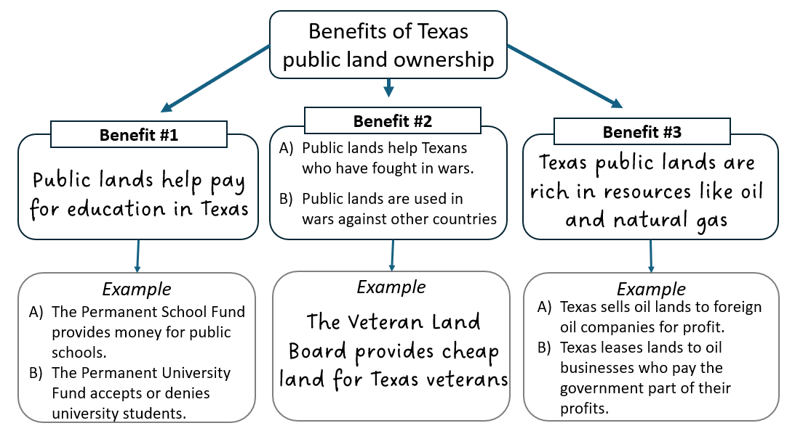
Writing: Short Answer Response
- Using the information from the previous step, choose the correct options to respond to the prompt: How has Texas ownership of its public lands benefited the development of Texas?

Texas’ ownership of its public lands has played an important role in the development of the state since its annexation in 1845. First, public lands help pay for education in Texas. One example of this is (A) the Permanent School Fund provides money for public schools. (B) the Permanent University Fund accepts or denies university students. Second, (A) public lands help Texans who have fought in wars. (B) public lands are used in wars against other countries. An example of this is the Veteran Land Board provides cheap land for Texas veterans. Lastly, Texas public lands are rich in natural resources like oil and natural gas. This benefits Texas because (A) Texas sells oil lands to foreign oil companies for profit. (B) Texas leases lands to oil businesses who pay the government part of their profits. In conclusion, there are many ways in which Texas’ ownership of its public lands benefits Texas and Texans.

