The Big Picture Advanced
Unit 6: The Republic of Texas

Name: |  | Date: |  | Period:

Part I: Analyze an Image

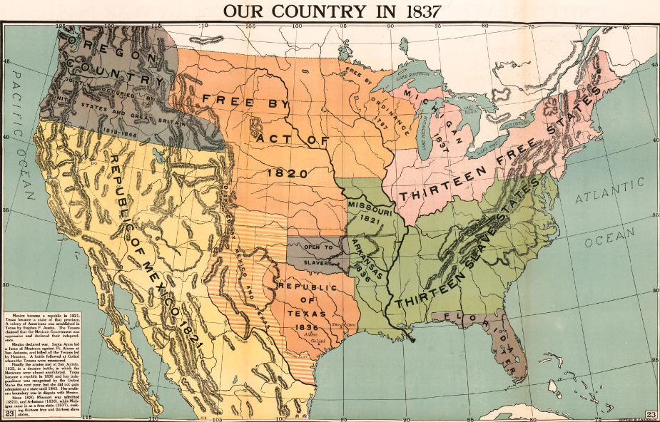  Figure 1 A political map of North America. The Library of Congress. | - What are three things you observe about the image?
- What are two things you can infer about this era of Texas history based on your observations?

- What do you predict we will see in this unit based on the image?

Part II: Essential Ideas Reading Passage

In the Texas Revolution unit, we learned how the conflict between centralists and federalists for control of the Mexican government spilled over into Texas. Eager to protect their right to self-government, the people of Texas rebelled against Santa Anna’s centralist government and won their independence following the Battle of San Jacinto on April 21, 1836. With that victory, Texas became an independent nation called the Republic of Texas.
The Republic of Texas faced a steady stream of challenges during its short time as a country from 1836 to 1845. First, the government of Mexico did not recognize Texas as an independent nation. In the eyes of Mexico, Texas was still a Mexican province in rebellion – not its own country. Additionally, Mexico disputed the boundaries that Texas claimed in the Treaties of Velasco. And it wasn’t just Mexico: The Republic of Texas’ government struggled to find other countries who were willing to recognize and trade with Texas.
Second, the provisional government of Texas had borrowed a great deal of money from American merchants to finance the Revolution. As a result, Texas was already $1.25 million dollars in debt when it became independent. Economic struggles throughout the era would cause Texas’s national debt to climb to nearly $12 million by 1845.
Third, as more and more Anglo-Americans moved into Texas, there were often conflicts between these new Anglo settlers and the American Indians who lived in the region. Competition for resources, especially control of land in east Texas, led to a great deal of violence between these groups.
Fourth, the growth of anti-slavery movements during this time period caused a number of challenges for the Republic of Texas and its slave-based cotton economy. When Texas applied for statehood with the United States in 1837, 1844, and 1845, many Northern U.S. politicians opposed Texas joining the United States because they worried that adding another southern slave state would give the South too much power in the government. Texas also had a hard time finding trade partners because many countries like Great Britain did not want to do business with the Republic’s slave-based economy.
The Republic of Texas era was shaped by the numerous challenges that faced the young republic from 1836 to 1845. Attempts to address these challenges led the people and their government to join the United States in 1845. This act would have lasting consequences for Texas, the United States, and Mexico for generations to come.

Part III: Comprehension Questions

- According to the reading passage, which location on the map was the site of the majority of conflicts between Anglos and American Indians in Texas?  - 1  - 2  - 3  - 4  - Why do you think this site saw the most conflict between Anglos and American Indians in Texas? | 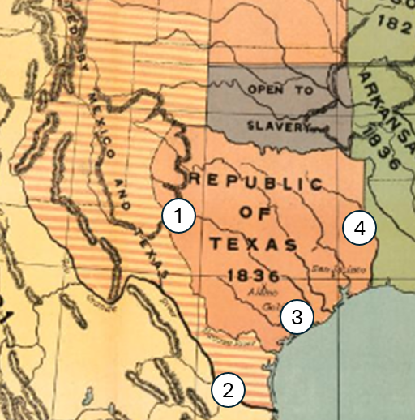

- Three years after Texas defeated Santa Anna at the Battle of San Jacinto and declared itself to be a free and independent nation, a Mexican newspaper in Veracruz stated that the Mexican government, “is not aware of the existence of a nation called the Republic of Texas, but only a horde of adventurers in rebellion against the laws of the government of the republic.”
How does this quote support the Essential Ideas reading on the previous page?

- Read the following primary source quote below and then answer the question that follows.
“Texas cannot continue in its present state: it must either, by virtue of its annexation to the United States, become a slave-holding country, or it must have a distinct existence as a free state.”

- Proceedings of the General Anti-Slavery Convention in Britain, 1843

Based on the primary source quote, which answer best explains Great Britain’s point of view on slavery in Texas?
- The people of Great Britain wanted to push Texas to join the United States in an effort to put an end to slavery in the Republic of Texas.
- If Texas joined the United States it would continue to have slavery, but if it remained independent it would have to get rid of slavery.
- It would be beneficial to Texas to get rid of slavery in order to establish trade with Britain.
- The Republic of Texas government was determined to get rid of slavery in order to join the United States or form a trade alliance with the British.

- In your own words, explain three challenges the Republic of Texas faced during its time as a nation from 1836 to 1845.

