The Big Picture Foundations
Unit 6: The Republic of Texas

Name: |  | Date: |  | Period:

Part I: Analyze an Image

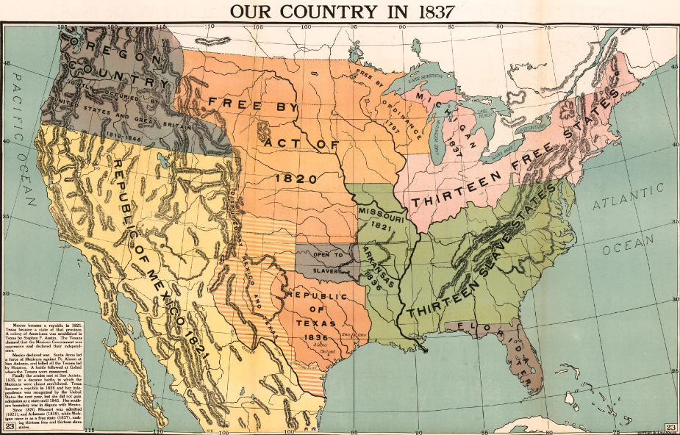  Figure 1 A political map of North America. The Library of Congress. | - What is one thing you observe about the?
- What is one thing you can infer about this era of Texas history based on your observations? Check TWO that you think are most likely.
- This era will include issues, discussions, or conflict over slavery.
- This era will include territorial conflict between Mexico and Texas.
- This era will include economic partnerships between the U.S. and Europe
- This era will include American attempts to buy Mexican land.

- What do you predict we will see in this unit based on the image? Circle or highlight two to four options you think are most likely.

Territorial conflict between Texas and Mexico | Arguments over slave-based economies | War with European powers like Spain
European colonization of the Americas | A relationship between Texas and the U.S. | Texas political and geographic issues

Part II: Essential Ideas Reading Passage

In the Texas Revolution unit, we learned how the conflict between centralists and federalists for control of the Mexican government affected Texas. Texans wanted to protect their right to self-government, so the people of Texas rebelled against Santa Anna’s centralist government. They won their independence following the Battle of San Jacinto on April 21, 1836. With that victory, Texas became an independent nation called the Republic of Texas.
The Republic of Texas faced many challenges during its short time as a country from 1836 to 1845. First, the government of Mexico did not recognize Texas as an independent nation. To Mexico, Texas was still a Mexican province in rebellion; it was not its own country. Additionally, Mexico disputed the boundaries that Texas claimed in the Treaties of Velasco. And it wasn’t just Mexico: The Republic of Texas’ government struggled to find other countries who were willing to recognize and trade with Texas.
Second, the provisional government of Texas had borrowed a great deal of money from American merchants to finance, or pay for, the Revolution. As a result, Texas was already $1.25 million dollars in debt when it became independent. Economic struggles throughout the era would cause Texas’s national debt to climb to nearly $12 million by 1845.
Third, as more and more Anglo-Americans moved into Texas, there were often conflicts between these new Anglo settlers and the American Indians who lived in the region. Many Anglos and American Indians competed for resources and land, especially in east Texas. This often led to a great deal of violence between these groups.
Fourth, during this time, more and more people in the world were beginning to oppose slavery. This caused a number of challenges for the Republic of Texas and its slave-based cotton economy. Texas applied to become a state in the United States three times during this era, but many American northerners opposed Texas joining the United States. They were worried that adding another southern slave state would give the South too much power in the government. Texas also had a hard time finding trade partners because many countries like Great Britain did not want to do business with the Republic because it used slave labor on its plantations.
The Republic of Texas era was shaped by the numerous challenges that faced the young country from 1836 to 1845. Texas tried several solutions to address these challenges, including trade with England and joining the United States. Eventually, Texas was able to join the United States in 1845. This act would have lasting consequences for Texas, the United States, and Mexico for generations to come.

Part III: Comprehension Questions

- According to the reading passage, which location on the map was the site of the majority of conflicts between Anglos and American Indians in Texas?  - 1  - 2  - 3  - 4 | 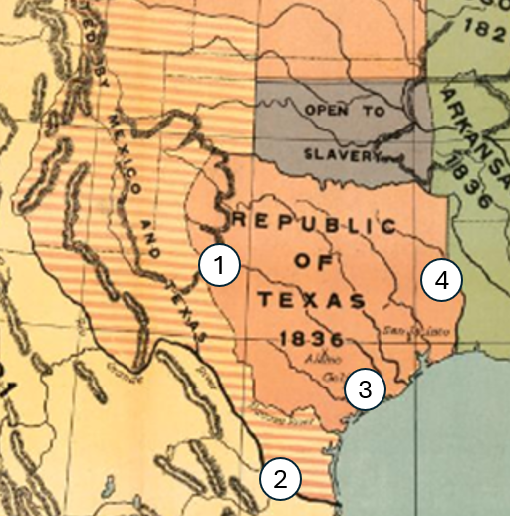

- Why do you think this site saw the most conflict between Anglos and American Indians in Texas?
  - Mexican immigrants, Anglo settlers, and American Indians in the south all wanted access to southern silver mines.
  - The coastal tribes like the Karankawa were more war-like than other Texas Indian tribes like the Caddo, Comanche, and Wichita.
  - Anglos immigrating into east Texas often wanted to settle on the same lands that eastern tribes like the Caddo and Cherokee occupied.
  - American immigrants migrating into west Texas often raided and attacked the sedentary Comanche settlements in the west.

- Three years after Texas defeated Santa Anna at the Battle of San Jacinto and declared itself to be a free and independent nation, a Mexican newspaper in Veracruz stated that the Mexican government, “is not aware of the existence of a nation called the Republic of Texas, but only a horde of adventurers in rebellion against the laws of the government of the republic.”
This quote provides evidence to support which of the following facts from the reading?
  - Mexico did not recognize Texas as an independent nation.
  - The British would not trade with a country that supported slavery.
  - The U.S. government was uncertain about accepting Texas as an American state.
  - The Republic of Texas struggled with the issue of debt throughout the era.

- Read the following primary source quote below and then answer the question that follows.
“Texas cannot continue in its present state: it must either, by virtue of its annexation to the United States, become a slave-holding country, or it must have a distinct existence as a free state.”

- Proceedings of the General Anti-Slavery Convention in Britain, 1843

Based on the primary source quote, which answer best explains Great Britain’s point of view on slavery in Texas?
- The people of Great Britain wanted to push Texas to join the United States in an effort to put an end to slavery in the Republic of Texas.
- If Texas joined the United States it would continue to have slavery, but if it remained independent it would have to get rid of slavery.
- Texas should get rid of slavery in order to establish trade with Britain.
- The Republic of Texas government was determined to get rid of slavery in order to join the United States or form a trade alliance with the British.

- In your own words, explain two challenges the Republic of Texas faced during its time as a nation from 1836 to 1845.
The Republic of Texas faced many challenges during its time as a nation from 1836 to 1845. One challenge was (A) the Republic of Texas’ government’s increasing debt (B) conflict with other Mexican states like New Mexico and California (C) the majority of Texans opposed slave labor. Another challenge Texas faced was (D) Spain’s attempts to recolonize northern Mexico (B) Texas struggled to gain international recognition and trade partners (C) the U.S. wanted to annex the Republic of Texas.

