
Warm-up: What’s the Story?
Unit 6: The Republic of Texas
Name: |  | Date: |  | Period:

Directions: The men in the photo were part of a group called the Texas Rangers. This photo was taken after the Republic of Texas era, but the Rangers played a significant role in the Republic of Texas.
Consider the challenges the Republic of Texas faced. What role do you think the Texas Rangers played in addressing these challenges? Use the image to make inferences to support your answer. | 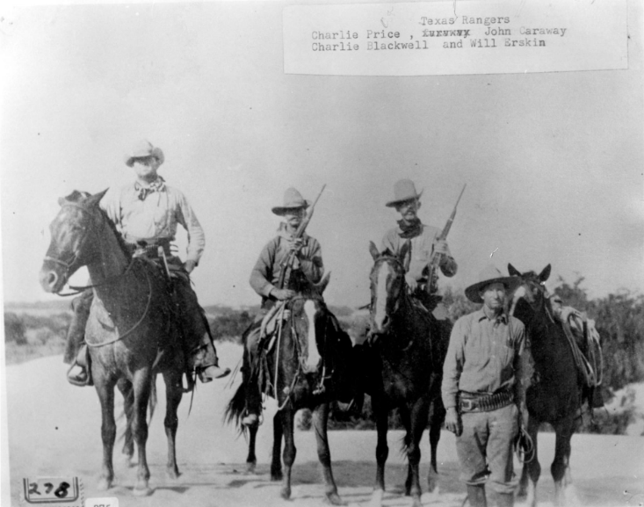

Warm-up: What’s the Story?
Unit 6: The Republic of Texas
Name: |  | Date: |  | Period:

Directions: The men in the photo were part of a group called the Texas Rangers. This photo was taken after the Republic of Texas era, but the Rangers played a significant role in the Republic of Texas.
Consider the challenges the Republic of Texas faced. What role do you think the Texas Rangers played in addressing these challenges? Use the image to make inferences to support your answer. | 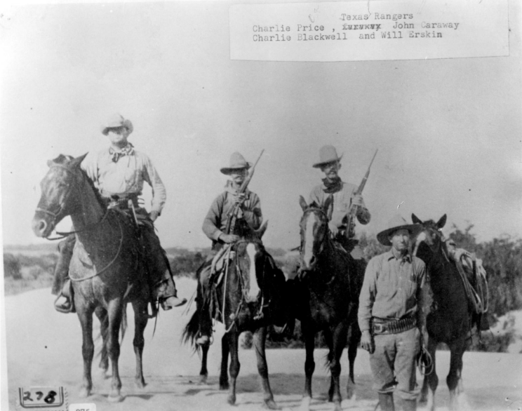


What’s the Story? Exit Ticket

Directions: Circle or highlight the significant challenges the Republic of Texas faced during its time as an independent nation from 1836 to 1845. Choose FOUR.
The U.S. opposed Texas annexation for years because of the issue of slavery and to avoid war with Mexico. | Anglo settlers and Texas Indians often experienced conflicts as both groups competed for land and resources. | President Santa Anna mounted a full-scale invasion of Texas, reconquering the southwestern portion of the young nation.
Texas struggled to maintain its own power in the face of multiple British attempts to take control of the Republic. | The Republic of Texas struggled to establish diplomatic and commercial relationships with other countries. | The Republic of Texas was too weak to protect itself from Mexican incursions into Texas territory.

What’s the Story? Exit Ticket

Directions: Circle or highlight the significant challenges the Republic of Texas faced during its time as an independent nation from 1836 to 1845. Choose FOUR.
The U.S. opposed Texas annexation for years because of the issue of slavery and to avoid war with Mexico. | Anglo settlers and Texas Indians often experienced conflicts as both groups competed for land and resources. | President Santa Anna mounted a full-scale invasion of Texas, reconquering the southwestern portion of the young nation.
Texas struggled to maintain its own power in the face of multiple British attempts to take control of the Republic. | The Republic of Texas struggled to establish diplomatic and commercial relationships with other countries. | The Republic of Texas was too weak to protect itself from Mexican incursions into Texas territory.

