 Warm-up: Who’s Who of the Republic of Texas
Unit 6: The Republic of Texas
Name: |  | Date: |  | Period:

Directions: The image below is a photograph of Sam Houston’s kitchen at his home in Huntsville where he lived from 1847 to his death in 1863. Make observations and inferences about the image to complete your warm-up.
What do you observe about the image? Based on your observations, what can you infer about daily life in Texas in the 1800s? | 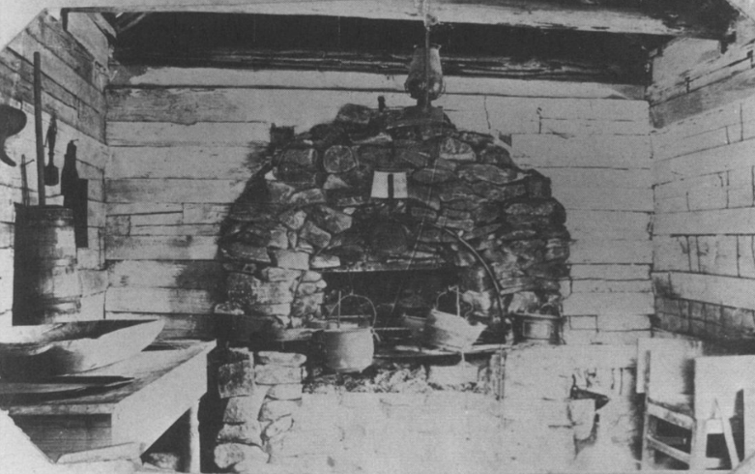

Warm-up: Who’s Who of the Republic of Texas
Unit 6: The Republic of Texas
Name: |  | Date: |  | Period:

Directions: The image below is a photograph of Sam Houston’s kitchen at his home in Huntsville where he lived from 1847 to his death in 1863. Make observations and inferences about the image to complete your warm-up.
What do you observe about the image? Based on your observations, what can you infer about daily life in Texas in the 1800s? | 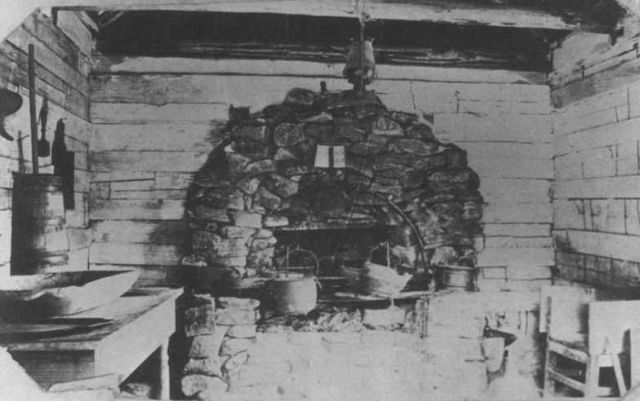

Who’s Who of the Republic of Texas Exit Ticket

Choose 2 people from today’s lesson. Write one name in each blank below. | Choose whether you think your two people would have been friends or opponents and then explain your reasoning.
I think ___________________________________________ and _______________________________________________ | Would have been friends / opponents because _____________________________________________________________ _____________________________________________________________ _____________________________________________________________

Who’s Who of the Republic of Texas Exit Ticket

Choose 2 people from today’s lesson. Write one name in each blank below. | Choose whether you think your two people would have been friends or opponents and then explain your reasoning.
I think ___________________________________________ and _______________________________________________ | Would have been friends / opponents because _____________________________________________________________ _____________________________________________________________ _____________________________________________________________

