**Looking Ahead: *Advanced***

*Unit 3: The Spanish Colonial Era*

|  |  |  |  |  |  |
| --- | --- | --- | --- | --- | --- |
| Name: |  | Date: |  | Period: |  |

**Part I: Transitioning to a New Era**

The Spanish Colonial Era was a period of time in Texas history characterized by Spain’s attempt to strengthen its claim to Texas. Spain established the Mission Presidio system in Texas to convert and assimilate Texas Indians into Spanish culture and prevent any French advancement into the region. This attempt was ultimately unsuccessful for a number of reasons. First, Spain failed to provide its Texas settlements with the support they needed. Additionally, most Texas Indians had no interest in mission life. Finally, powerful tribes like the Comanche successfully raided and attacked Spanish settlements for years, weakening Spain’s presence in Texas even further.

During the early 1800s, the War for Mexican Independence brought more than a decade of turmoil, battles, and uncertainty to the people of New Spain, especially Texas. Some filibusters from the United States entered Texas to join in the fight for Mexican independence. Spain’s response to rebellion in Texas was swift and harsh, reducing the Spanish population in Texas even further.

In 1821, the war ended, and Mexico was finally free from Spain. Though many in Mexico were probably ecstatic about their hard-won independence, the newly formed government of Mexico was facing a number of serious problems. One of the most serious was Texas.

1. How would you summarize the primary characteristics of the Spanish Colonial Era?
2. How did the events of the Spanish Colonial affect Texas specifically?

**Part II: What’s Going on in Texas?**

When Mexico became a country, it included more than twenty states spanning 1.7 million square miles. How could Texas possibly be its most serious problem?!

In order to better understand this, let’s first look at some letters written by the last Spanish governor of Texas to the government of New Spain.

Antonio Martínez was the Spanish governor of Texas during the last four years of the War for Mexican Independence, 1817-1821. He wrote to the government constantly during that time.

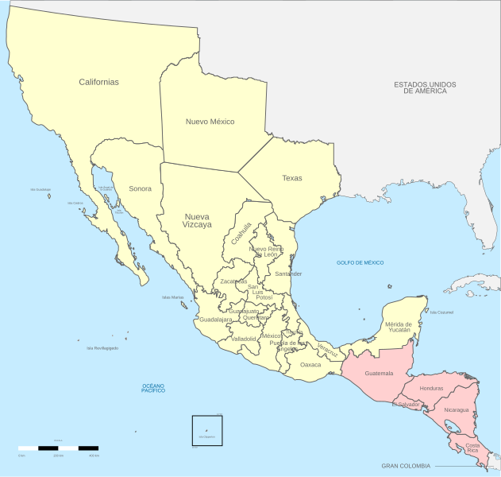

|  |
| --- |
| Before the revolution this province had nine missions and only four are left … each one has only from eight to ten inhabitants, most of whom are too old and poor to provide  for their own maintenance (not even so little as a gun for defense). Each day they beg me to remove them since they have no means of support and are unable to defend themselves against the continual attacks of the savages. |

1. What does Governor Martínez have to say about life for Spanish settlers in Texas?
2. What do you think Martínez means with the term “savages?” What bias, if any, does this term demonstrate?

|  |
| --- |
| …these troops … have been maintained only by some small loans which these citizens have made with great injury to their credit and the livelihood of their families, to such extent that when I saw they were poverty stricken and had nothing left to give I was compelled to contribute to these troops my small supply of grain and some cash I have for my family, and now … with things in this state, the citizens, troops, and I myself are absolutely impoverished.  The repeated orders which Your Excellency has given to the Minister of the Treasury of Saltillo are unequivocal proof that you truly desire that these troops receive all the assistance possible, but up to now your orders have not been executed nor do I believe they will be because the money is lacking, as I have been told.  In such case the preservation of this province and the prevention of irreparable ills, even its general abandonment, demand that you aid me directly or by means of effective measures that cannot be delayed; otherwise I will not be able to avoid the consequences of my fatal situation nor can I be responsible for saving this province which has been entrusted to my care.   * God keep Your Excellency many years. Bexar, October 28, 1820. |

1. According to Governor Martínez, who is providing for the Spanish troops at the presidios? How has this affected the people involved?
2. According to Martínez, why are the Spanish people of Texas in such a desperate state?
3. What does Martínez claim will be the result if the Spanish government does not provide support to Texas?

**Part III: Mexico, We Have a Problem.**

After Mexico won its war against Spain for independence, the leadership of Mexico began setting up a government and determining the most serious problems facing the new country. There was definitely no shortage of challenges!

First, the government was responsible for an enormous amount of land inhabited by incredibly diverse groups of people – many of whom, like many American Indians, did not consider themselves Mexican. Another challenge was that most parts of the country were distant and isolated from the seat of government in Mexico City. Additionally, Mexico was surrounded by potential rivals. Russia had been exploring closer and closer to California, some in the United States believed Texas should be part of the U.S., and Spain itself still occupied territory nearby in the Caribbean.

With all of these serious issues, what challenge was the government of Mexico most concerned about? Read the following excerpt from a government report about the challenges facing Mexico in 1821.

|  |
| --- |
| The most important problem is the security of the Province of Texas.  Cities are not formed of buildings but of people. The defense of kingdoms consists of defending its population, great or small. The Great Wall did not protect China from the Tartars, it fell when confronted by superior numbers.  The province of Texas is so fertile, of such an excellent climate, so rich in metals and natural resources that when one reads the description by the geographers they believe they speak of Paradise. Complete admiration compels them to ask, “Why didn’t the Spaniards dedicate all their looks and efforts to populate [Texas]?”  These circumstances cause the covetous looks of the European nations, and those of the United States are even greater because they are closer.  It would be an irreparable loss to the Empire if this beautiful Province is lost. In order to save it there remains only one recourse – to populate it. |

1. According to the report, what did the Mexican government consider to be the most important challenge it was facing in 1821?
2. Did the Mexican government believe that Spain had handled Texas appropriately? Why or why not?
3. How did the Mexican government view Texas in 1821? Use text evidence to support your claim.
4. The report makes the claim, “These circumstances cause the covetous looks of the European nations, and those of the United States are even greater because they are closer.” Which statement below best paraphrases this claim?
   1. The United States and Europe are greater than Mexico, so Mexico should be very careful when dealing with these powers.
   2. Both European countries and especially the U.S. want Texas because it is so valuable.
   3. The European countries could be great allies, and the U.S. could be even greater allies because they are close to Mexico.
   4. Mexico should avoid great powers like the countries of Europe and the United States because they are too powerful.
5. What do you think Mexico might do in the next unit to address this problem of its weak claim to the incredibly valuable land of Texas?