**Looking Ahead: *Foundations***

*Unit 3: The Spanish Colonial Era*

|  |  |  |  |  |  |
| --- | --- | --- | --- | --- | --- |
| Name: |  | Date: |  | Period: |  |

**Part I: Transitioning to a New Era**

**The Spanish Colonial Era was a period of time in Texas history characterized by Spain’s attempt to strengthen its claim to Texas.** Spain established missions in Texas to convert and assimilate Texas Indians into Spanish culture. Spain established presidios near each mission to protect the people, and more importantly, to prevent any French advancement into the region.

**The Mission Presidio system was ultimately unsuccessful for a number of reasons**. First, Spain failed to give the settlements in Texas the support they needed. Additionally, most Texas Indians had no interest in mission life. Finally, powerful tribes like the Comanche successfully raided and attacked Spanish settlements for years. **This weakened Spain’s presence in Texas even further.**

During the early 1800s, the War for Mexican Independence brought more than a decade of turmoil, battles, and uncertainty to the people of New Spain, especially Texas. Some filibusters from the United States entered Texas to join in the fight for Mexican independence**. Spain’s response to rebellion in Texas was harsh, reducing the Spanish population in Texas even further.**

In 1821, the war ended, and Mexico was finally free from Spain. Though many in Mexico were probably incredibly happy about gaining independence, the new government of Mexico was facing a number of serious problems. **One of the most serious was Texas.**

1. How would you summarize the primary characteristics of the Spanish Colonial Era? Circle or highlight **TWO** answers in the response.

|  |
| --- |
| The primary characteristics of the Spanish Colonial Era are that **(A)** Spain unsuccessfully tried to hold onto Texas with the Mission Presidio System and **(B)** The United States successfully claimed Texas as part of the U.S. and **(C)** Spain expanded its colonies in North America to include Mexico and Texas and **(D)** the War for Mexico gained freedom for Mexico but left Texas even weaker than ever. |

**Part II: What’s Going on in Texas?**

When Mexico became a country, it included more than twenty states covering 1.7 million square miles. **How could Texas possibly be its most serious problem?!**

In order to better understand, let’s first look at some letters written by the last Spanish governor of Texas to the government of New Spain.

**Antonio Martínez** was the **Spanish governor of Texas** during the last four years of the War for Mexican Independence, 1817-1821. He wrote to the government constantly during that time.

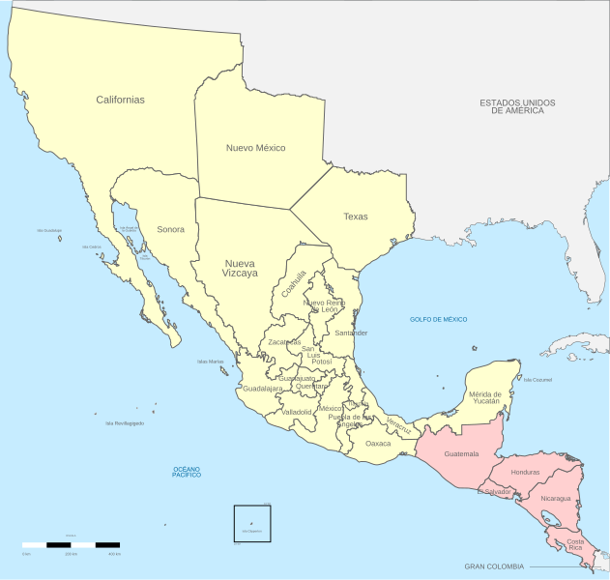

|  |
| --- |
| Before the revolution this province had **nine missions** and **only four are left** … each one has **only from eight to ten inhabitants**, most of whom are **too old** and **poor** to provide  for their own maintenance (not even so little as a gun for defense). Each day **they beg me to remove them** since they have no means of support and **are unable to defend themselves** against the continual attacks of the savages. |

1. According to Governor Martínez, what was life like for Spanish settlers in Texas during that time?
   1. Life was full of economic opportunity and successful trade relationships between the Spanish and the Texas Indians.
   2. Life was difficult because the few Spanish settlers in Texas were old, weak, and poor.
   3. Life was more difficult as a result of the war but had been fairly prosperous before the war.
   4. Life was easy for most, though some Spanish settlers struggled financially.

|  |
| --- |
| …these troops … have been maintained only by some **small loans which these citizens have made** with great injury to their credit and the livelihood of their families, to such extent that when **I saw they were poverty stricken** and had nothing left to give I was compelled to contribute to these troops my small supply of grain and some cash I have for my family, and now … with things in this state, **the citizens, troops, and I myself are absolutely impoverished**. |

1. According to Governor Martínez, who has been providing for the soldiers at the presidios in Texas?
   1. The Spanish settlers have taken out loans to help the soldiers, which has left everyone poor and without resources.
   2. The local Spanish government of San Antonio has been hiring the soldiers as agricultural workers when they aren’t working at the presidio.
   3. The Texas Indians supply most of the pay and resources for the soldiers, since the soldiers protect them.
   4. ~~All answers are correct.~~

|  |
| --- |
| In such case **the preservation of this province** and the prevention of irreparable ills, even its general abandonment, **demand that you aid me directly** or by means of effective measures that cannot be delayed; **otherwise I will not be able to avoid the consequences** of my fatal situation nor can I be responsible for saving this province which has been entrusted to my care.   * God keep Your Excellency many years. Bexar, October 28, 1820. |

1. What warning does Martínez make to the government of New Spain?
   1. ~~Martínez needs to preserve the province, so the French don’t take it over.~~
   2. People will get sick and abandon their families to search for help.
   3. The Texas Indian tribes like the Comanche will take over the Spanish settlements if no help arrives.
   4. If the government doesn’t send immediate help, Spain could lose Texas.

**Part III: Mexico, We Have a Problem.**

After Mexico won its war against Spain for independence, the leadership of Mexico began setting up a government and determining the most serious problems facing the new country. **There were definitely a lot of challenges**!

**First**, the government was responsible for an enormous amount of land inhabited by incredibly diverse groups of people. Many people living in Mexico in 1821, like many American Indians, did not consider themselves Mexican. **Another challenge** was that most parts of the country were distant and isolated from the government in Mexico City. **Additionally**, Mexico was surrounded by potential rivals. Russia had been exploring closer and closer to California, some in the United States believed Texas should be part of the U.S., and Spain itself still occupied territory nearby in the Caribbean.

With all of these issues, **what challenge was the government of Mexico most concerned about?** Read the following excerpt from a government report about the challenges facing Mexico in 1821.

|  |
| --- |
| **The most important problem is the security of the Province of Texas.**  The province of Texas is so **fertile**, of such an **excellent climate**, so **rich in metals and natural resources** that when one reads the description by the geographers they believe they speak of **Paradise**. Complete admiration compels them to ask, “Why didn’t the Spaniards dedicate all their looks and efforts to populate [Texas]?”  These circumstances cause **the covetous looks of** the European nations**, and those of the United States are even greater because they are closer**.  It would be an irreparable loss to the Empire if this beautiful Province is lost. In order **to save it** there remains only one recourse – **to populate it**. |

1. According to the report, what did the Mexican government consider to be the most important challenge it was facing in 1821?

|  |
| --- |
| The most important challenge facing Mexico in 1821 was the problem of _________________ _____________________________________________________________________________________________________ |

1. According to the report, how did the Mexican government view Texas in 1821?
   1. It viewed Texas as greater than the countries of Europe and the United States because it was closer to Mexico City.
   2. It viewed Texas as a problem that Mexico needed to get rid of before the U.S. or Europe got involved.
   3. It viewed Texas as very valuable and believed something should be done to keep it safe from outside threats.
   4. ~~All answers are correct.~~
2. The report makes the claim, “These circumstances cause the covetous looks of the European nations, and those of the United States are even greater because they are closer.” Which statement below best paraphrases this claim?
   1. The United States and Europe are greater than Mexico, so Mexico should be very careful when dealing with these powers.
   2. Both European countries and especially the U.S. want Texas because it is so valuable.
   3. ~~The European countries could be great allies, and the U.S. could be even greater allies because they are close to Mexico.~~
   4. Mexico should avoid great powers like the countries of Europe and the United States because they are too powerful.
3. What do you think Mexico might do in the next unit to address this problem of its weak claim to the incredibly valuable land of Texas?

|  |
| --- |
| In the next unit, I think Mexico might __________________________________________________________ _____________________________________________________________________________________________________ _____________________________________________________________________________________________________ to address this problem of its weak claim to the valuable land in Texas. |