Unit 3:

The Spanish Colonial Era

Lesson 9:

Looking Ahead
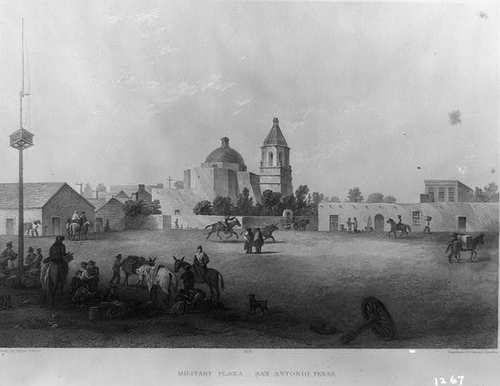

Looking Ahead

Warm-up

Warm-up:
Follow the directions to complete your warm-up
- Read the excerpt from a San Antonio newspaper in 1813.
- Consider the scenario and the question.
- Record your answer.
- Discuss with a partner.

Share with the class
In 1813, life in San Antonio is (blank)
One option to make things better could be (blank)

Essential Questions
How did the Spanish Colonial era affect Texas and its population?
How did Texas pose a challenge to the government of Mexico in 1821?

In today’s lesson…
1. We will examine the social and economic situation in Texas in 1821 and identify the specific challenges that Texas posed to the newly formed government of Mexico.
2. I will read primary source excerpts to identify specific challenges related to Texas and answer comprehension questions about each excerpt.

Transitioning to a New Era
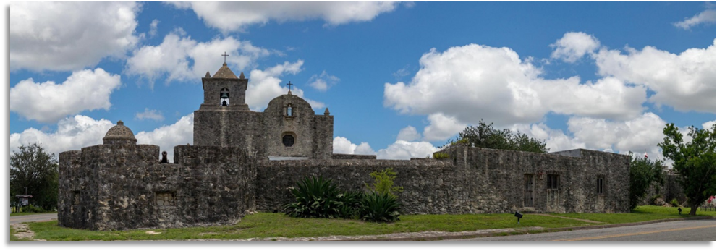
The Presidio at La Bahía.
The Portal to Texas History.

What’s Going on in Texas?
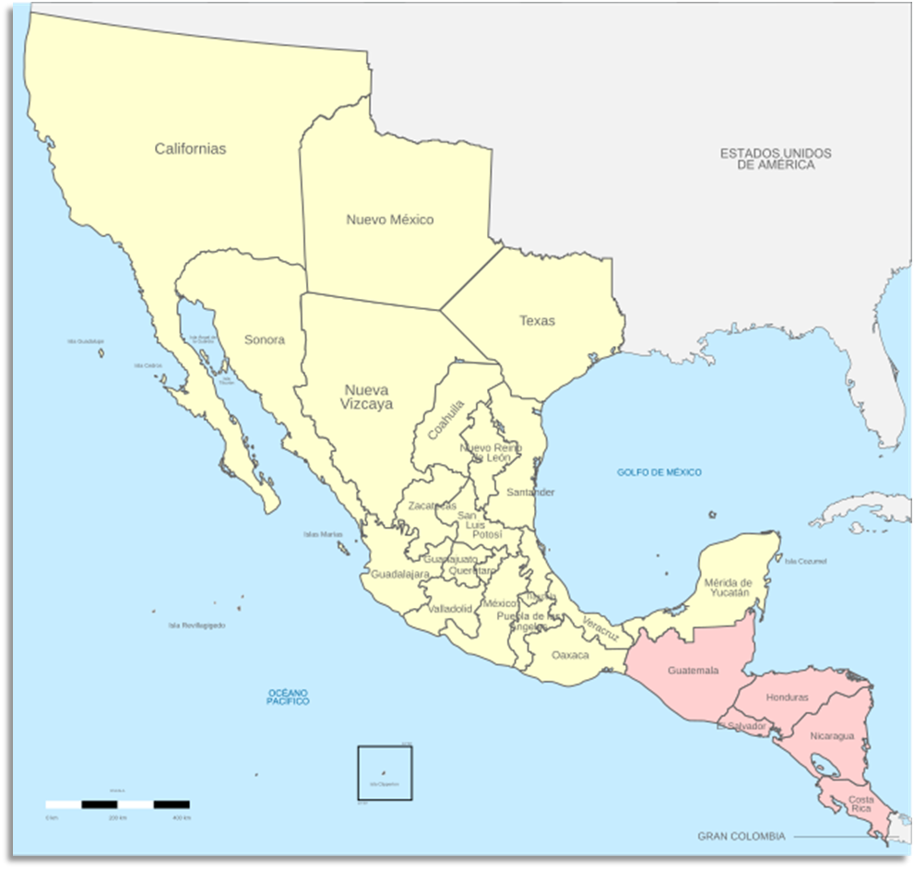

Mexico, We Have a Problem.


Looking Ahead

Exit Ticket

Exit Ticket:
Follow the directions to complete your exit ticket.
- Circle or highlight which action you think Mexico is most likely to take to address its concerns about Texas.
- Explain why you think Mexico would take that action.
- Discuss with a partner.

Share with the class 2
I think Mexico will probably (blank)
I think Mexico will take this action because (blank)

