 Warm-up: Mind Map Review
Unit 3: The Spanish Colonial Era
Name: |  | Date: |  | Period:

Look at the word bank below. Complete the mind map diagram by putting each term where you think it fits best.

- Caste System  - War for Mexican Independence  - Mission Presidio System  - Spanish Colonial Era  - Strengthen Spain’s claim to Texas | 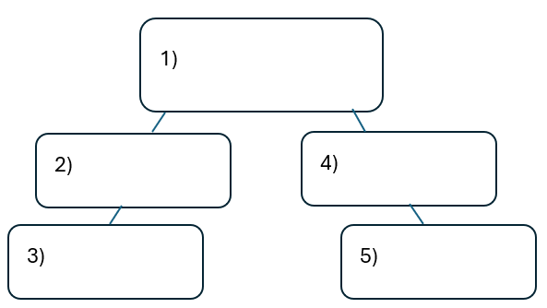

Warm-up: Mind Map Review
Unit 3: The Spanish Colonial Era
Name: |  | Date: |  | Period:

Look at the word bank below. Complete the mind map diagram by putting each term where you think it fits best.

- Caste System
- War for Mexican Independence
- Mission Presidio System
- Spanish Colonial Era
- Strengthen Spain’s claim to Texas


Mind Map Review Exit Ticket
Directions: Complete the sentence by choosing the best answer for each blank from the chart below.

The (1)____________ is primarily characterized by (2)____________

Answer choices for blank (1)  Circle the best answer | Answer choices for blank (2)  Circle the best answer

- War for Mexican Independence  - Mission Presidio System  - Filibusters in Texas  - Spanish Colonial Era | - American immigrants legally migrated to Texas to take part in agriculture and business.  - Spain’s attempts to maintain and strengthen its control on Texas and its colonies in New Spain.  - Mexico’s attempts to assimilate Texas Indians into the Mexican government.  - The Spanish-born colonists of New Spain’s attempts to overthrow the Spanish king.

Mind Map Review Exit Ticket

Directions: Complete the sentence by choosing the best answer for each blank from the chart below.

The (1)____________ is primarily characterized by (2)____________

Answer choices for blank (1)  Circle the best answer | Answer choices for blank (2)  Circle the best answer

- Conquistadors  - Columbian Exchange  - Age of Contact  - Reconquista | - American immigrants legally migrated to Texas to take part in agriculture and business.  - Spain’s attempts to maintain and strengthen its control on Texas and its colonies in New Spain.  - Mexico’s attempts to assimilate Texas Indians into the Mexican government.  - The Spanish-born colonists of New Spain’s attempts to overthrow the Spanish king.

