# **San Francisco de los Tejas**

# **Missions in Texas *- Advanced Readings***

# *Unit 3: The Spanish Colonial Era*

The first mission that Spain founded in east Texas was called **San Francisco de los Tejas.** Spain sent a Spanish soldier named **Alonso de León** and a friar named **Damián Massanet** in search of any French explorers who had survived La Salle’s expedition.

De León and Massanet heard rumors that there were Frenchmen living in east Texas among the **Caddo** people. As a result, De León and Massanet decided to establish their mission and presidio near present-day **Nacogdoches** in **1690** to prevent the French in Louisiana from encroaching on Spanish territory in east Texas. The Spanish also hoped to convert and assimilate members of the **Hasinai Caddo** tribe who lived in the region.

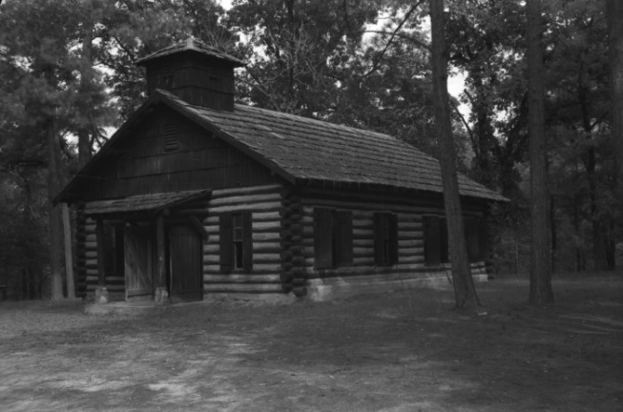

Figure 1: The reconstructed church building from the mission. The Portal to Texas History A geographic map of Texas with its contemporary political borders showing the approximate location of mission San Francisco de los Tejas near present-day Nacogdoches
 Figure 2: A map showing the approximate location of the mission.

The Caddo were a powerful agricultural tribe that focused on building strong trade relationships with other tribes throughout the region. They also traded with Frenchmen who had settled in Louisiana.

The Caddo had little interest in the Spanish beyond developing a trade relationship. When the Spanish at the mission and presidio ran out of items of value to trade, the Caddo lost interest in continuing that relationship.

In addition to Caddo disinterest, San Francisco de los Tejas and other missions that were established in the region faced a number of challenges from 1690 to 1693. **Floods** from the Neches River destroyed a second mission’s church. The Spanish often **lacked supplies** due to the mission’s extreme distance from the more populated areas of Mexico. **Diseases** like **smallpox** swept through the mission killing many Caddo people. So many Caddo died, in fact, that it is reported they began to believe the baptismal water at the church was deadly.

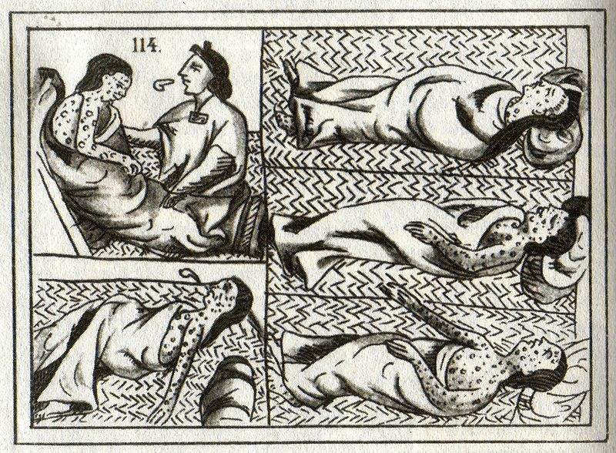

Figure 3: A 16th century drawing of American Indian smallpox victims.

The Caddo grew increasingly opposed to the Spanish presence in their region and began to push for the Spanish to leave the area. Some friars were so disheartened by the struggles over the years that they fled the mission to return to Mexico. Eventually, at the insistence of the Caddo, in **1693** the remaining friars dismantled the mission, burned the buildings, and abandoned the area entirely.

In **1716**, a Spanish friar named **Francisco Hidalgo** attempted to reopen the mission under the new name **Nuestro Padre San Francisco de los Tejas.** The new mission faced similar challenges, however. The new mission faced similar challenges, however, and it was closed and abandoned in **1719**.

In general, these first east Texas missions failed to achieve their goals of converting and assimilating Texas Indians and maintaining a Spanish presence in east Texas.

# **Los Adaes**

# **Missions in Texas *- Advanced Readings***

# *Unit 3: The Spanish Colonial Era*

The government of New Spain appointed a Spanish soldier named **Domingo Ramón** and a Spanish friar named **Antonio Margil de Jesús** to establish a presence in east Texas in **1717** to prevent any potential French encroachment into the region.

Ramón and Margil de Jesús founded the mission and presidio of **Los Adaes** in present-day Louisiana to prevent French advancement into New Spain and convert the Caddo Indians. Interestingly, a French man named **Louis St. Denis** actually helped establish the mission when the Spanish government offered no help!

The mission was abandoned only two years later in **1719** after an issue with a few French soldiers in the area that came to be known as **“The Chicken War.”**

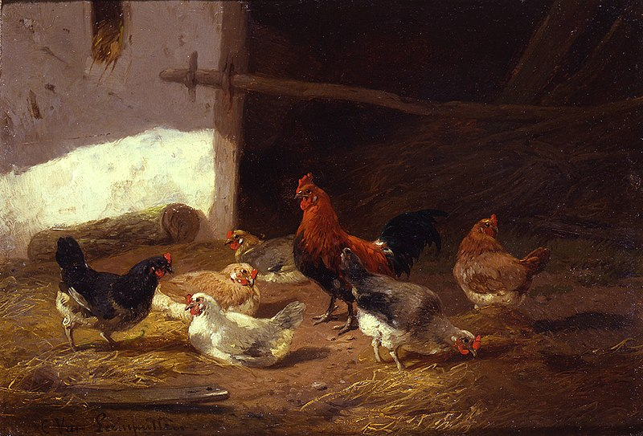

Figure 4: Chickens in a farmyard by Cornelius Van Leemputten

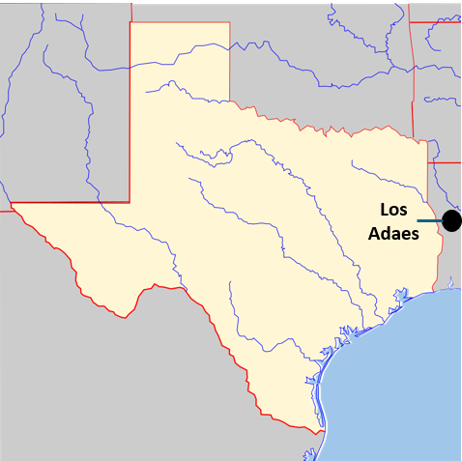 Figure 5: A map of the approximate location of Los Adaes.

Contrary to its name, no chickens actually fought in the Chicken War. On a hot June day, a few French soldiers raided a henhouse at the Spanish mission. While the French were trying to escape, the

stolen chickens spooked the horses and caused a small disturbance. The Spanish missionaries heard of this and, believing they were under attack by a superior force, they abandoned the mission and fled to San Antonio.

In reality, the Chicken War was barely a disturbance, let alone an actual war. To the few Spaniards at the mission, however, it appeared to be a serious threat from their French rivals. As a result, los Adaes closed down in **1719**, and the Spanish abandoned the mission and presidio.

Los Adaes reopened in **1721** under the direction of the wealthy governor of Coahuila y Tejas, **the Marques de Aguayo.** The friars at the mission planned

to minister to the Caddo people living in the region, however the Caddo were only interested in establishing trade relationships with the Spanish. They had no interest in assimilating into Spanish culture at the missions.

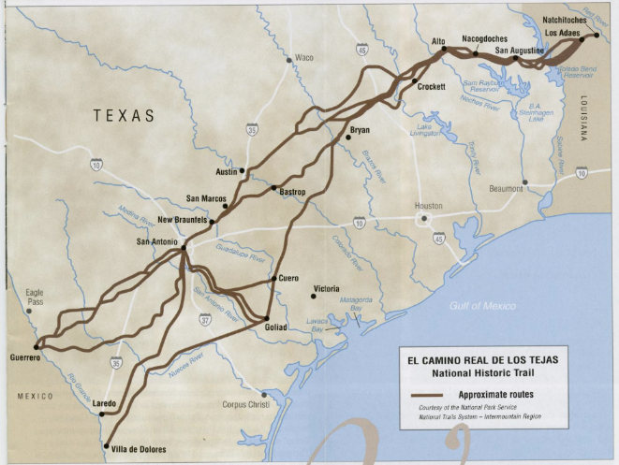

Figure 6: El Camino Real. The Portal to Texas History.

Los Adaes struggled with the same issues that plagued other east Texas missions**. It was incredibly difficult to access supplies from Mexico due to its distant location.** The Spaniards at Los Adaes depended on trade with their French rivals in the area to maintain their settlement!

In addition to the lack of supplies, there was a long period of **bad weather** and **crop failures** that made life more difficult for settlers at the mission and in the nearby Spanish towns and ranches.

In **1721**, **Spain** **declared Los Adaes the capital of Texas** in the hopes of strengthening the settlement there, while at the same time reducing the number of soldiers at the presidio. For decades, despite the many difficulties at the mission, Los Adaes was the easternmost Spanish settlement in Texas.

Then, in **1762** France was forced to give up all of its North American territory after being defeated by the British in **the French and Indian War.** The Louisiana territory west of the Mississippi River transferred into Spanish control and the threat of French encroachment into Texas practically disappeared.

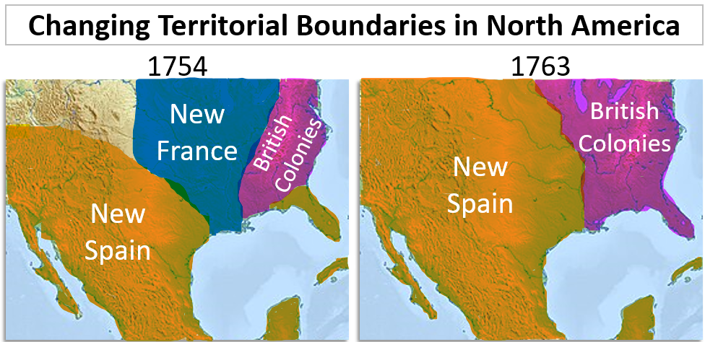

Spain closed Los Adaes in **1772**. The people at the mission and the surrounding settlements moved to **San Antonio**, which was named the new capital of Texas in 1773.

# **San Antonio de Valero**

# **Missions in Texas *- Advanced Readings***

# *Unit 3: The Spanish Colonial Era*

In **1718**, Spain established **San Antonio** as a midpoint for travelers on their way to and from the east Texas missions. A Spanish friar named **Antonio de Olivares** founded mission **San Antonio de Valero** as the first Spanish mission and presidio in San Antonio. Presidio Bexar was founded nearby. This mission will be significant later in Texas history when it is known by another name: **The Alamo**. More on that in later units!

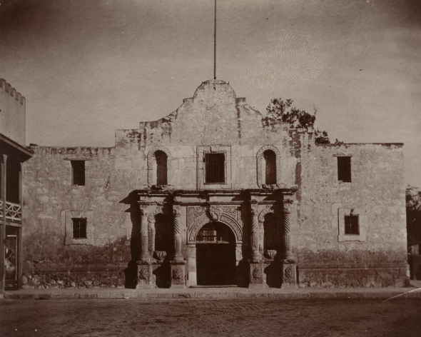

Figure 7: San Antonio de Valero's church, known today as the Alamo. The Portal to Texas History.

Spain went on to establish a total of five missions in San Antonio during the early 1700s. These missions attempted to convert and assimilate Texas Indians primarily from various **Coahuiltecan** tribes. There were reportedly more than 300 Texas Indians living at the San

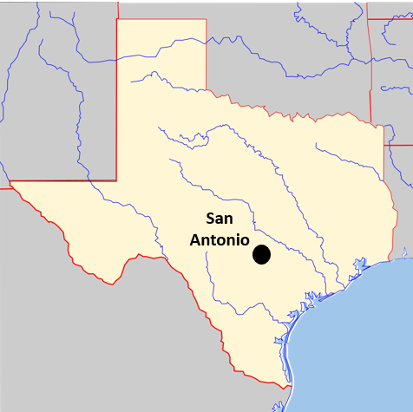

Figure 8: A map of the approximate location of San Antonio

Antonio missions by the 1740s and 1750s.

While in many ways the San Antonio missions appeared to be more successful than other missions in Texas, they still struggled with many of the same issues facing other missions across the region. Living conditions were difficult. European **diseases** killed many Texas Indians at the missions. Receiving supplies from central Mexico was a challenge, and the government of New Spain never provided the missions with adequate support, manpower, or supplies.

In addition to the challenges listed above, the Texas Indians living at the San Antonio missions were typically more interested **in protection from rival tribes** than accepting mission life. The Coahuiltecan people often sought refuge at the San Antonio missions from rival **Apache** tribes. The missions themselves were also frequently the target of Apache raids.

When the **Comanche** migrated into Texas and became the dominant power on the Great Plains beginning in the mid-1700s, San Antonio settlements were faced with attacks and raids by the powerful Comanche as well.

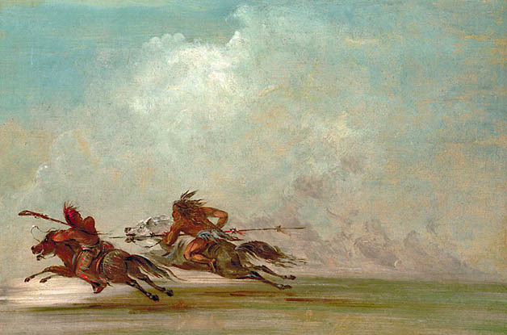

Figure 9: War on the Plains, by George Catlin.

There was another challenge that was unique to the missions and settlements at San Antonio. In 1731, a group of Spanish colonists from the **Canary Islands** immigrated to San Antonio. The Canary Islands are located off the northwest coast of Africa. The Spanish had colonized these islands in the 15th Century.

The arrival of these new settlers from the Canary Islands caused some disruption within the community as they appeared to receive special treatment and privileges from the government.

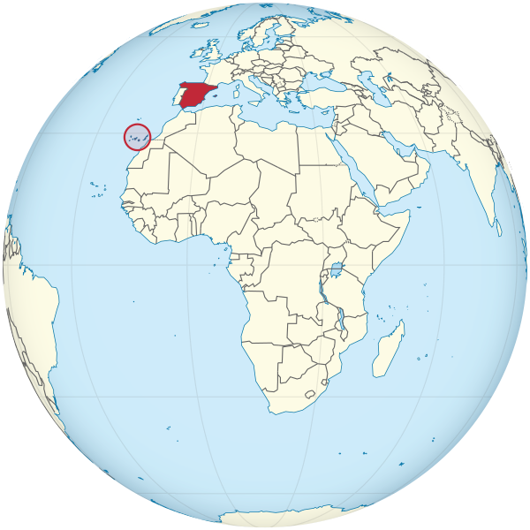

Figure 10: A map of the Canary Islands, circled in red.

**The Canary Islanders** were granted titles of nobility upon their arrival, meaning that they and their descendants would be considered a higher class with more power than others in the community. Needless to say, many of the settlers who already lived in San Antonio were upset by this apparent preferential treatment.

Despite the dissatisfaction of some San Antonio residents, the **Canary Islanders** played an important role in the development of San Antonio, including building **canals** and expanding the **irrigation system** to allow for better farming in the region. This in turn made settlements in San Antonio much more successful than many others.

The mission closed in 1793 when Spain began to end the mission system in Texas.

# **La Bahía**

# **Missions in Texas *- Advanced Readings***

# *Unit 3: The Spanish Colonial Era*

The Spanish typically chose the locations of the earliest missions based on where they felt the missions were most likely to deter French encroachment into Texas. The missions in east Texas, for example, were meant to prevent any French advancement into east Texas from Louisiana. The location for the mission and presidio Nuestra Señora de la Bahía del Espiritu Santo de Zúñiga was also chosen with the French threat in mind.

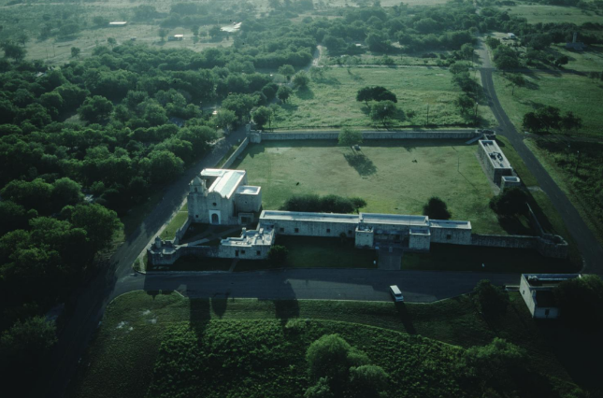

Figure 11: La Bahía. The Portal to Texas History

La Bahía del Espiritu Santo, also simply known as **La Bahía**, was founded in **1721** in **Matagorda Bay**, near the site of Robert La Salle’s failed Fort Saint Louis.

The governor of Coahuila y Tejas, **the Marques de Aguayo,** authorized the establishment of the mission in an attempt to secure the coast for Spain and convert and assimilate the various

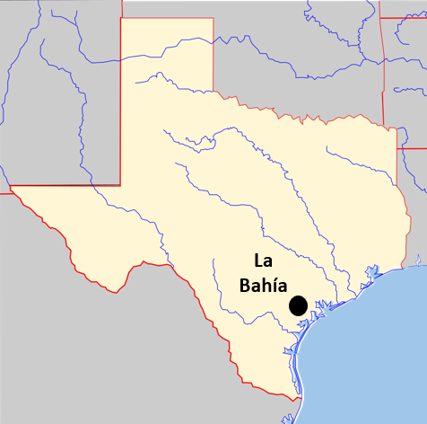

Figure 12: A map of the approximate final location of La Bahía

groups of **Karankawa** in the region. A Spanish military officer named **Domingo Ramón** even founded the presidio on the actual ruins of La Salle’s old fort!

La Bahía was relocated multiple times, ultimately ending up on the San Antonio River near present-day **Goliad**. The settlements that grew around La Bahía became important locations for trade and business along the **Camino Real**.

La Bahía struggled with many challenges and difficulties over the years. **Diseases** like **malaria** took a significant toll on the population at the mission. Shortages of food, supplies, and clothing often made mission life difficult. Additionally, there were frequent disputes between the leadership at the missions and presidios.

There were also several conflicts between the Spanish soldiers at the presidio and the Karankawa. The Spaniards at La Bahía frequently tried to forcefully convert the Karankawa people to Catholicism and establish a firm control over Karankawa lands. Many of the Karankawa people resisted these Spanish attempts at control. Over time, conflict between the two groups led to the deterioration of the relationship between the Spanish and the Karankawa people. One extreme example of this deterioration was the **Spanish-Karankawa War** of the late 1700s.

Spain closed the mission in 1794, though the grounds and buildings would go on to be utilized in later significant events including the War for Mexican Independence and the Texas Revolution.

# **San Sabá**

# **Missions in Texas *- Advanced Readings***

# *Unit 3: The Spanish Colonial Era*

Mission San Sabá was founded in **1757** to convert and assimilate the **Apache** Indians of the Great Plains. The relationship between the Spanish and the Apache in the region had been filled with conflict during the early 1700s. The Apache often attacked and raided missions and settlements in places like San Antonio.

Spanish friars began petitioning the government of New Spain to build missions in ***Apachería*** – or the Apache’s Land – in the early 1700s. The friars had hoped that ministering to the Lipan Apache might help develop a peaceful relationship between the two groups. The Spanish government denied those initial requests, however.

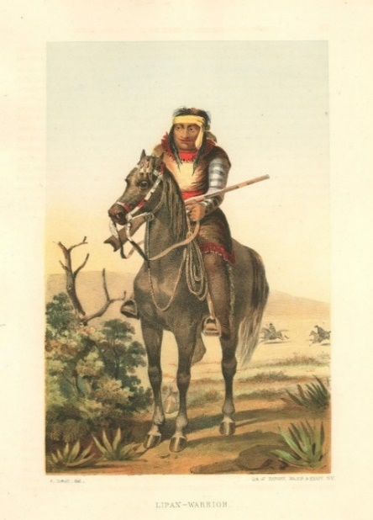

Figure 13: A Lipan Apache Warrior. The Portal to Texas History

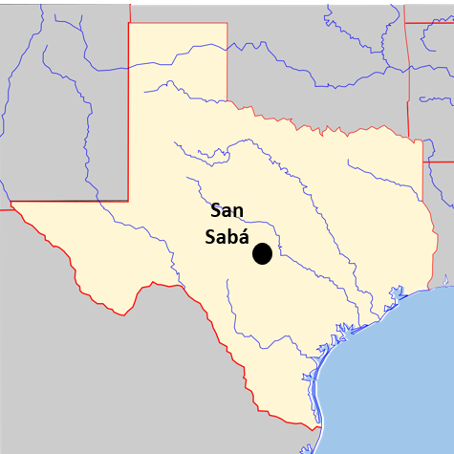

Figure 14: A map of the approximate location of mission San Sabá

When the **Comanche** migrated to Texas in the **1730s and 1740s**, they quickly came to dominate the Great Plains. Conflict between the Comanche and Apache broke out as the Comanche pushed the Apache farther into South Texas and out of the Great Plains region. This is sometimes referred to as **“the War for the Great Plains**.”

In **1749**, the Apache made a **peace treaty** with the Spanish and requested a mission near **San Antonio**. Like other Texas Indian tribes, the Apache were not interested in mission life or assimilating into Spanish culture. The Apache hoped that the Spanish presence in the region would provide them with some protection from Comanche attacks. They may have also hoped the Comanche would direct their attacks to the Spanish instead.

Mission San Sabá faced many challenges like so many other missions across Texas. The Apache had no interest in mission life, and the missionaries never truly understood their Indigenous culture. In fact, no Apache ever even lived at the mission. Many missionaries were so disheartened by the mission’s failure to minister to the Apache that several of them abandoned the mission to return to San Antonio.

One significant issue at mission San Sabá was safety. This was especially challenging because the presidio for San Sabá was located far from the mission. The Spanish friars had wanted the presidio farther from the mission to avoid any potential conflict between the soldiers and the Apache at the mission. The unintentional effect of this distance was that it made the mission more difficult to protect.

**This all came to a head on March 16, 1758, when 2000 Comanche and their allies attacked the mission at San Sabá.** Reports indicated that seventeen Texas Indians and eight Spaniards at the mission were killed in the attack and many others were badly wounded. It was also reported that eight soldiers were attacked and in grave condition. Only one priest, Father Miguel Molina, escaped.

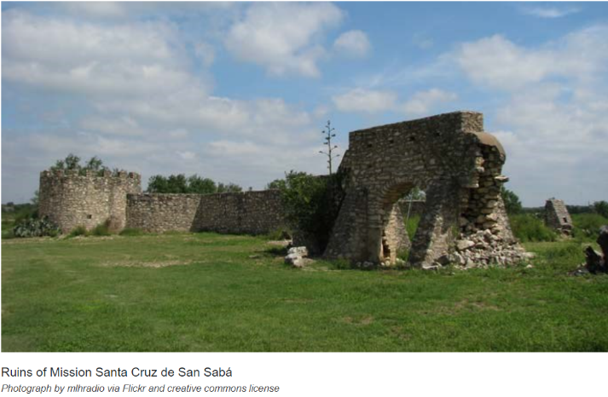

Figure 15: The ruins of San Sabá. The National Parks Service.

The mission itself was destroyed by fire in the attack. It was never reopened, as Spain began to retreat from its northern settlements along the Great Plains – the area often known as ***Comanchería****,* or the Comanche’s land.

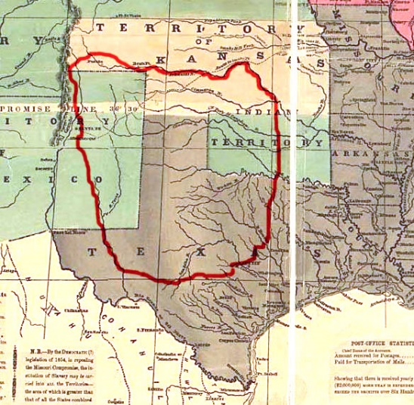

Figure 16: A map of Comanchería - or the land of the Comanche.

# **Corpus Christi de la Isleta**

# **Missions in Texas *- Advanced Readings***

# *Unit 3: The Spanish Colonial Era*

Corpus Christi de la Isleta was founded by **Antonio de Otermín** and **Fray Francisco de Ayeta** near the west Texas town of **El Paso** in **1682** to convert and assimilate the **Tigua** **Indians**. It is considered to be the first mission Spain established in Texas. It was initially constructed on the **Rio Grande** **River,** though it was moved several times as a result of flooding.

**Otermín** and **Ayeta** had originally lived in New Mexico where they had attempted to convert and assimilate the Pueblo people. Spanish rule in New Mexico had been harsh and oppressive. As a result, a Pueblo medicine man named **Po’Pay** led a rebellion against the Spanish and successfully drove them out of the Pueblo lands.

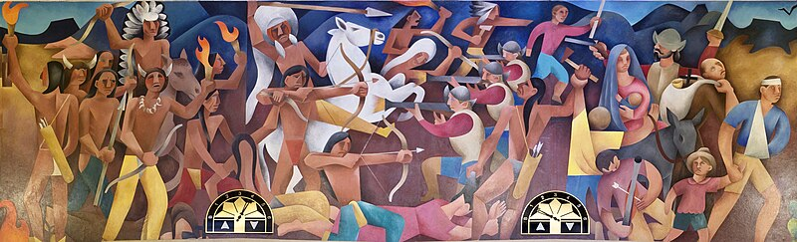

Figure 17: A painting by Loren Mozley of the Pueblo Revolt of 1680. WPA mural at the Albuquerque Courthouse.

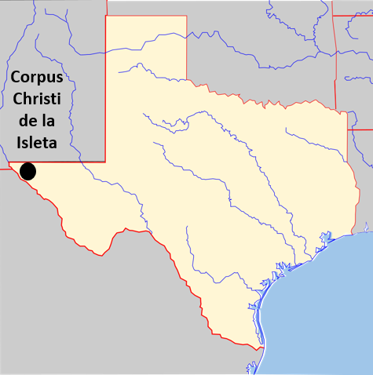

Figure 18: : A map of the approximate location of mission Corpus Christi de la Isleta

Some Tigua people had been allied with the Spanish in New Mexico, while others

had been held captive by the Spanish. Following the revolt, the Spaniards and their Tigua allies and captives moved to the El Paso area where they established mission **Corpus Christi de la Isleta.**

Mission Isleta was established on the Rio Grande River, though frequent flooding and changes in the course of the river forced the mission to relocate several times over the years.

Corpus Christi de la Isleta and the community that grew around it have existed for approximately 300 years! **It is the oldest continuously occupied settlement in Texas**.

Many Tigua people in the El Paso area are still closely associated with the mission and have preserved their Indigenous culture while integrating elements of it into Spanish Catholic traditions. Some Tigua associated with the mission today still observe several Catholic holy days with Indigenous rituals including dancing, drumming, and chanting.

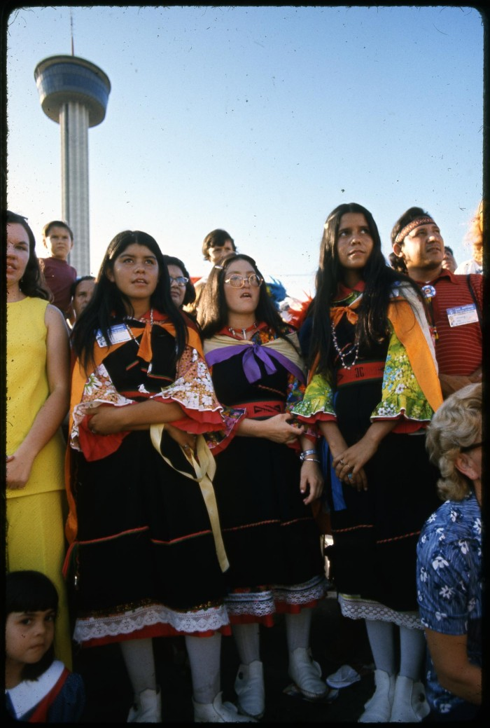

Figure 19: A photograph of young Ysleta Tigua women in traditional clothing. The Portal to Texas History.

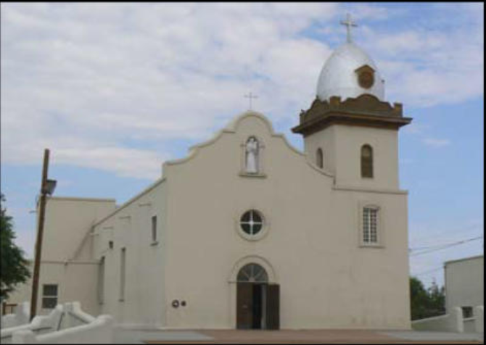

Figure 20: The reconstructed church at Corpus Christi de la Isleta. The Portal to Texas History.

During the late 1880s, the Tigua wrote their own tribal laws and constitution as a way to better protect and preserve their Indigenous heritage and culture.

In 1968 the Tigua became a federally recognized tribe. Today there are 574 federally recognized Indian tribes in the United States, and approximately 200 more tribes that are not officially federally recognized.

# **San Jose y San Miguel de Aguayo**

# **Missions in Texas *- Advanced Readings***

# *Unit 3: The Spanish Colonial Era*

The French threat in east Texas had caused several missions in that region to close during the 1690s and early 1700s. Many of the people who had been at those missions often relocated to San Antonio. A Spanish friar named **Antonio Margil de Jesús** had established mission **Los Adaes** in east Texas in 1717 under the direction of the governor of Coahuila y Tejas, **the Marques de Aguayo**.

Los Adaes closed as a result of conflict with the French in 1719, and **Margil de Jesus** moved to San Antonio and founded mission **San Jose y San Miguel de Aguayo** in 1720. Mission Aguayo was founded to convert and assimilate Texas Indians from various tribes including the Coahuiltecan and Karankawa.

Mission Aguayo faced many challenges while it was in operation. European **diseases** like **smallpox** and the **measles** killed a significant portion of the Texas Indian population at the mission. The mission was frequently the target of **Comanche** and **Apache attacks**, and as a result, many Texas Indians who feared the Apache sought refuge within the walls of the mission. Making matters worse, there were typically only two soldiers stationed

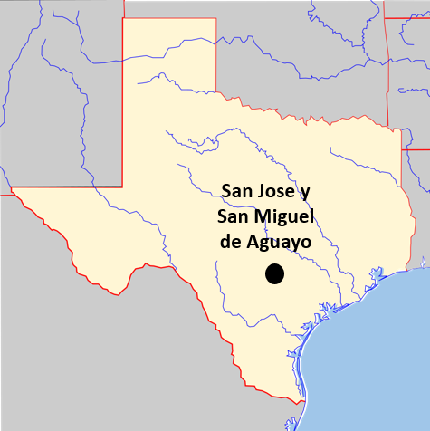

Figure 21: A map of the approximate location of mission San Jose y San Miguel de Aguayo

at the presidio, providing the mission with very little military support or protection.

Additionally, like so many other

Texas missions, Aguayo also often lacked the support and resources of the government of New Spain.

Despite facing many challenges, the friars and Indian residents at mission San Jose de Aguayo successfully developed **ranching** and **agriculture** at the mission. They raised thousands of cattle, sheep, oxen, and horses on the mission ranches. They also ran a successful flour mill and cultivated corn, beans, potatoes, cotton, and fruit on mission farms.

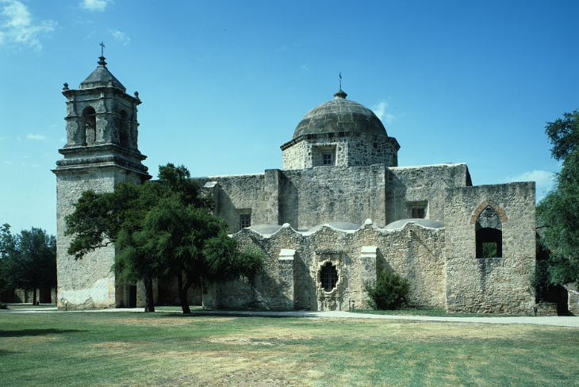

Figure 22: The chapel at San Jose y San Miguel de Aguayo. The Library of Congress.

In the mid-1700s new leadership at the mission began construction on a new church. The new church was built in the rich, ornate style of traditional Spanish cathedrals.

In 1793 Spain began ending the mission system in Texas. Over time the population of Coahuiltecans living at the mission continually decreased, San Jose de Aguayo was officially closed as a mission in 1824.

The church and grounds have been preserved and restored throughout the years. Mission San José is the largest mission complex in the San Antonio Mission National Historical Park system. It is also still an active Roman Catholic parish that holds regular services in the church.

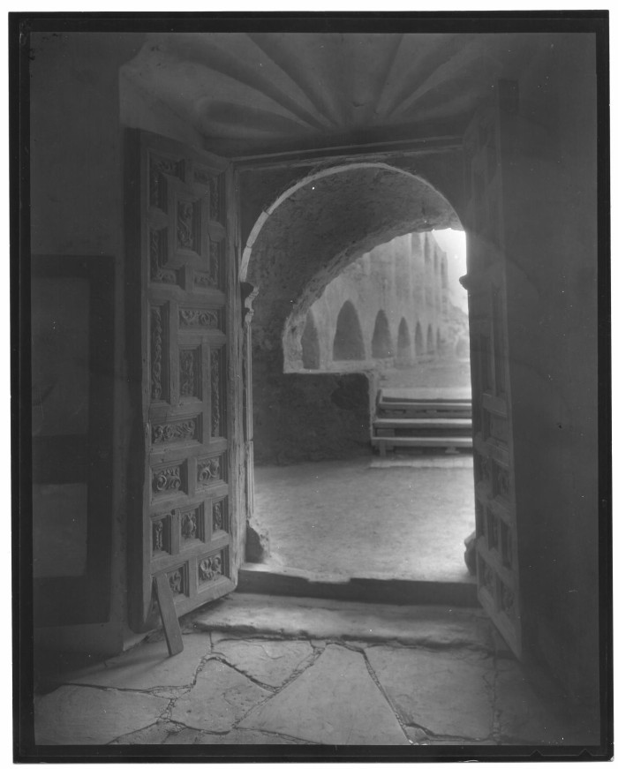

Figure 23: Photograph taken from inside the chapel at mission San Jose de Aguayo. The Portal to Texas History