# **Texas Missions: Part Two *Advanced***

# *Unit 3: The Spanish Colonial Era*

|  |  |  |  |  |  |
| --- | --- | --- | --- | --- | --- |
| Name: |  | Date: |  | Period: |  |

This is part two of your Texas Missions lesson. In this part of the assignment, you will take notes on the Texas missions presented by other groups in your class. You will not record information about your own mission here.

**Map of Missions:** As each group presents, mark the approximate location of their mission on the map below. Label the mission with its most basic name. Write neatly and clearly.

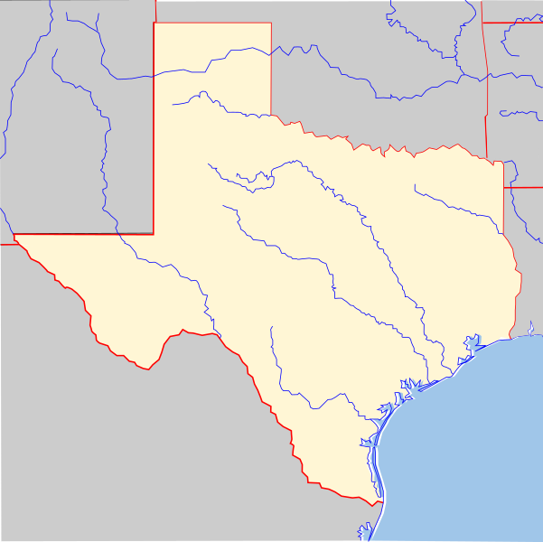

|  |
| --- |
| **Name of Mission:**  **Date:** |

|  |  |
| --- | --- |
| **Specific Goal(s) of the Mission** | **People of the Mission** |

|  |  |
| --- | --- |
| **Challenges** | **Achievements** |

|  |  |
| --- | --- |
| **Interesting Facts** | **Outcome** |

|  |
| --- |
| **Name of Mission:**  **Date:** |

|  |  |
| --- | --- |
| **Specific Goal(s) of the Mission** | **People of the Mission** |

|  |  |
| --- | --- |
| **Challenges** | **Achievements** |

|  |  |
| --- | --- |
| **Interesting Facts** | **Outcome** |

|  |
| --- |
| **Name of Mission:**  **Date:** |

|  |  |
| --- | --- |
| **Specific Goal(s) of the Mission** | **People of the Mission** |

|  |  |
| --- | --- |
| **Challenges** | **Achievements** |

|  |  |
| --- | --- |
| **Interesting Facts** | **Outcome** |

|  |
| --- |
| **Name of Mission:**  **Date:** |

|  |  |
| --- | --- |
| **Specific Goal(s) of the Mission** | **People of the Mission** |

|  |  |
| --- | --- |
| **Challenges** | **Achievements** |

|  |  |
| --- | --- |
| **Interesting Facts** | **Outcome** |

|  |
| --- |
| **Name of Mission:**  **Date:** |

|  |  |
| --- | --- |
| **Specific Goal(s) of the Mission** | **People of the Mission** |

|  |  |
| --- | --- |
| **Challenges** | **Achievements** |

|  |  |
| --- | --- |
| **Interesting Facts** | **Outcome** |

|  |
| --- |
| **Name of Mission:**  **Date:** |

|  |  |
| --- | --- |
| **Specific Goal(s) of the Mission** | **People of the Mission** |

|  |  |
| --- | --- |
| **Challenges** | **Achievements** |

|  |  |
| --- | --- |
| **Interesting Facts** | **Outcome** |