# **Texas Missions: Part Two *Foundations***

# *Unit 3: The Spanish Colonial Era*

|  |  |  |  |  |  |
| --- | --- | --- | --- | --- | --- |
| Name: |  | Date: |  | Period: |  |

This is part two of your Texas Missions lesson. In this part of the assignment, you will take notes on the Texas missions presented by other groups in your class.

**Map of Missions:** As each group presents, mark the approximate location of their mission on the map below. Label the mission with its most basic name. Write neatly and clearly.

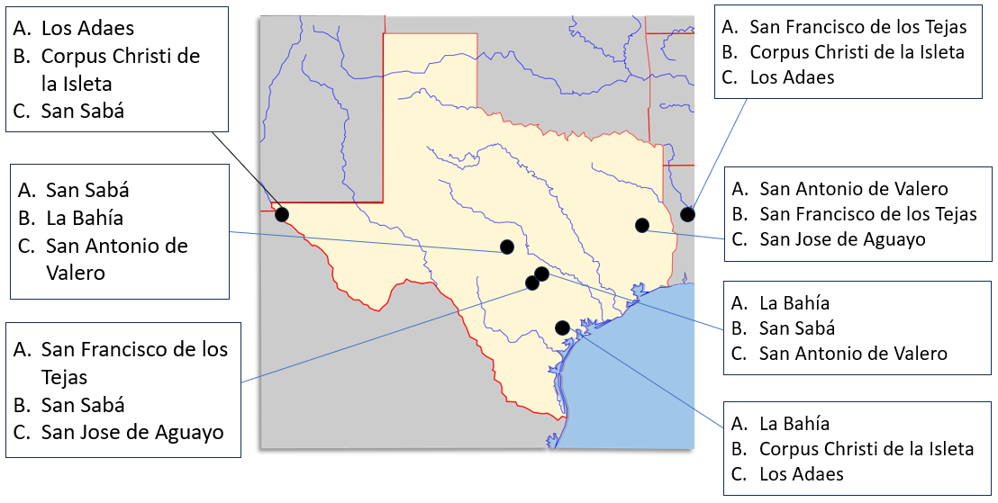

|  |
| --- |
| **Corpus Christi de la Isleta - 1682** |

|  |  |
| --- | --- |
| **Specific Goal(s) of the Mission**  Convert the ________________  Keep the ____________________ out of east Texas. | **People of the Mission**  Antonio de Otermín Spanish **soldier** / **friar** at the mission  Fray Francisco de Ayeta Spanish **soldier** / **friar** at the  mission. |

|  |  |
| --- | --- |
| **Challenges** (Circle or highlight all that apply)  Apache raids // Comanche attacks //  Disease // Friars left the mission //  // Flooding // Crop Failures | **Achievements** |

|  |  |
| --- | --- |
| **Interesting Facts**  Longest continually occupied settlement in Texas – 300 years! | **Outcome**   1. It still operates today. 2. It closed in the late 1700s. |

|  |
| --- |
| **San Francisco de los Tejas - 1690** |

|  |  |
| --- | --- |
| **Specific Goal(s) of the Mission**  Convert the ________________  Keep the ___________________ out of east Texas. | **People of the Mission** (choose the correct option)  Alonso de León Spanish **soldier** / **friar** at the presidio  Damián Massanet Spanish **soldier** / **friar** at the mission  Francisco Hidalgo Spanish **soldier** / **friar** at the mission |

|  |  |
| --- | --- |
| **Challenges** (Circle or highlight all that apply)  Texas Indians not interested // Apache raids // Spanish Disease // Floods // Too many soldiers // Lack of supplies // French threat | **Achievements** |

|  |  |
| --- | --- |
| **Interesting Facts** | **Outcome**   1. Closed in 1830 2. Closed in 1693 3. Still open today |

|  |
| --- |
| **Los Adaes - 1717** |

|  |  |
| --- | --- |
| **Specific Goal(s) of the Mission**  Convert the ________________  Keep the __________________ out of east Texas. | **People of the Mission**  Domingo RamónSpanish **soldier** / **friar** at the presidio  Antonio Margil de JesúsSpanish **soldier** / **friar** at the  mission**.**  Marques de Aguayo The Spanish **governor** / **commander**  of **New Mexico** / **Texas**.  Louis St. Denis **French** **supporter** / **French** **opponent** |

|  |  |
| --- | --- |
| **Challenges** (Circle or highlight all that apply)  French threat // The Chicken War // Crop Failures // Distance from Mexico // Lack of supplies // Depend on French trade // Apache attacks | **Achievements** |

|  |  |
| --- | --- |
| **Interesting Facts**  Los Adaes was the first capital of Texas | **Outcome**   1. Closed in 1772 2. People moved to San Antonio 3. Both are correct |

|  |
| --- |
| **San Antonio de Valero - 1718** |

|  |  |
| --- | --- |
| **Specific Goal(s) of the Mission**  Convert the ______________________  Provide a midpoint on the way to and from _____________________ | **People of the Mission**  Antonio de Olivares: A Spanish **friar** / **soldier**  /  **Governor** / at the mission |

|  |  |
| --- | --- |
| **Challenges** (Circle or highlight all that apply)  Disease // Floods // Apache raids // Lack of Supplies //  Too many interested Texas Indians //  Comanche raids // Canary Islanders | **Achievements** |

|  |  |
| --- | --- |
| **Interesting Facts**  San Antonio was the second capital of Texas. It’s later known as “the Alamo.” | **Outcome**   1. Still open as a mission today 2. Closed in 1693 3. Closed in 1772 |

|  |
| --- |
| **San Jose de Aguayo - 1720** |

|  |  |
| --- | --- |
| **Specific Goal(s) of the Mission**  Convert the ___________________________ | **People of the Mission**  Antonio Margil de JesúsSpanish **soldier** / **friar** / **governor**  at the mission**.**  Marques de AguayoSpanish **soldier** / **friar** / **governor**  at the mission**.** |

|  |  |
| --- | --- |
| **Challenges** (Circle or highlight all that apply)  Flooding // Lack of supplies // French threat // Disease //  Lack of support from New Spain | **Achievements** |

|  |  |
| --- | --- |
| **Interesting Facts**  It is one of the largest Spanish missions and part of the National Park System today. | **Outcome**   1. Still operating as a mission today 2. Closed in 1824 3. Closed in 1693 |

|  |
| --- |
| **La Bahía** - **1721** |

|  |  |
| --- | --- |
| **Specific Goal(s) of the Mission**  Convert the ___________________________ | **People of the Mission**  Domingo RamónSpanish **soldier** / **friar** at the presidio  Marques de AguayoSpanish **soldier** / **friar** / **governor**  at the mission**.** |

|  |  |
| --- | --- |
| **Challenges** (Circle or highlight all that apply)  Comanche attacks // Disease // Flooding // Conflict between the soldiers and Texas Indians // Lack of supplies and support | **Achievements** |

|  |  |
| --- | --- |
| **Interesting Facts**    It was built on the ruins of Robert La Salle’s French fort Saint Louis | **Outcome**   1. Closed in 1793 2. Closed in 1825 3. Still operates as a mission |

|  |
| --- |
| **San** **Sabá - 1757** |

|  |  |
| --- | --- |
| **Specific Goal(s) of the Mission**  Convert the ___________________________ | **People of the Mission**  Father Miguel Molina Spanish **soldier** / **friar** / **governor**  at the mission**.** |

|  |  |
| --- | --- |
| **Challenges** (Circle or highlight all that apply)  Apache disinterest in the mission // Distant presidio //  Friars abandoned the mission // Comanche attack with allies  // soldiers, friars, and Apache killed or wounded //  Floods // Burned and destroyed // | **Achievements** |

|  |  |
| --- | --- |
| **Interesting Facts** | **Outcome**   1. Mission destroyed in an attack 2. Never reopened 3. Both answers are correct |