# 

# **Texas Missions: Part Two *Grade Level***

# *Unit 3: The Spanish Colonial Era*

|  |  |  |  |  |  |
| --- | --- | --- | --- | --- | --- |
| Name: |  | Date: |  | Period: |  |

This is part two of your Texas Missions lesson. In this part of the assignment, you will take notes on the Texas missions presented by other groups in your class.

**Map of Missions:** As each group presents, mark the approximate location of their mission on the map below. Label the mission with its most basic name. Write neatly and clearly.

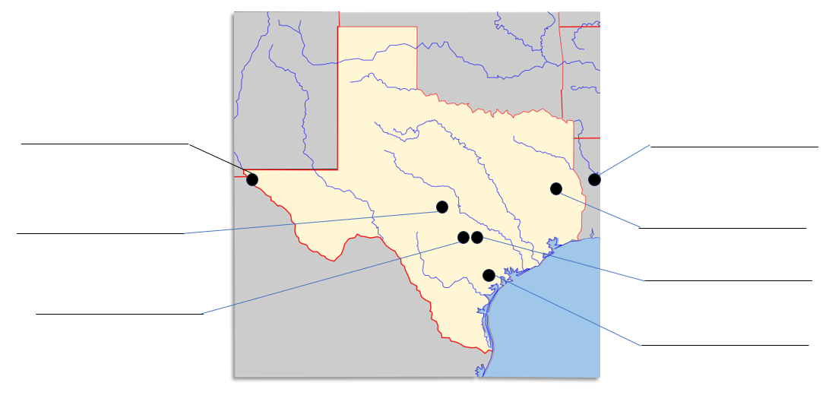

|  |
| --- |
| **Corpus Christi de la Isleta - 1682** |

|  |  |
| --- | --- |
| **Specific Goal(s) of the Mission** | **People of the Mission**  Antonio de Otermín  Fray Francisco de Ayeta |

|  |  |
| --- | --- |
| **Challenges** | **Achievements** |

|  |  |
| --- | --- |
| **Interesting Facts** | **Outcome** |

|  |
| --- |
| **San Francisco de los Tejas - 1690** |

|  |  |
| --- | --- |
| **Specific Goal(s) of the Mission** | **People of the Mission**  Alonso de León  Damián Massanet  Francisco Hidalgo |

|  |  |
| --- | --- |
| **Challenges** | **Achievements** |

|  |  |
| --- | --- |
| **Interesting Facts** | **Outcome** |

|  |
| --- |
| **Los Adaes - 1717** |

|  |  |
| --- | --- |
| **Specific Goal(s) of the Mission** | **People of the Mission**  Domingo Ramón  Antonio Margil de Jesús  Marques de Aguayo  Louis St. Denis |

|  |  |
| --- | --- |
| **Challenges** | **Achievements** |

|  |  |
| --- | --- |
| **Interesting Facts** | **Outcome** |

|  |
| --- |
| **San Antonio de Valero - 1718** |

|  |  |
| --- | --- |
| **Specific Goal(s) of the Mission** | **People of the Mission**  Antonio de Olivares |

|  |  |
| --- | --- |
| **Challenges** | **Achievements** |

|  |  |
| --- | --- |
| **Interesting Facts** | **Outcome** |

|  |
| --- |
| **San Jose de Aguayo - 1720** |

|  |  |
| --- | --- |
| **Specific Goal(s) of the Mission** | **People of the Mission**  Antonio Margil de Jesús  Marques de Aguayo |

|  |  |
| --- | --- |
| **Challenges** | **Achievements** |

|  |  |
| --- | --- |
| **Interesting Facts** | **Outcome** |

|  |  |
| --- | --- |
| **Specific Goal(s) of the Mission** | **People of the Mission**  Domingo Ramón  Marques de Aguayo |

|  |
| --- |
| **La Bahía** - **1721** |

|  |  |
| --- | --- |
| **Challenges** | **Achievements** |

|  |  |
| --- | --- |
| **Interesting Facts** | **Outcome** |

|  |
| --- |
| **San** **Sabá - 1757** |

|  |  |
| --- | --- |
| **Specific Goal(s) of the Mission** | **People of the Mission**  Father Miguel Molina |

|  |  |
| --- | --- |
| **Challenges** | **Achievements** |

|  |  |
| --- | --- |
| **Interesting Facts** | **Outcome** |