Unit 3:

The Spanish Colonial Era

Lesson 6:

Texas Missions
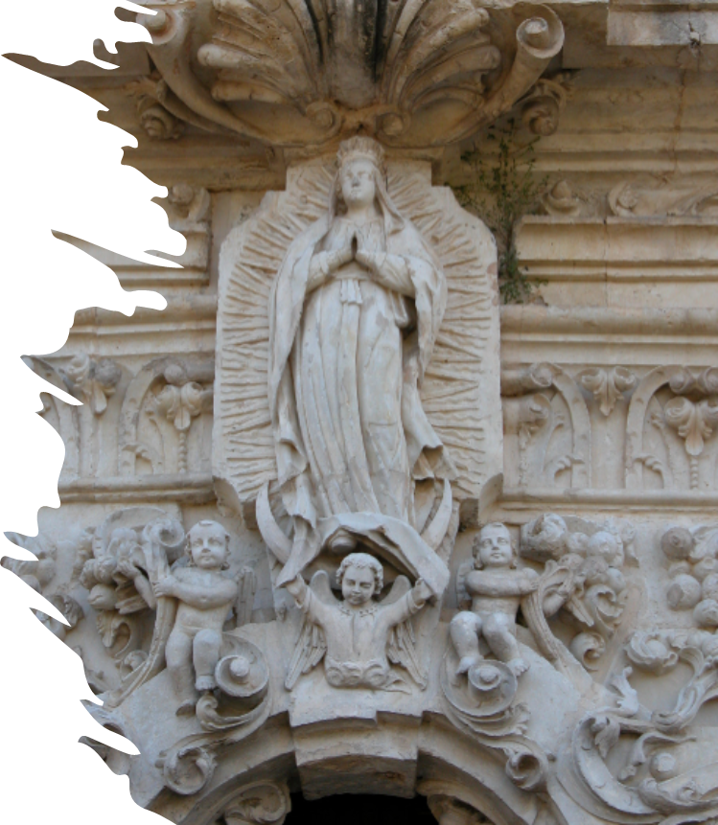

Warm-up
Follow the directions to complete your warm-up.
Respond to the prompts on your warm-up.
Discuss with a partner.

Share with the class
One thing we know about the Mission Presidio System in Texas is (blank)
One problem we know that occurred at some Texas missions was (blank)
One question I have about the Texas missions is (blank)

Essential Question
What are the key people, places, events, and information related to significant Spanish missions in Texas?

In today’s lesson…
1. We will examine significant information related to seven prominent Spanish missions established in Texas during the Spanish Colonial era.
2. I will work with my group to research one mission. I will present my findings to the class and take notes on the significant information when other groups present.

This Assignment has two parts:

Part One: Group Project & Presentation.
1. You will be assigned to a group. Your group will be assigned one Spanish mission in Texas. As a group you will read a passage about your mission and use the reading to create a slideshow presentation about your mission.
2. You will follow the directions on the slideshow to complete this presentation. You will then present your mission to the class.

Part Two: Individual Note Taking & Engagement
1. While other groups are presenting, you will take notes on key information about each mission. You will be respectful and attentive of each presentation and take accurate notes, asking questions when appropriate.

Student Group Presentation Slideshow Instructions for Part One:
You have been assigned to report on one Spanish mission in Texas. Follow the instructions to complete this group project.
Step 1: Group Role Assignments
- Each person in your group will choose one of the elements of Texas history on the next slide.
- Type the name of each group member under their choice.
Choose one image below from Texas history and type your name in the box beneath it.

Student name
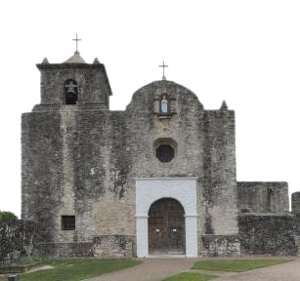
Student name

Student name
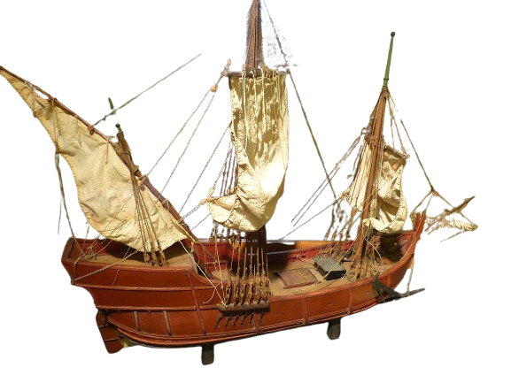
Student name
What are your assigned slides?
Type your 2 slide numbers into the box below your name.
Slides 8 & 9
Name of Missions
Images
Slides 10 & 11
People at the mission
Slides 12 & 13
Challenges at the mission
Achievements at the mission
Slides 14 & 15
Interesting Facts
Outcome

Student Group Presentation Slideshow Instructions 2
Step 2: The Reading
- As a group, read the passage that goes with your assigned mission.
- The passage is NOT included in these slides
- Each person can take turns reading one sentence or one paragraph at a time.
- You are encouraged to take quick notes, specifically about the portion of the presentation which you are assigned to cover.

Student Group Presentation Slideshow Instructions 3
Step 3: Completing Your Slides
- Look at your assigned slides (refer to your slide #3)
- The directions for each of your slides are to the left of your slide.
- Follow the directions to complete your slide.
- You will present your information to the class. Review your information so you are comfortable with your part of the presentation.

Grading Rubric
The grade is based on individual work. There is no group grade.
Grades are earned according to the following criteria:
Component
Information
Description
The information in your presentation should be accurate, informative, and as detailed as possible.
Points
5
Component
Material Presentation
Description
Each person in the group should have slides that are neat and organized.
Points
5
Component
Oral Presentation
Description
Each person who presents should speak loudly, slowly, and clearly for their portion of the presentation.
Points
5
Component
Engagement
Description
When other students are presenting, you are listening closely, taking notes, and completing your work for each mission being presented.
Points
5

Group Presentations!

Part Two: Individual Note Taking & Engagement

Individual Note Taking & Engagement
As each group presents their mission to the class, you will listen and take notes on the significant information of each mission.
1. The mission’s name and date of founding
2. The specific goal for the mission
3. The people of the mission
4. The challenges and achievements of the mission
5. An interesting fact about the mission
6. The outcome of the mission

Mapping the Missions
You will mark the approximate location of each mission on your map and label the mission with its most common name.
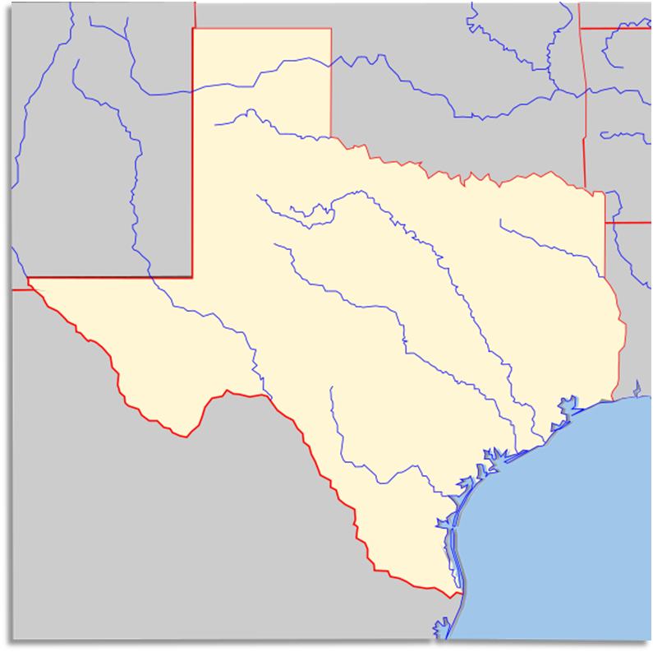

Exit Ticket
Follow the directions to complete your exit ticket.
Respond to the prompts on your exit ticket.
Discuss with a partner.

Share with the class 2
One challenge that we have learned about at the missions is (blank)
One achievement that we have learned about at the missions is (blank)
I think the Mission Presidio System in Texas will ultimately succeed / fail. Evidence that supports my claim is (blank)

