Warm-up
- Responses will vary
Lesson
Part I of this lesson is a group project in which student groups are assigned one Spanish mission. They read the passage on their mission, then complete their slides based on their assigned role in the group.
Part II of this assignment consists of student groups presenting information about their mission using their prepared slides. The rest of the class takes notes in their worksheet about each mission.
The basics of each mission are included in the map and chart below

Labeling the Map
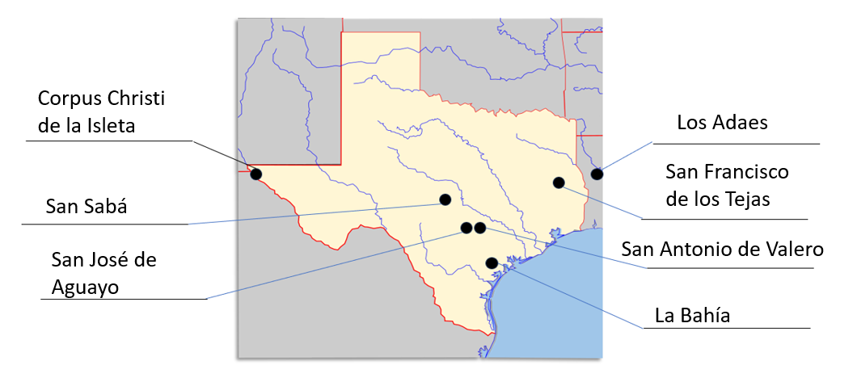

Notes on the Missions
Corpus Christi de la Isleta - 1682

Specific Goal(s) of the Mission  Convert the Tigua  Keep the French out of east Texas. | People of the Mission  Antonio de Otermín Spanish soldier at the mission  Fray Francisco de Ayeta Spanish friar at the mission

Challenges (Circle or highlight all that apply)  Frequent flooding required them to move the mission several times. | Achievements  It has existed for 300 years  The Tigua have preserved their culture and become a federally recognized tribe.

Interesting Facts  Longest continually occupied settlement in Texas – 300 years! | Outcome  It still operates today.

San Francisco de los Tejas - 1690

Specific Goal(s) of the Mission  Convert the Hasinai Caddo  Keep the French out of east Texas. | People of the Mission (choose the correct option)  Alonso de León Spanish soldier at the presidio  Damián Massanet Spanish friar at the mission  Francisco Hidalgo Spanish friar at the mission

Challenges (Circle or highlight all that apply)  Texas Indians not interested; Disease; Floods; Lack of supplies; French threat; Friars fled the mission; Spanish forced out by the Caddo | Achievements  n/a

Interesting Facts  Answers will vary | Outcome  Closed in 1693

Los Adaes - 1717

Specific Goal(s) of the Mission  Convert the Caddo  Keep the French out of east Texas. | People of the Mission  Domingo Ramón Spanish soldier at the presidio  Antonio Margil de Jesús Spanish friar at the  mission.  Marques de Aguayo The Spanish governor of Texas.  Louis St. Denis French supporter

Challenges (Circle or highlight all that apply)  French threat; The Chicken War; Distance from Mexico; Lack of supplies; Not enough soldiers; Depended on French trade | Achievements  n/a

Interesting Facts  Los Adaes was the first capital of Texas | Outcome  Closed in 1772  Missionaries moved to San Antonio

San Antonio de Valero - 1718

Specific Goal(s) of the Mission  Convert the Coahuiltecan  Provide a midpoint on the way to and from east Texas | People of the Mission  Antonio de Olivares: A Spanish friar  at the mission

Challenges (Circle or highlight all that apply)  Disease; Floods; Apache raids; Lack of Supplies and manpower;  Comanche raids; | Achievements  Large population in the 1740s and 1750s  Relatively successful

Interesting Facts  San Antonio was the second capital of Texas. It’s later known as “the Alamo.” | Outcome  Closed in 1793

San Jose de Aguayo - 1720

Specific Goal(s) of the Mission  Convert the Coahuiltecan and Karankawa | People of the Mission  Antonio Margil de Jesús Spanish friar at the mission.  Marques de Aguayo Spanish governor at the mission.

Challenges (Circle or highlight all that apply)  Lack of supplies or military support;  Diseases like smallpox and the measles | Achievements  Ran a successful flour mill  Took part in ranching and agriculture  Still an active church today

Interesting Facts  It is one of the largest Spanish missions and part of the National Park System today. | Outcome  Mission closed in 1824

La Bahía - 1721

Specific Goal(s) of the Mission  Convert the Karankawa  Defend against French threat on the coast | People of the Mission  Domingo Ramón Spanish soldier at the presidio  Marques de Aguayo Spanish governor of Texas

Challenges (Circle or highlight all that apply)  Disease; Leadership disputes; Conflict between the soldiers and Texas Indians; Lack of supplies and support; Leadership disputes | Achievements  Important location for trade along the Camino Real

Interesting Facts  It was built on the ruins of Robert La Salle’s French fort Saint Louis | Outcome  Closed in 1793

San Sabá - 1757

Specific Goal(s) of the Mission  Convert the Lipan Apache | People of the Mission  Father Miguel Molina Spanish friar at the mission.

Challenges (Circle or highlight all that apply)  Apache disinterest in the mission; Distant presidio;  Friars abandoned the mission; Comanche attacked with allies; soldiers, friars, and Apache killed or wounded;  Burned and destroyed | Achievements  n/a

Interesting Facts  Responses will vary | Outcome  Mission destroyed in an attack  Never reopened

Exit Ticket
- Responses will vary

