San Francisco de los Tejas

Missions in Texas – Foundations Readings

Unit 3: The Spanish Colonial Era

The first mission that Spain founded in east Texas was called San Francisco de los Tejas. Spain sent a Spanish soldier named Alonso de León and a friar named Damián Massanet to search for any French explorers who had survived La Salle’s expedition.
De León and Massanet heard that there were Frenchmen living in east Texas near the Caddo people. As a result, De León and Massanet decided to establish their mission and presidio near present-day Nacogdoches in 1690. Spain hoped to prevent the French in Louisiana from moving into Spanish territory in east Texas. The Spanish also hoped to convert and assimilate members of the Hasinai Caddo tribe who lived in the region.
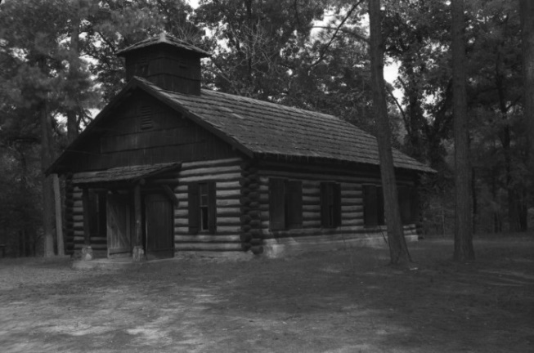
Figure 1: The reconstructed church building from the mission. The Portal to Texas History 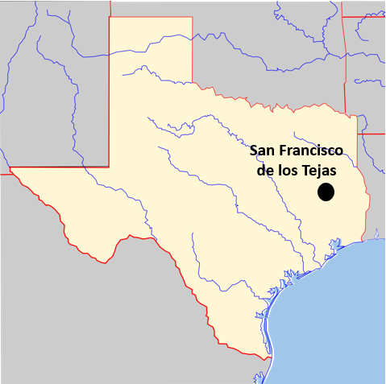 Figure 2: A map showing the approximate location of the mission.
The Caddo were a powerful agricultural tribe. They also focused on building strong trade relationships with other tribes throughout the region. When the French arrived, they started trading with them too.
Challenges at the Mission
The Caddo were only interested in trading with the Spanish. They didn’t want to live at the missions or assimilate into Spanish culture. When the Spanish ran out of items of value to trade, the Caddo lost interest in continuing that relationship.

The missions in the region faced a lot of challenges from 1690 to 1693. Floods from the Neches River destroyed another mission’s church. The Spanish often lacked supplies because east Texas was very far from the more populated parts of Mexico. European diseases like smallpox killed many Caddo people. So many Caddo died, in fact, that it is reported they began to believe the water for baptisms was deadly.

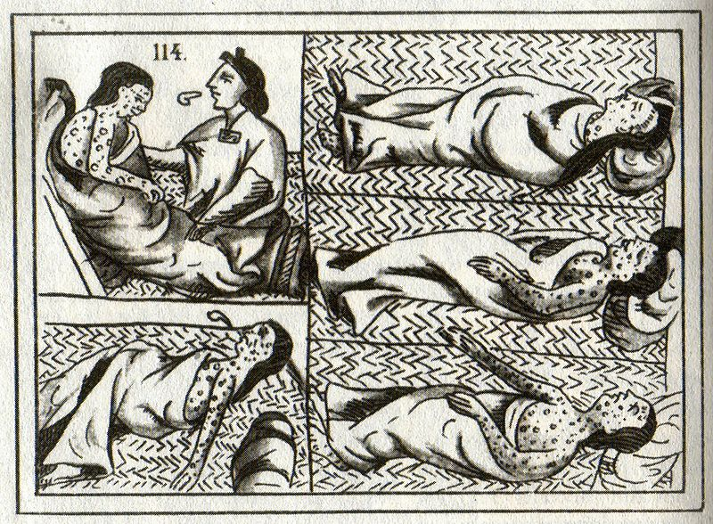
Figure 3: A 16th century drawing of American Indian smallpox victims.

The Caddo grew more and more opposed to the Spanish presence in their region. They began to push for the Spanish to leave the area. Some friars were so upset by the struggles over the years that they left the mission to return to Mexico.
Eventually, the Caddo forced the Spanish at the missions to leave the mission entirely. The remaining friars took the mission apart and burned the buildings. They abandoned the area in 1693.
In 1716, a Spanish friar named Francisco Hidalgo attempted to reopen the mission under the new name Nuestro Padre San Francisco de los Tejas. The Spanish were still worried about the French in the area. The new mission faced similar challenges, however. The new mission faced similar challenges, however, and it was closed and abandoned in 1719.
In general, these first east Texas missions were unable to convert or assimilate Texas Indians or establish a strong Spanish presence in east Texas.

Los Adaes

Missions in Texas – Foundations Readings

Unit 3: The Spanish Colonial Era

The government of New Spain sent a Spanish soldier named Domingo Ramón and a Spanish friar named Antonio Margil de Jesús to establish a presence in east Texas in 1717. Spain wanted to prevent the French in Louisiana from moving into.
Ramón and Margil de Jesús founded the mission and presidio of Los Adaes in present-day Louisiana to prevent French advancement into New Spain and convert the Caddo Indians. Interestingly, a French man named Louis St. Denis actually helped establish the mission when the Spanish government offered no help!
The mission was abandoned only two years later in 1719 after an issue with a few French soldiers in the area that came to be known as “The Chicken War.”
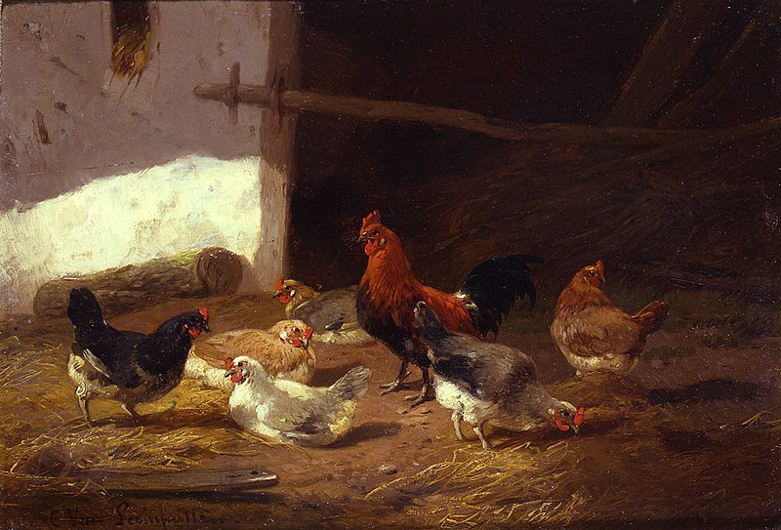
Figure 4: Chickens in a farmyard by Cornelius Van Leemputten

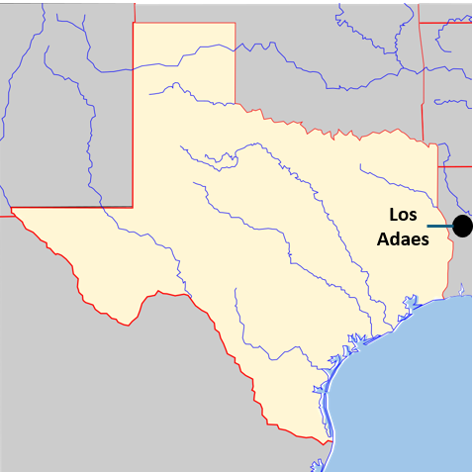 Figure 5: A map of the approximate location of Los Adaes.

Despite the name, no chickens actually fought in the Chicken War. On a hot June day, a few French soldiers raided a henhouse at the Spanish mission. While the French were trying to escape, the
chickens scared the horses and caused a small disturbance. The Spanish missionaries heard of this and thought they were under attack. They abandoned the mission and fled to San Antonio.
In reality, the Chicken War was a small disturbance, not an actual war. The Spaniards at the mission didn’t know this at the time, however. As a result, los Adaes closed down in 1719, and the Spanish abandoned the mission and presidio.
In 1721, the governor of Texas, the Marques de Aguayo, reopened Los Adaes. Spain was still worried about the French. The friars at the mission planned
to try to convert the Caddo people living in the region. The Caddo, however, were only interested in trade with the Spanish. They had no interest in assimilating into Spanish culture at the missions.

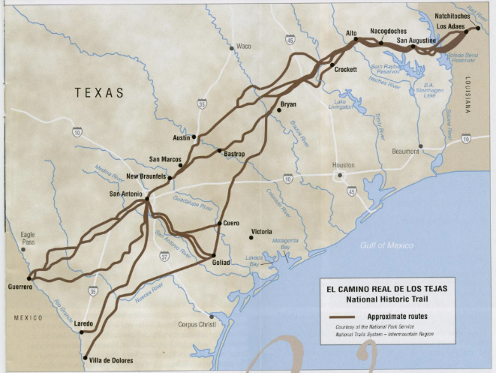
Figure 6: El Camino Real. The Portal to Texas History.
Los Adaes struggled with the same issues that faced other east Texas missions. It was very difficult to receive supplies from Mexico because of its distant location. The Spaniards at Los Adaes actually depended on trade with their French rivals in the area!
In addition to the lack of supplies, there was a long period of bad weather and crop failures that made life more difficult for settlers at the mission and in the nearby Spanish towns and ranches.
In 1721, Spain made Los Adaes the capital of Texas. Spain wanted to strengthen the settlement there, but they also reduced the number of soldiers at the presidio. This made the area even weaker. For decades, despite the many difficulties at the mission, Los Adaes was the easternmost Spanish settlement in Texas.
Then, in 1762 France was forced to give up all of its North American territory after losing to the British in the French and Indian War. The Louisiana territory west of the Mississippi River transferred into Spanish control. With the French out of Louisiana, Spain was no longer concerned about the French moving into Texas.
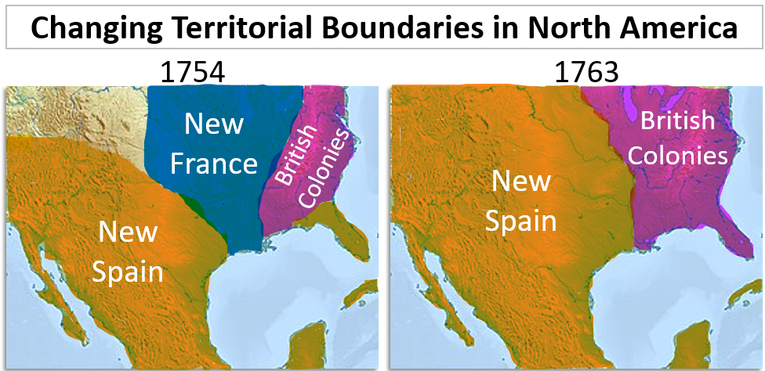
Spain closed Los Adaes in 1772. The people at the mission and the surrounding settlements moved to San Antonio. San Antonio became the new capital of Texas in 1773.

San Antonio de Valero

Missions in Texas - Foundations Readings

Unit 3: The Spanish Colonial Era

In 1718, Spain established San Antonio. The Spanish wanted a midpoint where travelers could stop on their way to and from the east Texas missions. A Spanish friar named Antonio de Olivares founded mission San Antonio de Valero.
Presidio Bexar was founded nearby. This was the first Spanish mission and presidio in San Antonio. This mission will be significant later in Texas history when it is known by another name: The Alamo. More on that in later units!
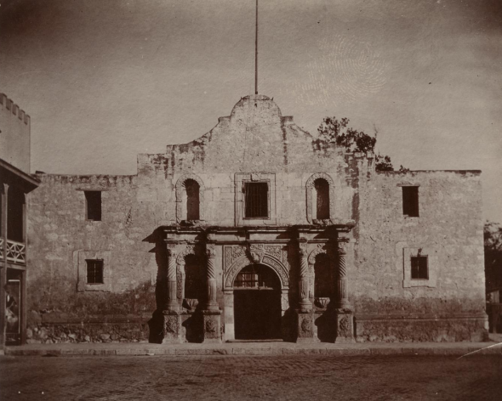
Figure 7: San Antonio de Valero's church, known today as the Alamo. The Portal to Texas History.
Spain founded a total of five missions in San Antonio during the early 1700s. These missions attempted to convert and assimilate Texas Indians primarily from various Coahuiltecan tribes. Reports show that there were more than 300
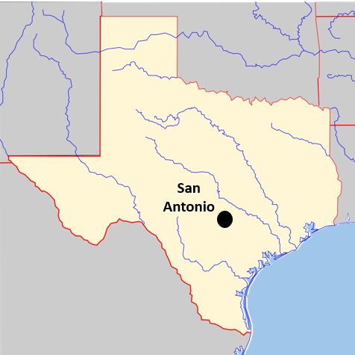
Figure 8: A map of the approximate location of San Antonio
Texas Indians living at the San Antonio missions by the 1740s and 1750s.
In many ways the San Antonio missions were more successful than other missions in Texas. However, they still struggled with many issues that faced other missions across the region.
Living conditions were difficult. European diseases killed many Texas Indians at the missions. Receiving supplies from central Mexico was a challenge, and the government of New Spain never provided the missions with adequate support, manpower, or supplies.
In addition to the challenges listed above, most Texas Indians living at the San Antonio missions were primarily interested in the missions because they provided protection from rival tribes. For example, the Coahuiltecan people often lived at the San Antonio missions to escape attacks from their powerful rivals, the Apache. The Apache often attacked the missions also.
When the Comanche migrated into Texas in the mid-1700s, they became the dominant power on the Great Plains. The Comanche began to attack and raid the San Antonio missions too. This also caused less powerful tribes to seek safety at the missions.
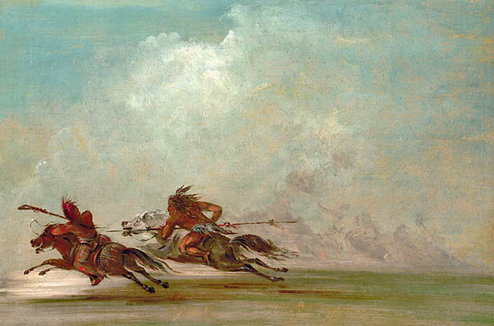
Figure 9: War on the Plains, by George Catlin.
There was another challenge that was unique to San Antonio. In 1731, a group of Spanish colonists from the Canary Islands immigrated to San Antonio. The Canary Islands are located off the northwest coast of Africa. The Spanish had colonized these islands in the 15th Century.
Some people in San Antonio were unhappy with the arrival the Canary Islanders. These new settlers appeared to receive special treatment and privileges from the government.
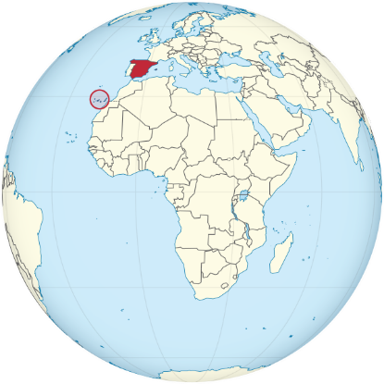
Figure 10: A map of the Canary Islands, circled in red.
The Canary Islanders were granted titles of nobility upon their arrival. This meant that their families would be considered a higher class with more power than others in the community. Many of the settlers who already lived in San Antonio were upset by this because they thought it was unfair.
Even though some people were unhappy, the Canary Islanders played an important role in the development of San Antonio. One important thing they accomplished was building canals, or man-made waterways for transportation. They also expanded the irrigation system to bring more water into the area for farming. This made settlements in San Antonio much more successful than many others.
The mission closed in 1793 when Spain began to end the mission system in Texas.

La Bahía

Missions in Texas - Foundations Readings

Unit 3: The Spanish Colonial Era

In the beginning, the Spanish chose the locations of the missions based on where they thought the French threat was greatest. For example, Spain established missions in east Texas because the French were nearby in Louisiana. The location for the mission and presidio Nuestra Señora de la Bahía del Espiritu Santo de Zúñiga was also chosen with the French threat in mind.
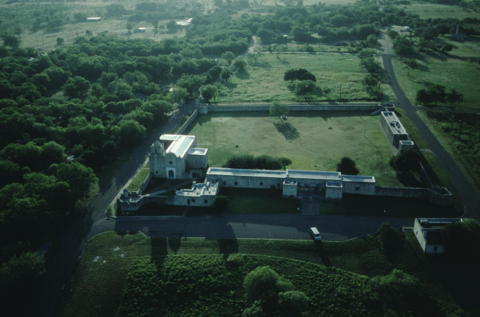
Figure 11: La Bahía. The Portal to Texas History
La Bahía was founded in 1721 in Matagorda Bay, near the site of Robert La Salle’s failed Fort Saint Louis.
The governor of Coahuila y Tejas, the Marques de Aguayo, wanted to establish the mission there because Spain was worried about the French returning to the Texas coast. Spain also wanted to convert and assimilate the Karankawa in the region.
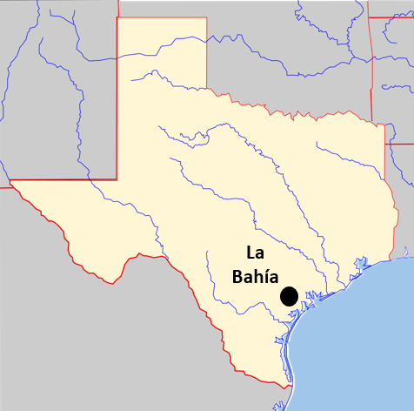
Figure 12: A map of the approximate final location of La Bahía
A Spanish soldier named Domingo Ramón even founded the presidio on the actual ruins of La Salle’s old fort!
La Bahía had to move multiple times. It finally ended up on the San Antonio River near present-day Goliad. The settlements that grew around La Bahía became important locations for trade and business along the Camino Real.
La Bahía struggled with many challenges and difficulties over the years. European diseases like malaria killed many Texas Indians at the mission. Shortages of food, supplies, and clothing often made mission life difficult. Additionally, there were frequent disputes, or arguments, between the leadership at the missions and presidios.
There were also conflicts between the Spanish soldiers at the presidio and the Karankawa. The Spaniards at La Bahía often tried to force the Karankawa to convert and assimilate. Some Spaniards tried to control Karankawa lands.
Many of the Karankawa people resisted these Spanish attempts at control. Over time, conflict between the two groups caused the relationship to completely fall apart. One extreme example of this was the Spanish-Karankawa War of the late 1700s.
Spain closed the mission in 1793, though the grounds and buildings would go on to be used in later significant events including the War for Mexican Independence and the Texas Revolution.

San Sabá

Missions in Texas - Foundations Readings

Unit 3: The Spanish Colonial Era

Mission San Sabá was founded in 1757 to convert and assimilate the Lipan Apache Indians of the Great Plains. The relationship between the Spanish and the Apache in the region had been filled with conflict during the early 1700s. The Apache often attacked and raided missions and settlements in places like San Antonio.
Spanish friars began petitioning, or writing letters to the government, to ask permission to build a mission in Apachería – or the Apache’s Land – in the early 1700s. The friars had hoped that converting the Apache might help develop a peaceful relationship between the two groups. The Spanish government denied those initial requests, however.
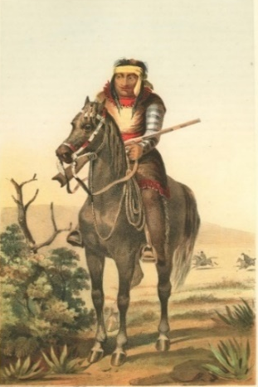
Figure 13: A Lipan Apache Warrior. The Portal to Texas History
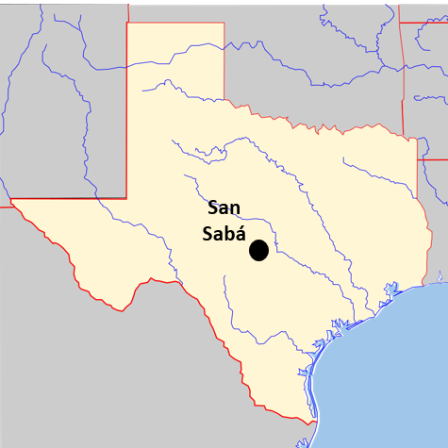
Figure 14: A map of the approximate location of mission San Sabá
When the Comanche migrated to Texas in the 1730s and 1740s, they quickly came to dominate the Great Plains. Conflict between the Comanche and Apache broke out. The Comanche pushed the Apache farther into South Texas and out of the Great Plains region. This is sometimes referred to as “the War for the Great Plains.”
In 1749, the Apache made a peace treaty with the Spanish and requested a mission near San Antonio. Like other Texas Indian tribes, the Apache were not interested in mission life or assimilating into Spanish culture. The Apache hoped that the Spanish missions and presidios would protect them from Comanche attacks. They may have also hoped the Comanche would start attacking to the Spanish instead.
Mission San Sabá faced many challenges like many other missions across Texas. The Apache had no interest in mission life, and the missionaries never truly understood their Indigenous culture. In fact, no Apache ever even lived at the mission. Many missionaries were so upset by the mission’s failure to convert the Apache that several of them abandoned the mission to return to San Antonio.
One significant issue at mission San Sabá was safety. This was especially challenging because the presidio for San Saba was located far from the mission. The friars wanted the presidio far from the mission. At other missions in Texas, there were sometimes conflicts between the soldiers and Indians at the mission. The friars thought there would be fewer conflicts if the presidio was farther away. Unfortunately, this also made the mission more difficult to protect.
Safety became a very real problem on March 16, 1758. On that day, 2000 Comanche and their allies attacked the mission at San Sabá. Reports showed that seventeen Texas Indians and eight Spaniards at the mission were killed in the attack. Many others were badly wounded. It was also reported that eight soldiers were wounded. Only one priest, Father Miguel Molina, escaped.
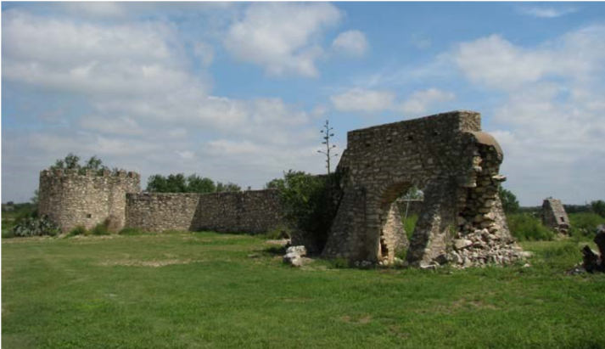
Figure 15: The ruins of San Sabá. The National Parks Service.
The mission was destroyed by fire in the attack, and it was never reopened. Not long after, Spain began to retreat from its missions along the Great Plains – the area often known as Comanchería, or the Comanche’s land.
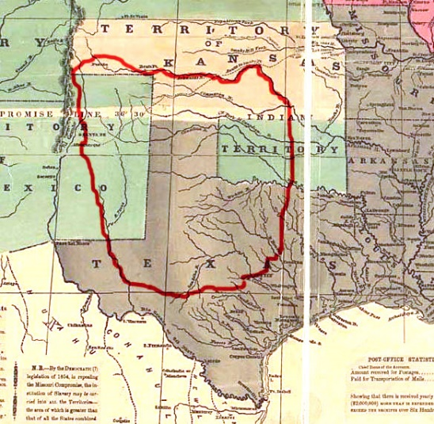
Figure 16: A map of Comanchería - or the land of the Comanche.

Corpus Christi de la Isleta

Missions in Texas - Foundations Readings

Unit 3: The Spanish Colonial Era

Corpus Christi de la Isleta was founded by Antonio de Otermín and Fray Francisco de Ayeta near El Paso in 1682. The mission was established to convert and assimilate the Tigua Indians. It is considered the first Spanish mission Texas. It was initially constructed on the Rio Grande River, though it was moved several times as a result of flooding.
Otermín and Ayeta had originally lived in New Mexico where they had attempted to convert and assimilate the Pueblo people. Spanish rule in New Mexico had been harsh and oppressive. As a result, a Pueblo medicine man named Po’Pay led a rebellion against the Spanish. The Pueblo Revolt successfully drove the Spanish out of Pueblo lands.
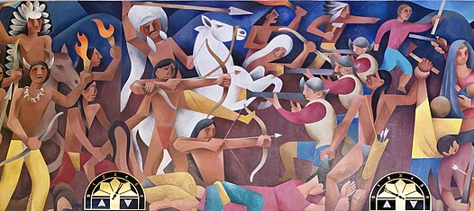
Figure 17: A painting by Loren Mozley of the Pueblo Revolt of 1680. WPA mural at the Albuquerque Courthouse.
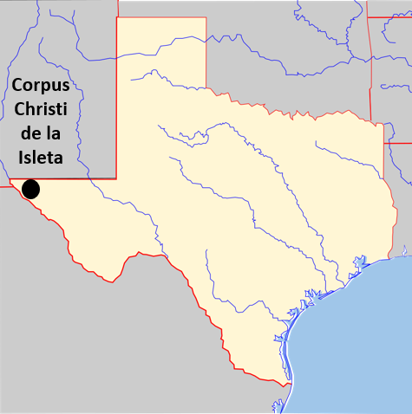
Figure 18: : A map of the approximate location of mission Corpus Christi de la Isleta
Some Tigua people had been allied with the Spanish in New Mexico. Others
had been held captive by the Spanish there. Following the revolt, the Spaniards and their Tigua allies and captives moved to the El Paso area where they established mission Corpus Christi de la Isleta.
Mission Isleta was established on the Rio Grande River, though frequent flooding and changes in the course of the river forced the mission to relocate several times over the years.
Corpus Christi de la Isleta and the community that grew around it have existed for approximately 300 years! It is the oldest continuously occupied settlement in Texas.
Many Tigua people in the El Paso area are still closely connected with the mission. They have preserved their Indigenous culture while combining elements of it into Spanish Catholic traditions. Some Tigua with the mission today still observe several Catholic holy days with Indigenous rituals including dancing, drumming, and chanting.
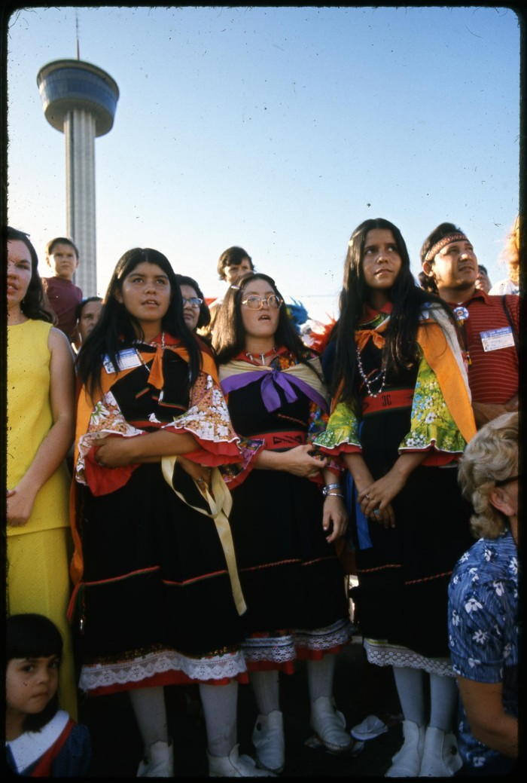
Figure 19: A photograph of young Ysleta Tigua women in traditional clothing. The Portal to Texas History.
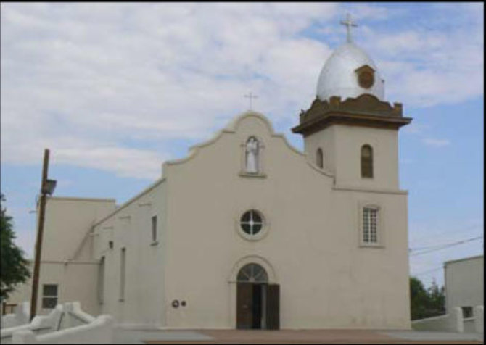
Figure 20: The reconstructed church at Corpus Christi de la Isleta. The Portal to Texas History.
During the late 1880s, the Tigua wrote their own tribal laws and constitution as a way to preserve their Indigenous heritage and culture.
In 1968 the Tigua became a federally recognized tribe. Today there are 574 federally recognized Indian tribes in the United States, and approximately 200 more tribes that are not officially federally recognized.

San José y San Miguel de Aguayo

Missions in Texas - Foundations Readings

Unit 3: The Spanish Colonial Era

The French threat in east Texas had caused several missions in that region to close during the 1690s and early 1700s. Many of the people who had been at those missions often relocated to San Antonio. A Spanish friar named Antonio Margil de Jesús had established mission Los Adaes in east Texas with the support of the governor of Coahuila y Tejas, the Marques de Aguayo.
Los Adaes closed as a result of conflict with the French in 1719. Margil de Jesus moved to San Antonio and founded mission San Jose y San Miguel de Aguayo in 1720. Mission Aguayo was founded to convert and assimilate Texas Indians from various tribes including the Coahuiltecan and Karankawa.
Mission Aguayo faced many challenges. European diseases like smallpox and the measles killed a large portion of the Texas Indian population at the mission. The mission was frequently the target of Comanche and Apache attacks. As a result, many Texas Indians who feared the Apache only lived at the mission for protection from their enemies.
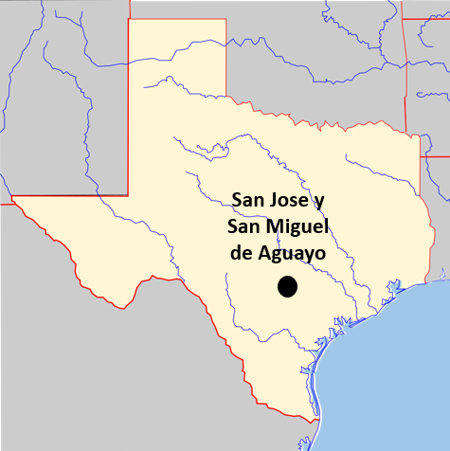
Figure 21: A map of the approximate location of mission San Jose y San Miguel de Aguayo
Making matters worse, there were typically only two soldiers stationed
at the presidio, providing the mission with very little military support or protection.
Additionally, like so many other
Texas missions, Aguayo also often lacked the support and resources of the government of New Spain.

Despite facing many challenges, the friars and Indian residents at mission San Jose de Aguayo successfully developed ranching and agriculture at the mission. They raised thousands of cattle, sheep, oxen, and horses on the mission ranches. They also ran a successful flour mill and grew corn, beans, potatoes, cotton, and fruit on mission farms.
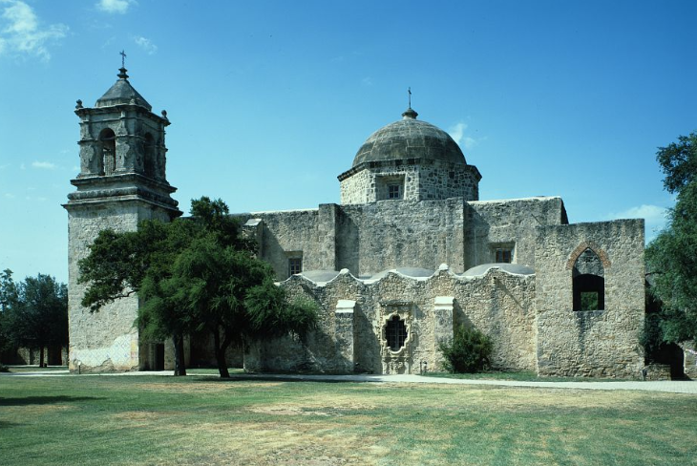
Figure 22: The chapel at San Jose y San Miguel de Aguayo. The Library of Congress.
In the mid-1700s the new leadership at the mission began to build a new larger church that still exists today.
In 1793, Spain began ending the mission system in Texas. Over time the population of Coahuiltecans living at the mission continually decreased. San Jose de Aguayo was officially closed as a mission in 1824.
The church and grounds have been preserved and restored throughout the years. Mission San José is the largest mission complex in the San Antonio Mission National Historical Park system. It is also still an active Roman Catholic parish that holds regular services in the church.
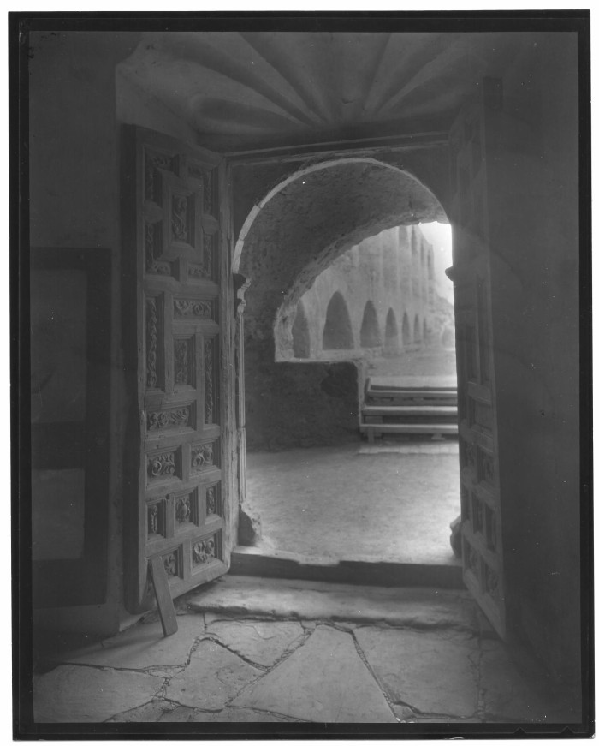
Figure 23: Photograph taken from inside the chapel at mission San Jose de Aguayo. The Portal to Texas History

