Texas Missions: Part Two Foundations

Unit 3: The Spanish Colonial Era

Name: |  | Date: |  | Period:

This is part two of your Texas Missions lesson. In this part of the assignment, you will take notes on the Texas missions presented by other groups in your class.
Map of Missions: As each group presents, mark the approximate location of their mission on the map below. Label the mission with its most basic name. Write neatly and clearly.
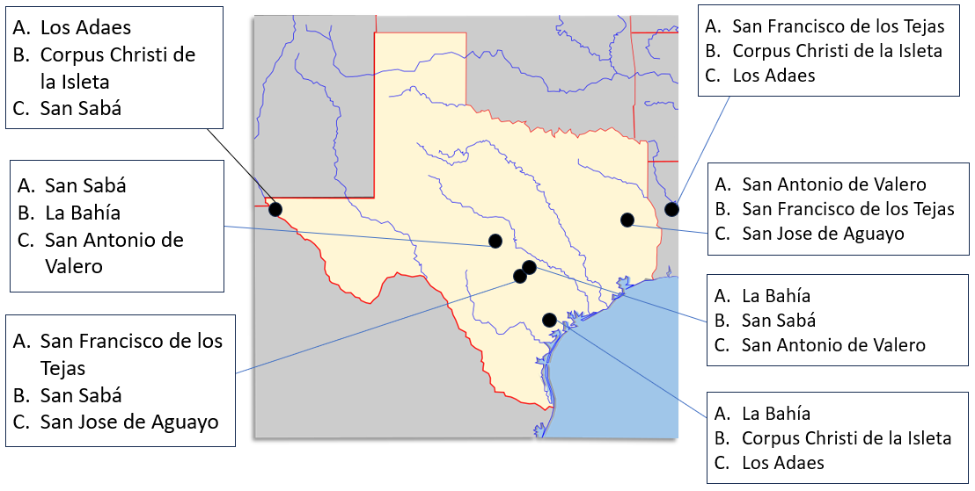
Corpus Christi de la Isleta - 1682

Specific Goal(s) of the Mission  Convert the ________________ | People of the Mission  Antonio de Otermín Spanish soldier / friar at the mission  Fray Francisco de Ayeta Spanish soldier / friar at the  mission.

Challenges (Circle or highlight all that apply)  Apache raids // Comanche attacks //  Disease // Friars left the mission //  // Flooding // Crop Failures | Achievements

Interesting Facts  Longest continually occupied settlement in Texas – 300 years! | Outcome  - It still operates today.  - It closed in the late 1700s.

San Francisco de los Tejas - 1690

Specific Goal(s) of the Mission  Convert the ________________  Keep the ___________________ out of east Texas. | People of the Mission (choose the correct option)  Alonso de León Spanish soldier / friar at the presidio  Damián Massanet Spanish soldier / friar at the mission  Francisco Hidalgo Spanish soldier / friar at the mission

Challenges (Circle or highlight all that apply)  Texas Indians not interested // Apache raids // Spanish Disease // Floods // Too many soldiers // Lack of supplies // French threat | Achievements

Interesting Facts | Outcome  - Closed in 1830  - Closed in 1693  - Still open today

Los Adaes - 1717

Specific Goal(s) of the Mission  Convert the ________________  Keep the __________________ out of east Texas. | People of the Mission  Domingo Ramón Spanish soldier / friar at the presidio  Antonio Margil de Jesús Spanish soldier / friar at the  mission.  Marques de Aguayo The Spanish governor / commander  of New Mexico / Texas.  Louis St. Denis French supporter / French opponent

Challenges (Circle or highlight all that apply)  French threat // The Chicken War // Crop Failures // Distance from Mexico // Lack of supplies // Depend on French trade // Apache attacks | Achievements

Interesting Facts  Los Adaes was the first capital of Texas | Outcome  - Closed in 1772  - People moved to San Antonio  - Both are correct

San Antonio de Valero - 1718

Specific Goal(s) of the Mission  Convert the ______________________  Provide a midpoint on the way to and from _____________________ | People of the Mission  Antonio de Olivares: A Spanish friar / soldier /  Governor / at the mission

Challenges (Circle or highlight all that apply)  Disease // Floods // Apache raids // Lack of Supplies //  Too many interested Texas Indians //  Comanche raids // Canary Islanders | Achievements

Interesting Facts  San Antonio was the second capital of Texas. It’s later known as “the Alamo.” | Outcome  - Still open as a mission today  - Closed in 1793  - Closed in 1672

San Jose de Aguayo - 1720

Specific Goal(s) of the Mission  Convert the ___________________________ | People of the Mission  Antonio Margil de Jesús Spanish soldier / friar / governor  at the mission.  Marques de Aguayo Spanish soldier / friar / governor  at the mission.

Challenges (Circle or highlight all that apply)  Flooding // Lack of supplies // French threat // Disease //  Lack of support from New Spain | Achievements

Interesting Facts  It is one of the largest Spanish missions and part of the National Park System today. | Outcome  - Still operating as a mission today  - Closed in 1824  - Closed in 1693

La Bahía - 1721

Specific Goal(s) of the Mission  Convert the ___________________________ | People of the Mission  Domingo Ramón Spanish soldier / friar at the presidio  Marques de Aguayo Spanish soldier / friar / governor  at the mission.

Challenges (Circle or highlight all that apply)  Comanche attacks // Disease // Flooding // Conflict between the soldiers and Texas Indians // Lack of supplies and support | Achievements

Interesting Facts  It was built on the ruins of Robert La Salle’s French fort Saint Louis | Outcome  - Closed in 1793  - Closed in 1825  - Still operates as a mission

San Sabá - 1757

Specific Goal(s) of the Mission  Convert the ___________________________ | People of the Mission  Father Miguel Molina Spanish soldier / friar / governor  at the mission.

Challenges (Circle or highlight all that apply)  Apache disinterest in the mission // Distant presidio //  Friars abandoned the mission // Comanche attack with allies  // soldiers, friars, and Apache killed or wounded //  Floods // Burned and destroyed // | Achievements

Interesting Facts | Outcome  - Mission destroyed in an attack  - Never reopened  - Both answers are correct

