Texas Missions: Part Two Grade Level

Unit 3: The Spanish Colonial Era

Name: |  | Date: |  | Period:

This is part two of your Texas Missions lesson. In this part of the assignment, you will take notes on the Texas missions presented by other groups in your class.
Map of Missions: As each group presents, mark the approximate location of their mission on the map below. Label the mission with its most basic name. Write neatly and clearly.
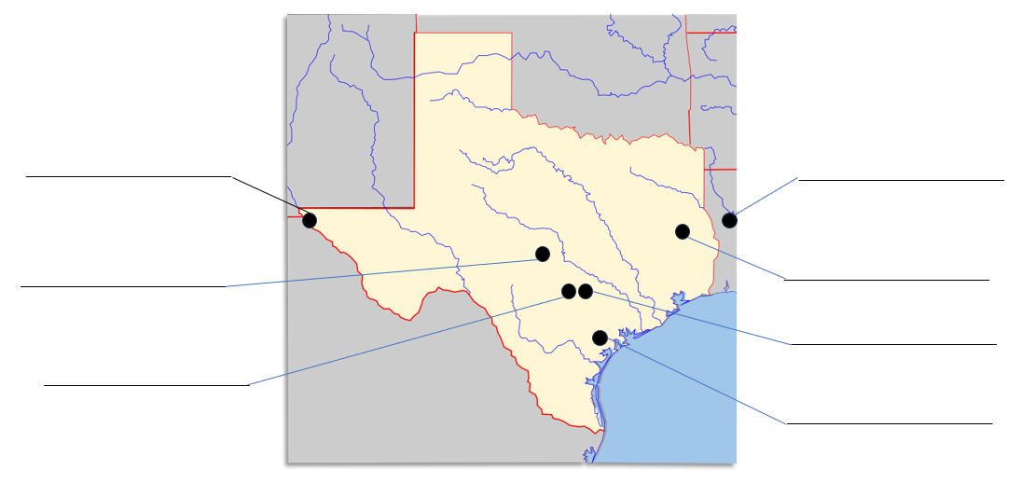
Corpus Christi de la Isleta - 1682

Specific Goal(s) of the Mission | People of the Mission  Antonio de Otermín  Fray Francisco de Ayeta

Challenges | Achievements

Interesting Facts | Outcome

San Francisco de los Tejas - 1690

Specific Goal(s)  of the Mission | People of the Mission  Alonso de León  Damián Massanet  Francisco Hidalgo

Challenges | Achievements

Interesting Facts | Outcome

Los Adaes - 1717

Specific Goal(s) of the Mission | People of the Mission  Domingo Ramón  Antonio Margil de Jesús  Marques de Aguayo  Louis St. Denis

Challenges | Achievements

Interesting Facts | Outcome

San Antonio de Valero - 1718

Specific Goal(s) of the Mission | People of the Mission  Antonio de Olivares

Challenges | Achievements

Interesting Facts | Outcome

San Jose de Aguayo - 1720

Specific Goal(s) of the Mission | People of the Mission  Antonio Margil de Jesús  Marques de Aguayo

Challenges | Achievements

Interesting Facts | Outcome

Specific Goal(s) of the Mission | People of the Mission  Domingo Ramón  Marques de Aguayo

La Bahía - 1721

Challenges | Achievements

Interesting Facts | Outcome

San Sabá - 1757

Specific Goal(s) of the Mission | People of the Mission  Father Miguel Molina

Challenges | Achievements

Interesting Facts | Outcome

