Catholic Religion  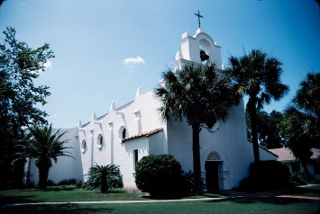 | Acequias  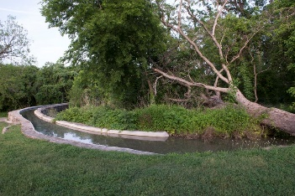
Fresco  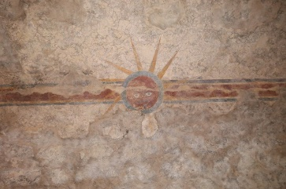 | Tortillas  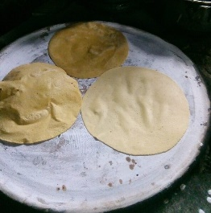
Hacienda  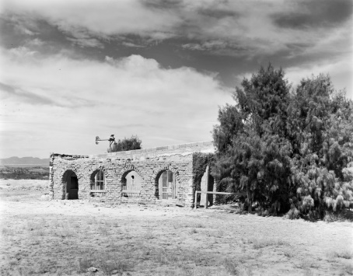 | Tejano Music  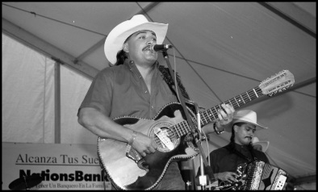
Vaquero  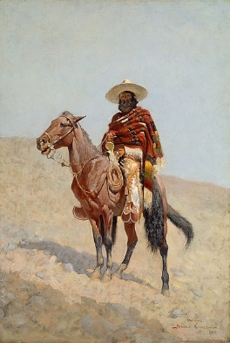 | Rodeo  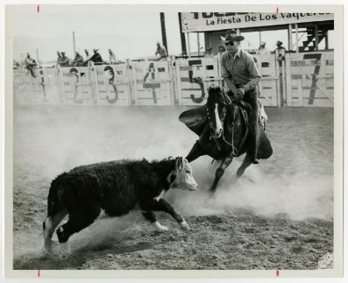
Acequias are Spanish wells or canals that were built during the Colonial Era for irrigation to bring water to settlements like San Antonio. Some can still be seen today.  Pictured on this card: The Espada Acequia built in 1731 in San Antonio. Library of Congress. | Today, approximately 30% of Texas’ population practices the Catholic faith that was brought to Texas with the Mission Presidio System.  Pictured on this card: A Spanish-style church near Victoria, TX. The Portal to Texas History.
Today, corn and flour tortillas are a staple of Mexican and Tex-Mex food. They originated in the Mexican and Indigenous cultures of modern-day Mexico.  Pictured on this card: Homemade corn tortillas, by Fermín Jiménez Rodríguez. | There are still some remaining frescoes, or paintings on the walls, at several Spanish churches in Texas. They often show religious scenes or symbols.  Pictured on this card: The Sun Fresco at Mission Concepción. The National Park Service
Tejano music is a combination of music from Spanish and Mexican culture combined with other cultures that migrated to Texas in the 1800s including German and Czech cultures.  Pictured on this card: Juan P. Moreno and his Tejano Band. The Portal to Texas History. | Haciendas were Spanish homes that were established in Texas during the Colonial Era. People who lived in haciendas often took part in ranching, rodeos, or cattle drives.  Pictured on this card: The Ochoa Hacienda in Presidio County. The Portal to Texas History
Rodeos can be traced back to Mexican vaqueros and Spanish conquistadors. They included competitive events to showcase skills like roping, riding, and branding.  Pictured on this card: a typical rodeo event, cattle-roping. The Portal to Texas History. | Vaquero is the Spanish word for cowboy. Tejano vaqueros were ranchers who worked with livestock in the Spanish settlements in Texas.  Pictured on this card: A painting called “A Mexican Vaquero” from the Art Institute of Chicago.

