# **The Big Picture *Grade Level***

*Unit 3: The Spanish Colonial Era*

|  |  |  |  |  |  |
| --- | --- | --- | --- | --- | --- |
| Name: |  | Date: |  | Period: |  |

**Part I: Analyze an Image**

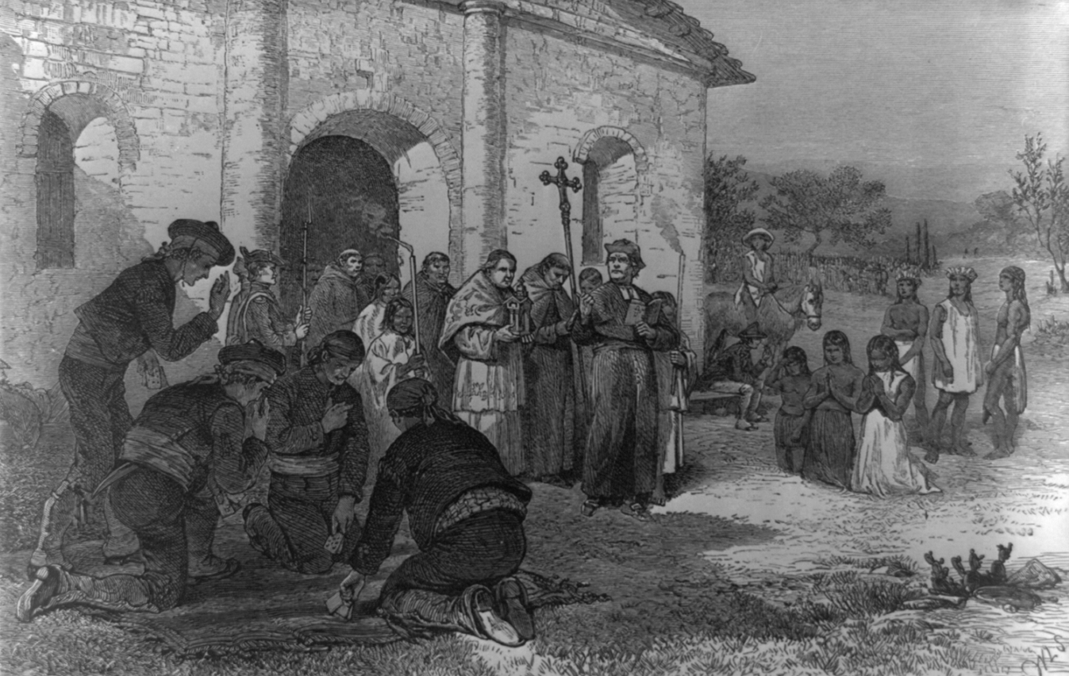

Figure 1 “The Spanish Mission at the Alamo.” Created in the 18th Century. Library of Congress

1. Describe three things you notice about the image.
2. Based on the image, what do you think we will learn about in this unit?

**Part II: Essential Ideas Reading Passage**

The Spanish Colonial Era was a period of time characterized by numerous growing problems in New Spain. This was especially true for Spanish Texas. After Spain’s failure to find gold or other valuable resources in Texas, the Spanish had turned their attention away from their northern **frontier**. Then, a French explorer named Robert La Salle arrived on the Texas coast in 1685. As we saw in the last unit, La Salle’s expedition was a complete failure, but it still troubled the Spanish all the same. The Spanish didn’t want their rival – the French – **encroaching** on the territory of New Spain.

The Spanish government had a problem to solve: How could it prevent France from taking control of Texas? Spain still didn’t see Texas as **economically valuable**, but Texas could be valuable as a **buffer zone.** Texas could provide a safe distance between Spain’s profitable silver mines near Mexico City and the rest of North America. Spain wanted an inexpensive, easy way to maintain its claim to Texas. At the same time, Spain wanted to use Texas to protect its most valuable North American territory: the region around Mexico City.

Spain’s solution to **solidifying** its claims to Texas was to colonize the region. Spain planned to establish religious settlements, or missions, and military forts, or presidios, in Texas. Spain had two primary goals for these settlements. First, friars at the missions would teach Texas Indians the Spanish language, culture, jobs, religion, and general way of life. Spain wanted Texas Indians to **assimilate** into Spanish culture. In Spain’s view, assimilated Texas Indians would be better Spanish **subjects**. Second, the soldiers at the presidios would protect the missions. More importantly, they would protect Texas from any future French **incursions**. Problem solved!

Unfortunately for Spain, numerous challenges arose during this time that caused the Spanish great **turmoil** in Texas. The mission system struggled for decades because Texas Indians had little interest in assimilating into Spanish culture, and Spain never provided the support the missions needed to succeed. Next, the Comanche migrated into Texas during these years and eventually became the most powerful group in the region. Additionally, Spain’s social system **discriminated** against people who were not born in Spain. This caused a growing dissatisfaction among the large population of non-Spanish born people in New Spain. This dissatisfaction would eventually lead to a war that would further weaken Spain’s claims to Texas. Finally, in the late 1700s New Spain gained a new neighbor to its east when the United States of America was founded. Some in America were interested in expanding west, which could pose another threat to Spain’s claims to Texas. Throughout this era, Texas would experience incredibly significant challenges and changes, and there would be many more yet to come.

**Part III: Vocabulary in Context**

1. Frontier
2. Encroaching
3. Economically valuable
4. Buffer zone
5. Solidifying
6. Assimilate
7. Subjects
8. Incursions
9. Turmoil
10. Discriminated
11. Worth a lot of money
12. Land at the edge of a settled region
13. Disturbance, uncertainty, and problems
14. Making something stronger
15. Invasions
16. People ruled by a king or queen
17. Slowly moving into someone else’s land
18. Treated unfairly because of uncontrollable factors like race or gender.
19. A large distance for protection
20. To completely adopt a different culture and way of life

**Part IV: Comprehension Questions**

1. How did Spain plan to solidify its claim to Texas? What two goals accompanied this plan?

|  |
| --- |
| Spain planned to solidify its claim to Texas by ____________________________________________ _______________________________________________________________________________________________. One goal for this plan was __________________________________________________________________ ________________________________________________________________________________________________. Another goal for this plan was ______________________________________________________________ ________________________________________________________________________________________________. |

1. Explain one struggle Spain faced during the Spanish Colonial Era.

|  |
| --- |
| One struggle Spain faced during the Spanish Colonial Era was _________________________ ________________________________________________________________________________________________ ________________________________________________________________________________________________ |