The Mission Presidio System: Guided Notes Advanced

Unit 3: The Spanish Colonial Era

Name: |  | Date: |  | Period:

The Mission Presidio System

Key Information: | Significance:
Essential Question – Your Response: | 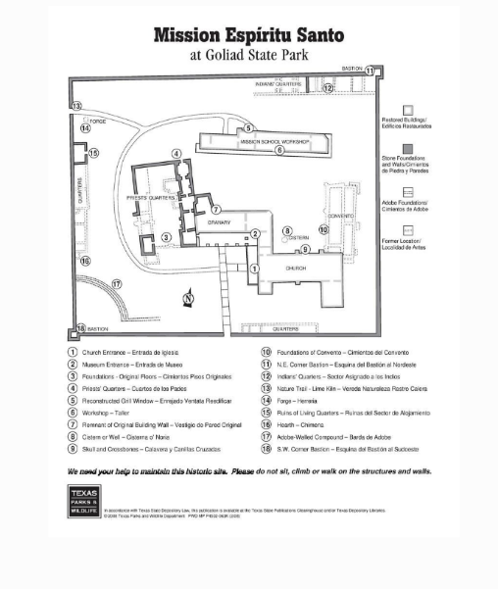

East Texas Missions

Key Information: | Significance:
Essential Question – Your Response: | 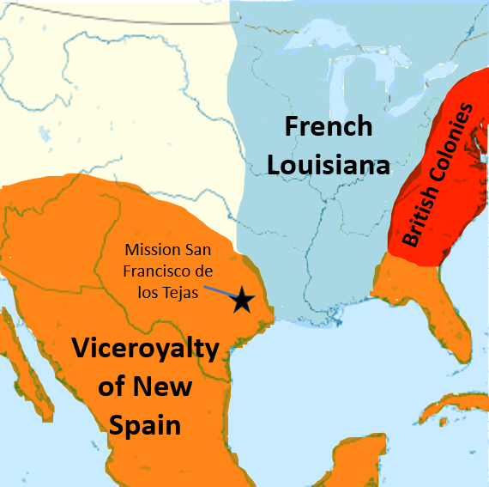

San Antonio

Key Information: | Significance:
Essential Question – Your Response: | 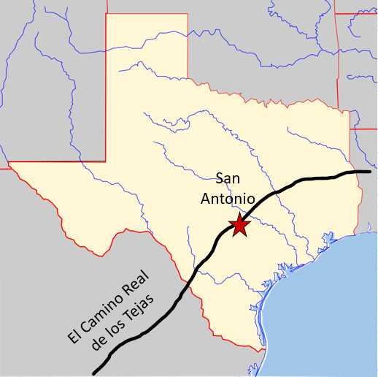

- When and why was San Antonio founded?

- Were the Spanish missions among the Caddo successful? Why or why not?

