The Mission Presidio System: Guided Notes Foundations

Unit 3: The Spanish Colonial Era

Name: |  | Date: |  | Period:

The Mission Presidio System

Key Information:  _________________________ settlements to ______________________ Indians and military forts to ______________________ the land from the _______________________. | Significance:  The Mission System _________________________ to give ________________________ a strong presence in _____________________________.
Essential Question – Your Response:  One reason for the mission system’s failure in Texas was (A) too many Texas Indians wanted to live at the missions (B) Texas Indians were not interested in mission life. | 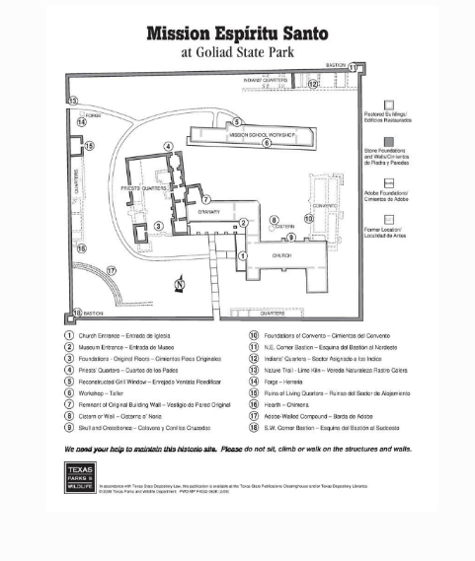

East Texas Missions

Key Information:  Spain established the first ___________________ in ___________________ Texas to prevent the ____________________ from entering the region. | Significance:  The ______________________ drove out the Spanish because of _______________________ and lack of _____________________________.
Essential Question – Your Response:  The Caddo / The Spanish had more power in the region. | 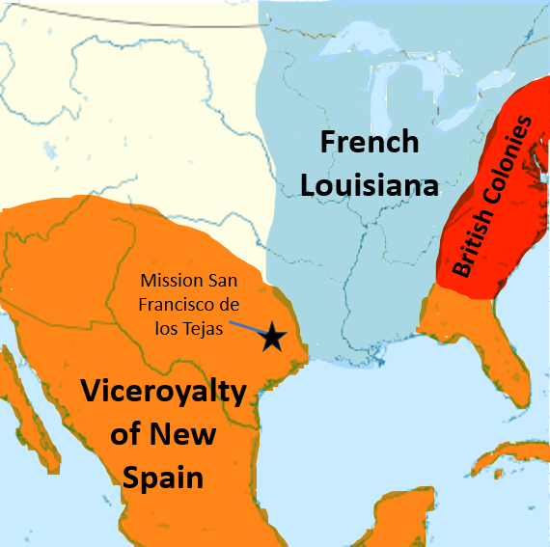

San Antonio

Key Information:  Spain founded _______________________________ in _________________ as a midpoint on the route to east Texas. | Significance:  __________________________________ will go on to become an important __________________ in Texas history.
Essential Question – Your Response:  I think Spain will / will not establish missions in San Antonio | 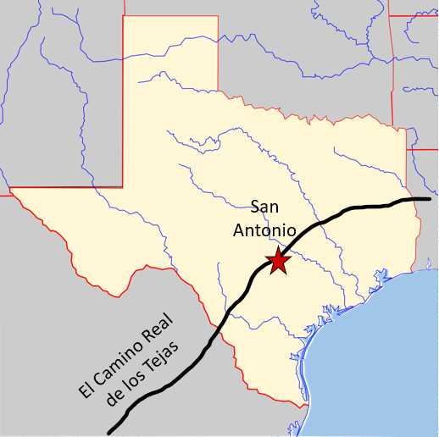

- When and why was San Antonio founded?
San Antonio was founded in (A) 1685 (B) 1718 (C) 1776 because (A) Spain needed a point midway through the journey to east Texas (B) Spain wanted to establish the first missions there for the Apache tribe.

- Were the Spanish missions among the Caddo successful? Why or why not?
The Spanish missions among the Caddo were / were not successful because (A) The Caddo were hostile toward the Spanish missionaries (B) The Spanish missionaries didn’t have enough space for all the Caddo people to live at the mission (C) The Caddo didn’t want to convert, and many died of Spanish diseases.

