The Mission Presidio System: Guided Notes Grade Level

Unit 3: The Spanish Colonial Era

Name: |  | Date: |  | Period:

The Mission Presidio System

Key Information: | Significance:
Essential Question – Your Response:  One reason for the mission system’s failure in Texas was __________________________________ _________________________________________________ _________________________________________________ | 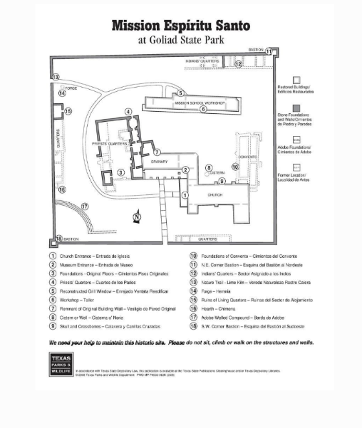

East Texas Missions

Key Information: | Significance:
Essential Question – Your Response:  The Caddo / The Spanish had more power in the region because ________________ _________________________________________________ _________________________________________________ | 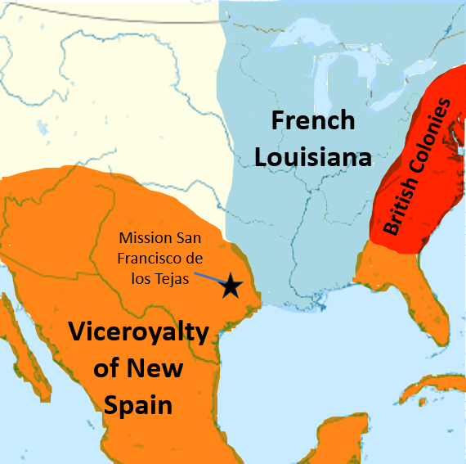

San Antonio

Key Information: | Significance:
Essential Question – Your Response:  I think Spain will / will not establish missions in San Antonio because __________ ________________________________________________ ________________________________________________ ________________________________________________ | 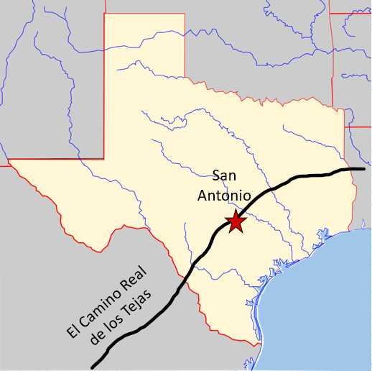

- When and why was San Antonio founded?
San Antonio was founded in ___________________ because ________________________________ ______________________________________________________________________________________________ ______________________________________________________________________________________________

- Were the Spanish missions among the Caddo successful? Why or why not?
The Spanish missions among the Caddo were / were not successful because ____ ____________________________________________________________________________________________________________________________________________________________________________________________

