
Warm-up: The Mission Presidio System
Unit 3: The Spanish Colonial Era
Name: |  | Date: |  | Period:

Directions: Read the scenario and answer the question that follows.

Picture this: The year is 1690, five years after La Salle landed in Texas. You are an advisor in the government of New Spain. The Spanish governor of Texas asks you where you think Spain should establish its first mission in Texas.  Where would you suggest Spain build its first mission? Why?  Circle the location you choose on the map. | 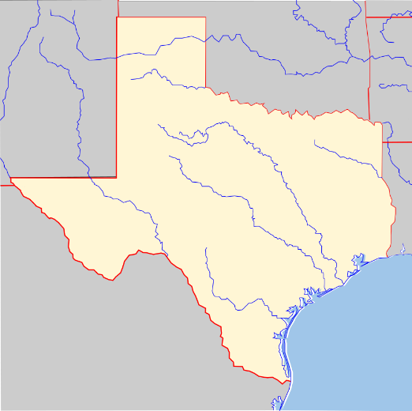

Warm-up: The Mission Presidio System
Unit 3: The Spanish Colonial Era
Name: |  | Date: |  | Period:

Directions: Read the scenario and answer the question that follows.

Picture this: The year is 1690, five years after La Salle landed in Texas. You are an advisor in the government of New Spain. The Spanish governor of Texas asks you where you think Spain should establish its first mission in Texas.
Where would you suggest Spain build its first mission? Why?
Circle the location you choose on the map.


The Mission Presidio System Exit Ticket

We know there were no cellphones in the 1600s when the Spanish began establishing missions, but let’s imagine . . .  Imagine: You are in east Texas at the new missions.  Now imagine that there were cellphones at the time. The Spanish governor of Texas sends you a message to see how it’s going.  How do you respond?  What would his response be? | 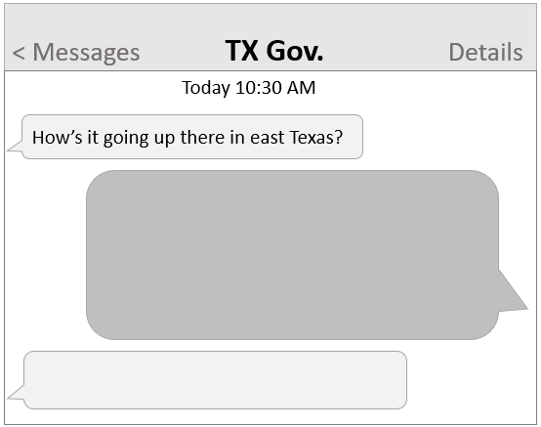

The Mission Presidio System Exit Ticket
We know there were no cellphones in the 1600s when the Spanish began establishing missions, but let’s imagine . . .

Imagine: You are in east Texas at the new missions.
Now imagine that there were cellphones at the time. The Spanish governor of Texas sends you a message to see how it’s going.
How do you respond?
What would his response be?

