|  |
| --- |
| **1)The Mission Presidio System**  **Advanced** |

After the arrival of Robert La Salle in 1685, Spain wanted to take measures to protect Texas from any future French incursions. But what could Spain do? Approximately 100 years earlier, the Spanish had established missions and presidios near their silver mines in central Mexico. Soldiers at the presidios protected the mines and trade routes, while friars at the missions attempted to assimilate American Indians in Mexico into Spanish culture.

As Spain turned its attention to Texas, the Spanish government decided to expand the Mission Presidio System into its northern frontier. The Spanish hoped that the Mission Presidio System in Texas would provide Texas the protection necessary to keep it out of the hands of their French rivals.

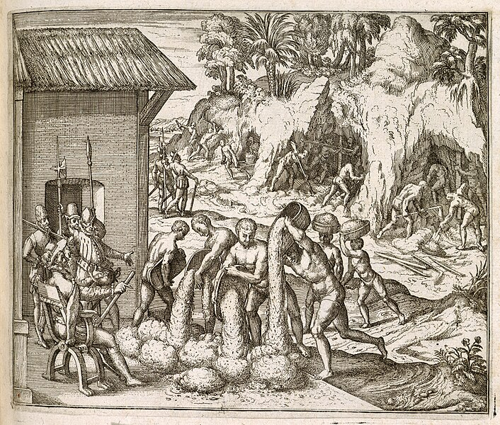

Figure 1 Enslaved people from Guinea digging for gold and silver in mines, for the Spanish colonists in Hispaniola. Engraving by Theodor de Bry from Girolamo Benzoni's Americae pars quinta.

|  |
| --- |
| **2) The Mission Presidio System in Texas**  **Advanced** |

The first missions Spain established in Texas were in the northern Coastal Plains region among the powerful Caddo Confederacy. The Caddo, however, were only interested in trade with the Spanish. They had no interest in mission life or assimilation.

As the Spanish established more missions in Texas, they ran into similar obstacles over and over again. Some tribes were interested in the missions for the resources or protection they provided. Almost none were interested in mission life, converting to Catholicism, or assimilating into Spanish culture. That wasn’t the only challenge the missions faced, however.

Missions often endured raids and attacks by powerful tribes like the Comanche or Apache. Disease often devastated tribal populations at the missions. Finally, the Spanish government never provided the resources or manpower the missions needed to be successful. As a result, the Mission Presidio System ultimately failed in Texas.

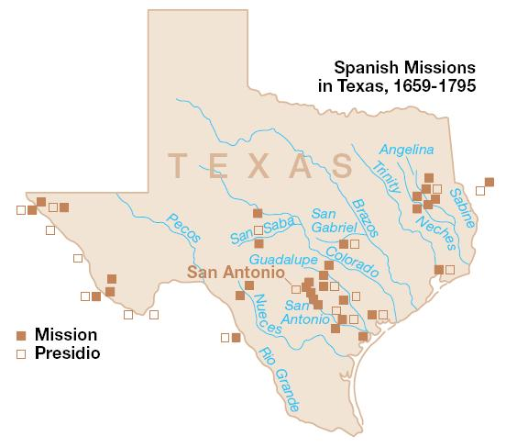

Figure 2 Spanish missions in Texas. National Park Service.

|  |
| --- |
| **3) The Apache and Comanche in Texas**  **Advanced** |

As much as Spain wanted to claim control of Texas, and as much as the Spanish feared the threat of the French, it was actually tribes like the Comanche and Apache that held the real power in the region.

Both the Comanche and Apache tribes had grown significantly in power after migrating into Texas, and they carried out an ongoing war between each other for control of the Plains. In some cases, less powerful tribes sought refuge from Comanche or Apache attacks at the Spanish missions, hoping the soldiers at the presidios would protect them. In many cases, the missions themselves were often the target of such attacks.

By the late 1700s, the Texas missions were clearly failing. The Spanish began ending the Mission Presidio System in Texas in 1793. Spain maintained its settlements in San Antonio and

began paying tribute to the Comanche in order to stop their attacks on Spanish settlers there. Though we sometimes refer to “Spanish Texas” during this time, it would be much more accurate to call it “*Comanchería*” or Comanche Land.

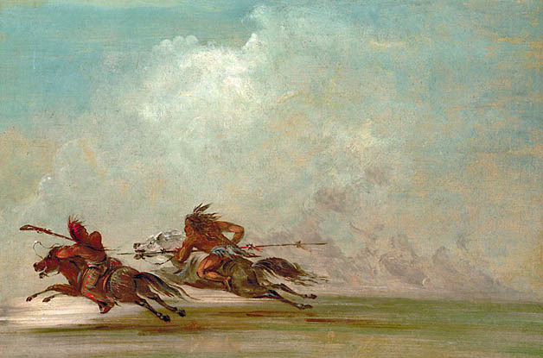

Figure 1 War on the Plains. George Catlin. 1834.

|  |
| --- |
| **4) The Louisiana Purchase 1803**  **Advanced** |

While Spain struggled to establish a presence in Texas in the late 1700s, on the east coast of North America British colonists were fighting a revolution to gain independence from their king in England. By the time Spain ended the mission system in Texas, the British colonists had won their freedom and established a new country: the United States of America.

In 1803, the U.S. bought an enormous amount of land called Louisiana from France. The borders of the Louisiana Purchase were not clear, which posed a problem for New Spain because according to the U.S., the land they purchased included territory in Texas. As a result, Spain saw the U.S. as a threat to their claims to Texas.

The Spanish still believed Texas was valuable as a buffer zone, though they still had no real control of the region. Once again, Spain found itself considering the question of how to maintain its claim to Texas.

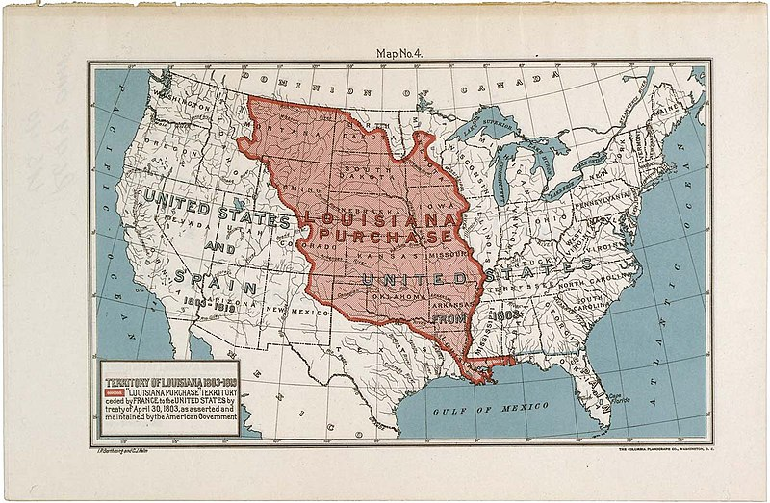

Figure 2 The Louisiana Purchase. National Archives and Records Administration.

|  |
| --- |
| **5) The War for Mexican Independence 1810 – 1821**  **Advanced** |

New Spain’s society had been established as a caste system that divided people into categories based on their race or ethnicity. People born in Spain held the most rights and highest positions of power, while people born in the Americas had fewer rights and fewer privileges.

After more than two centuries of life under this caste system, the people in the lower social classes had had enough. In 1810, a Spanish priest named Miguel Hidalgo led a rebellion against the government in New Spain. Though he was eventually killed, the rebellion grew.

After eleven years of fighting, Mexico won its independence from Spain in 1821. The war brought a lot of violence to Texas and had a particularly devastating effect on the already small Spanish population of the region.

Following the war, the newly formed government of Mexico was faced with the same problem that had troubled Spain – how could it strengthen its claims to Texas?

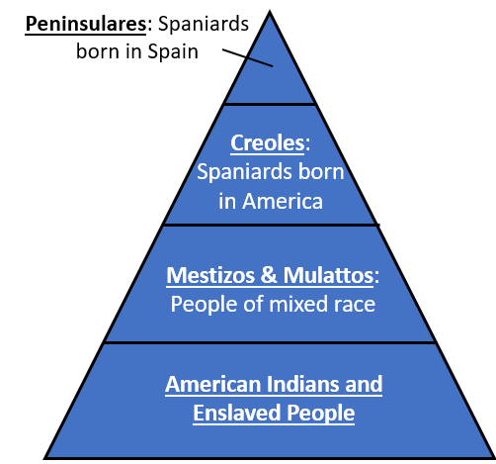

Figure 1 The Social Caste System in New Spain.

|  |
| --- |
| **6) The Filibusters in Texas**  **1810 - 1821 Advanced** |

In the middle of the War for Mexican Independence, some American men entered Texas illegally to take part in rebellious activities for their own reasons. These men are often referred to as filibusters.

The filibusters had different reasons for coming to Texas. Some were seeking adventure, resources, land, or profit. Some wanted to take part in the rebellion against Spain for Mexico’s independence. Some wanted Texas to become part of the United States. A few attempted to take over Texas towns and declare them free and independent from New Spain.

Regardless of why the filibusters came, the government of New Spain was extremely unhappy with their presence and took great measures to put a stop to their activities in Texas.

Spain’s actions to subdue filibuster activities in Texas weakened the already small Spanish population in the region.

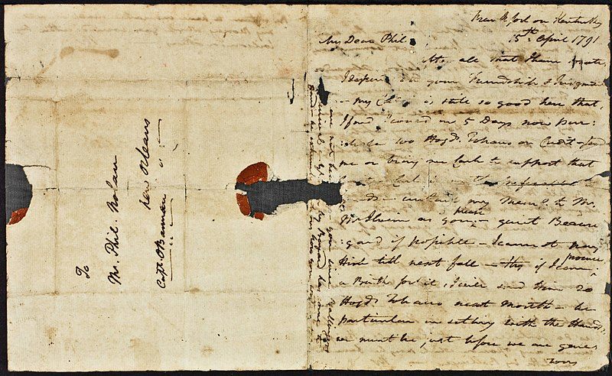

Figure 2 A photograph of a letter from James Wilkinson to Philip Nolan, two American filibusters who came to Texas. The Newberry Library.

|  |
| --- |
| **7) A New Country: Mexico**  **Advanced** |

Mexico gained its independence from Spain in 1821 after eleven years of war. During the war, American filibusters had entered Texas, sometimes teaming up with *Tejanos* (Mexicans who consider Texas home) to fight for Mexican independence. This greatly angered the government of Spain.

The Spanish military killed hundreds of Tejanos in Texas in retaliation for their role in the rebellion against Spain. Many other Tejanos fled Texas in search of safety. By the time the war ended, the Spanish population in Texas was only about two thousand people total.

As the people of Mexico set about creating their own government after the war, they were faced with a significant problem. It was essentially the same problem that had plagued New Spain for centuries: Texas was a valuable buffer zone between Mexico and the rest of North America, but Mexico’s claim to Texas was incredibly weak because there were so few people in the region. Texas could easily be overrun and taken over by just about anyone who wanted it. Mexico needed to find a way to strengthen its claim to Texas, and fast!

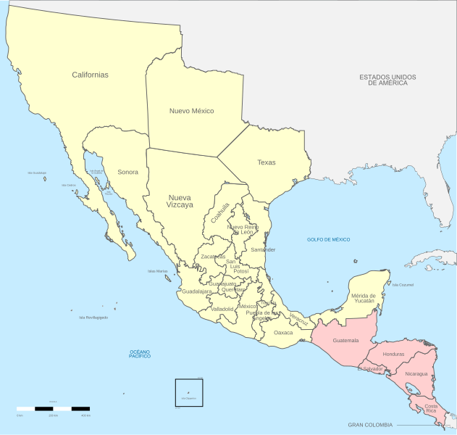

Figure 1 A map of Mexico, 1821.