|  |
| --- |
| **1)The Mission Presidio System**  **Foundations** |

After **Robert La Salle arrived in 1685**, Spain wanted to take steps to protect Texas from more French people coming into region. But what could Spain do? **Approximately 100 years earlier, the Spanish had established missions and presidios near their silver mines in central Mexico.** Soldiers at the presidios protected the mines and trade routes, while friars at the missions attempted to assimilate American Indians in Mexico into Spanish culture.

As Spain turned its attention to Texas, **the Spanish government decided to expand the Mission Presidio System into its northern frontier.** The Spanish hoped that the Mission Presidio System would **protect Texas from any possible French threat in the future**.

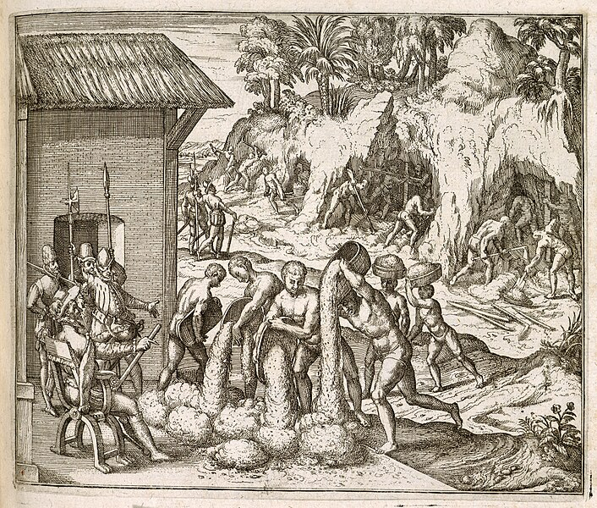

Figure 1 Enslaved people from Guinea digging for gold and silver in mines, for the Spanish colonists in Hispaniola. Engraving by Theodor de Bry from Girolamo Benzoni's Americae pars quinta.

|  |
| --- |
| **2) The Mission Presidio System in Texas**  **Foundations** |

The first missions Spain established in Texas were in the **northern Coastal Plains region** among the powerful **Caddo Confederacy**. The Caddo, however, were only interested in **trade** with the Spanish. They had no interest in mission life or assimilation.

As the Spanish established more missions in Texas, they ran into similar challenges over and over again. Some tribes were interested in the missions for the **resources or protection they provided. Almost none were interested in mission life, converting to Catholicism, or assimilating into Spanish culture.** That wasn’t the only challenge the missions faced, however.

Missions often experienced **raids** and **attacks** by powerful tribes like the **Comanche** or **Apache**. **Disease** often killed many Texas Indians at the missions. Finally, the Spanish government never provided the **resources** or **manpower** the missions needed to be successful. **As a result, the Mission Presidio System ultimately failed in Texas.**

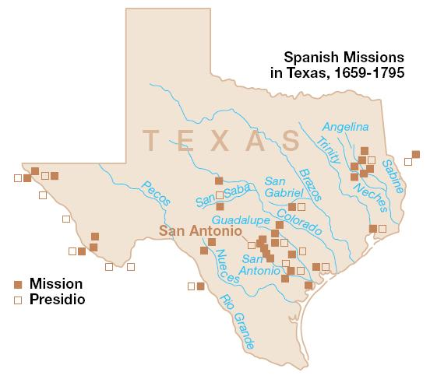

Figure 2 Spanish missions in Texas. National Park Service.

|  |
| --- |
| **3) The Apache and Comanche in Texas**  **Foundations** |

Spain wanted to claim control of Texas, and the Spanish were afraid of the French claiming the region. **In reality, it was actually tribes like the Comanche and Apache that held the real power in Texas.**

Both the Comanche and Apache tribes had grown significantly in power after migrating into Texas. **They carried out an ongoing war between each other for control of the Plains**. In some cases**, less powerful tribes** moved into the missions, hoping the presidios would **protect** them from attacks. In many cases, **the missions themselves were often the target of such attacks.**

By the late 1700s, the Texas missions were clearly failing. **The Spanish ended the Mission Presidio System in Texas in 1793.** Spain kept its settlements in San Antonio and

began paying the Comanche valuable resources like horses in order to stop their attacks on Spanish settlers there. Though we sometimes refer to “Spanish Texas” during this time, it would be much more accurate to call it “***Comanchería***” or Comanche Land.

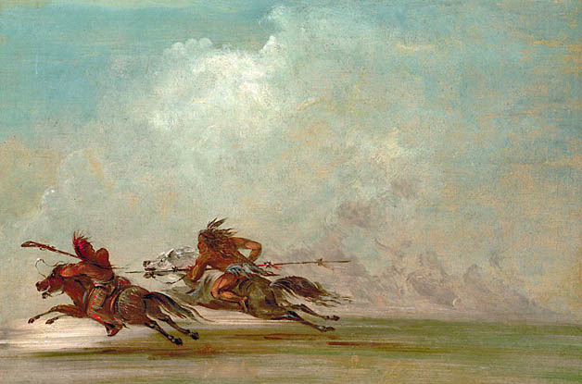

Figure 1 War on the Plains. George Catlin. 1834.

|  |
| --- |
| **4) The Louisiana Purchase 1803**  **Foundations** |

While Spain struggled in Texas in the late 1700s, on the east coast of North America **British colonists were fighting a revolution to gain independence from their king in England**. By the time Spain ended the mission system in Texas, the British colonists had won their freedom and established a new country: **the United States of America.**

In **1803**, the U.S. bought a large amount of land from France. The land was called **Louisiana**. **The borders of the Louisiana Purchase were not clear,** which was a problem for New Spain. **According to the U.S**., the land they purchased included territory in **Texas**. As a result, **Spain saw the U.S. as a threat to their claims to Texas**.

The Spanish still believed Texas was valuable as a **buffer zone,** however they still **had no real control of the region**. Once again, Spain had to try to answer the question of **how to maintain its claim to Texas.**

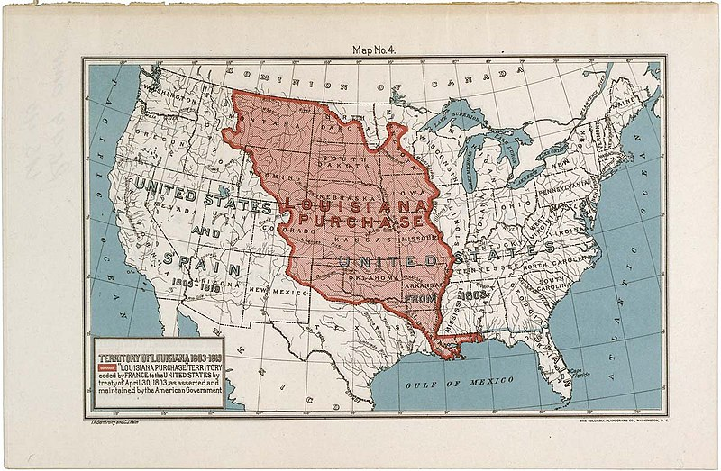

Figure 2 The Louisiana Purchase. National Archives and Records Administration.

|  |
| --- |
| **5) The War for Mexican Independence 1810 – 1821**  **Foundations** |

New Spain’s society had been established as a **caste system** that divided people into categories based on their **race** or **ethnicity**. People born in Spain had the most rights and power, **while people born in the Americas had fewer rights and fewer privileges.**

After more than two centuries of life under this caste system, the people in the lower social classes had had enough. In **1810**, a Spanish priest named **Miguel Hidalgo** led a **rebellion** against the government in New Spain. **Though he was eventually killed, the rebellion grew.**

After eleven years of fighting, **Mexico won its independence from Spain in 1821**. The war brought a lot of **violence to Texas** and had a terrible effect on the already small Spanish population of the region.

After the war, the new **government of Mexico** was faced with the same problem that had troubled Spain – **how could it strengthen its claims to Texas?**

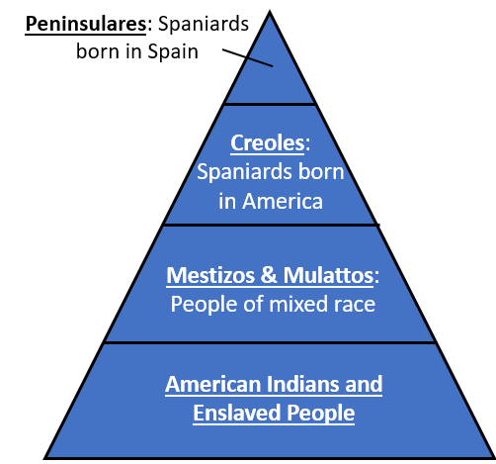

Figure 1 The Social Caste System in New Spain.

|  |
| --- |
| **6) The Filibusters in Texas**  **1810 - 1821 Foundations** |

In the middle of the War for Mexican Independence, **some American men entered Texas illegally to take part in rebellious activities for their own reasons.** These men are often referred to as **filibusters**.

**The filibusters had different reasons for coming to Texas.** Some wanted adventure, resources, land, or profit. **Some wanted to take part in the rebellion against Spain for Mexico’s independence**. Some wanted Texas to become part of the United States. A few attempted to take over Texas towns and declare them free and independent from New Spain.

Regardless of why the filibusters came, **the government of New Spain was extremely unhappy with their presence** and took great measures to put a stop to their activities in Texas.

Spain’s attempts to end filibuster activities in Texas **weakened the already small Spanish population in the region.**

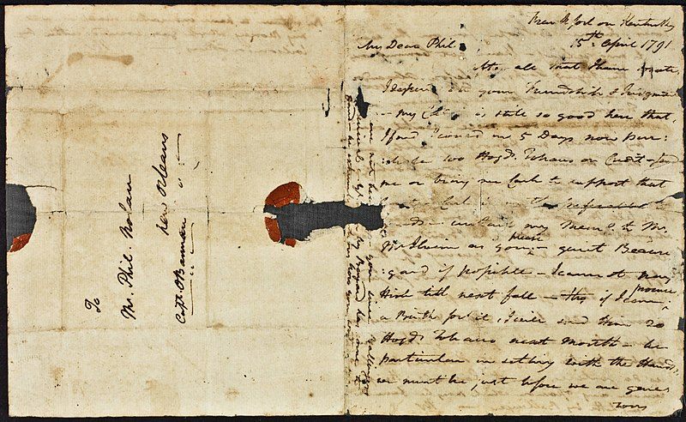

Figure 2 A photograph of a letter from James Wilkinson to Philip Nolan, two American filibusters who came to Texas. The Newberry Library

|  |
| --- |
| **7) A New Country: Mexico**  **Foundations** |

**Mexico gained its independence from Spain in 1821** after eleven years of war. During the war, American filibusters had entered Texas, sometimes teaming up with ***Tejanos*** **(Mexicans who consider Texas home)** to fight for Mexican independence. **This greatly angered the government of Spain.**

**The Spanish military killed hundreds of Tejanos in Texas to punish them for their role in the rebellion against Spain.** Many other Tejanos fled Texas in search of safety. By the time the war ended, the **Spanish population in Texas was only about two thousand people total.**

As the people of Mexico set about creating their own government after the war, **they were faced with a significant problem**. It was essentially the same problem that had troubled New Spain for centuries: **Texas was a valuable buffer zone between Mexico and the rest of North America,** but **Mexico’s claim to Texas was incredibly weak because there were so few** **people in the region**. Texas could easily be taken over by just about anyone who wanted it. **Mexico needed to find a way to strengthen its claim to Texas, and fast!**

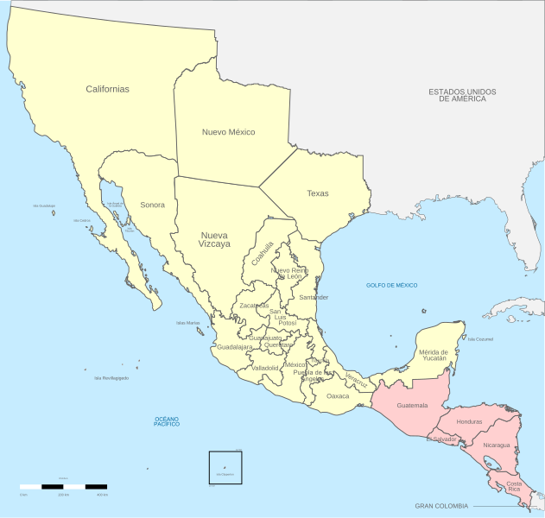

Figure 1 A map of Mexico, 1821.