The Alamo Extension Lesson Advanced
Unit 5: The Texas Revolution

Name: |  | Date: |  | Period:

Part I: The Map of the Alamo
Directions: Circle the approximate location of significant events based on the Timeline of the Alamo reading. Write a short note about what happened at that location.
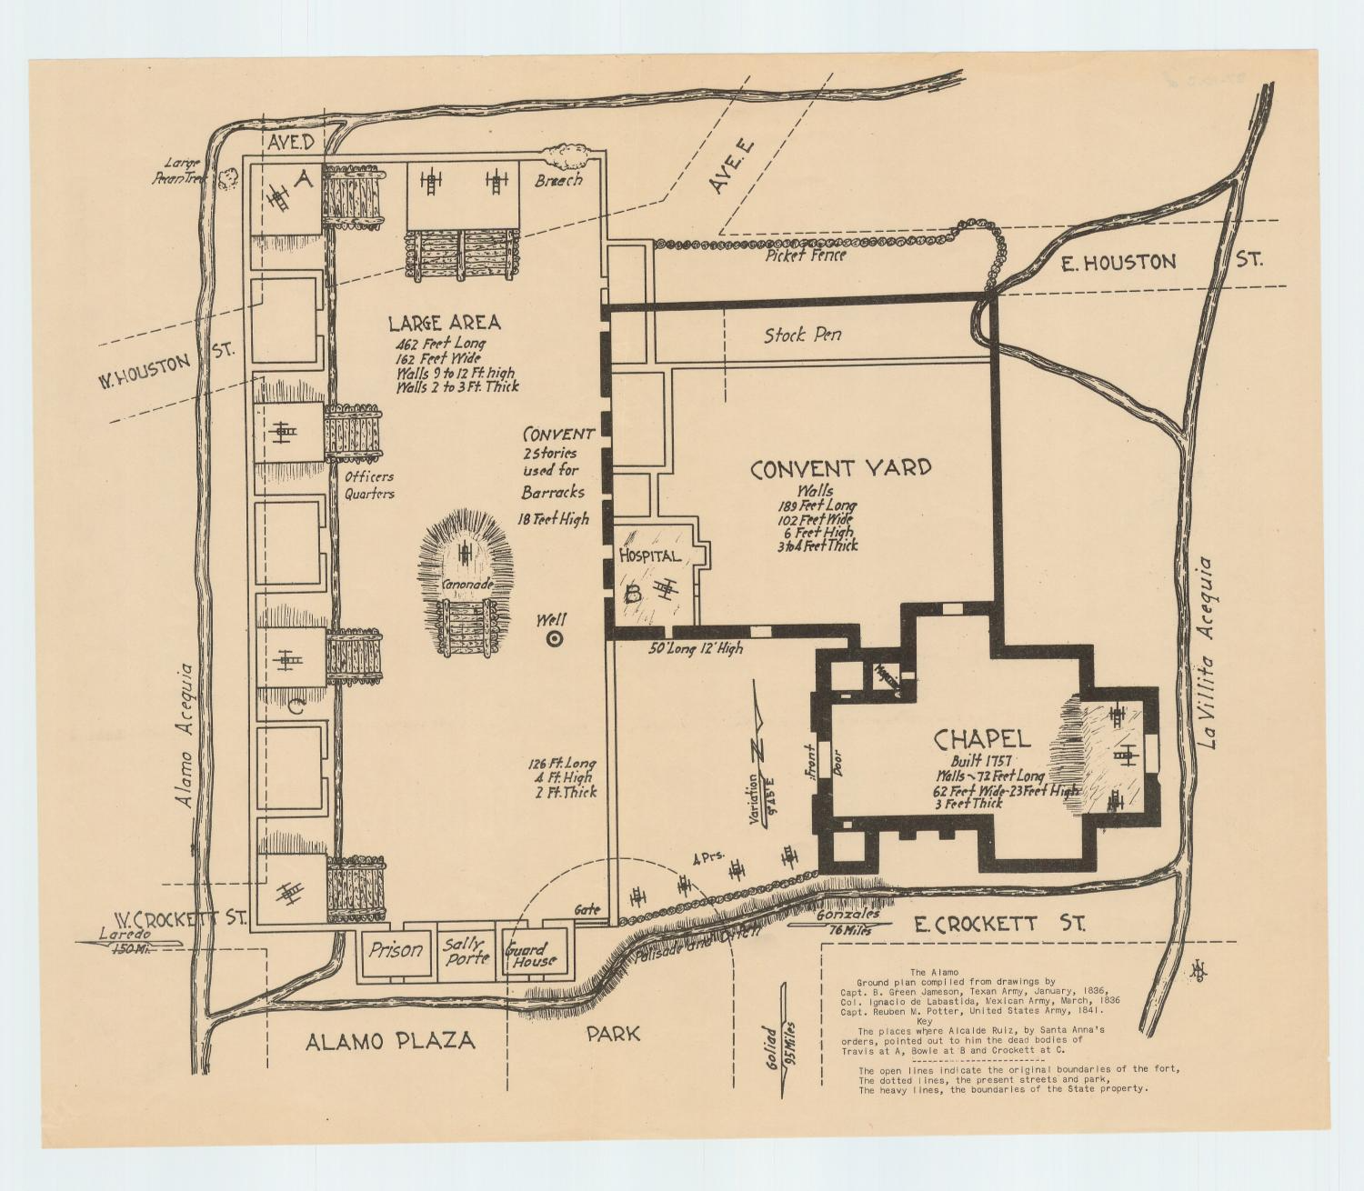

Figure 1: A map of the Alamo, Star of the Republic Museum, the Portal to Texas History

Part II: The Events of the Alamo Activity
Directions: You will choose ONE of the options below to demonstrate the events of the Alamo from the perspective of the defenders or civilians inside the Alamo. Use the “Timeline of Events” to guide your work.
 | Storyboard Activity | Journal Activity
Description of Assignment: | Create a storyboard (similar to a comic strip) of drawings showing the events of the siege and battle of the Alamo in chronological order. | Write a collection of journal entries from one point of view showing what it was like to experience the siege and battle of the Alamo.
Why should you choose this option? | - You like to draw, color, and use art to express ideas.  - You can show events from many different points of view within the Alamo.  - You want to show a lot of events from different points of view inside the Alamo. | - You like to write and use language to express ideas.  - You can show events from one person’s point of view inside the Alamo. (It can be a fictional person)  - You want to focus most on one personal experience from inside the Alamo.
Requirements for the Assignment: | - On one or more separate sheets of paper, create 10 – 14 hand-drawn images in a storyboard, (a series of small, square drawings in chronological order.)  - Include a title or caption for each image with dates and significant information about the event in the image.  - Optional writing: word bubbles to show speaking or any labeling you think necessary.  - Drawings must be neat and colorful.  - This will not be graded on artistic ability, but images should be clearly understandable. | - On one or more separate sheets of paper, create 10 – 14 hand-written journal entries presented in chronological order.  - Consider which point of view you want to represent: Alamo defenders (militia or regular army), enslaved people, women, or children.  - Each entry should include the date and important information about the events of that day.  - Each entry should also include opinions or experiences from the point of view of your character.  - This will not be graded on grammar, but writing should be clearly understandable.

