Name: | Date: | Class/Period:
The Texas Revolution: Connections to the Republic of Texas
Extension Lesson: Growth of Cotton and the Expansion of Slavery

Essential Question
How did the Texas Revolution contribute to the growth of cotton and expansion of slavery?
Tasks
The Map of the Southern United States
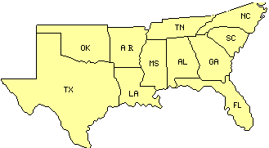
Today you will explore the growth of cotton and expansion of slavery using the Atlas of the Historical Geography of the United States with links embedded below.

Activity/Process
- Locate and name the region or regions that are situated in Texas, Louisiana, Mississippi and Alabama.

- What is the average growing season for Texas, Louisiana, Mississippi and Alabama? Based on what you have previously learned about the four regions, do the growing seasons in the Gulf Costal Plains benefit cotton farming? Justify your answer.

- Using the population growth map from 1790 to 1860 (click on the “Animate” bottom located at the bottom left) for the American South, explain how the growth in the southern United States had an impact of slavery. What natural resource did the settlers tend to settle near between 1800 and 1830? How would this help them in growing cotton?

- Review the population growth of enslaved people in the American South. What is the significance of this animation, what trends do you see? Click on the “Animate” button to the bottom left.

- Comparing the South’s population growth and the population growth of enslaved people maps, are the two maps connected? Justify your answer.

Evaluation
Using your own, your words describe why the South became an important region in America. Support your answer using your findings from the Activity/Process.

