Name: | Date: | Class/Period:

The Aftermath of the Texas Revolution:
Cotton and Slavery (Accommodated)

Instructions: Analyze the primary source documents and charts to answer the document analysis questions using supporting evidence.

Document A, Constitution of the Republic of Texas 1836, General Provisions
SEC 9. All persons of color who were slaves for life, previous to their emigration to Texas, and who are now held as bonded servants or otherwise, shall remain in the like state of servitude in which they would have been held in the country from which they came; provided the person or slave be the bona fide property of the person holding the same, either by purchase or otherwise. Congress shall pass no law to prohibit emigrants from the United States of America, from bringing their slaves with them, and holding them on the same terms and by the same tenure as they were held in the country from which they were brought. Congress shall have no power to pass laws for the emancipation [freeing] of slaves; nor shall any person holding slaves be permitted to emancipate them unless he removes them beyond the limits of this republic; unless, in case of meritorious conduct of the part of the slave, and by the consent of the legislature first had and obtained.
Kimble, H. S. “Copy of the Constitution of the Republic of Texas, March 17, 1836.” The Portal to Texas History. University of North Texas Libraries. https://texashistory.unt.edu; crediting The Dolph Briscoe Center for American History. Accessed July 19, 2021. https://texashistory.unt.edu/ark:/67531/metapth6708/

Analysis Questions:
- After careful consideration, what has the Republic of Texas done with Section 9 of the Constitution?
With Section 9, the Republic of Texas has
Name: | Date: | Class/Period:
- Does Section 9 promote slavery in Texas? Who would come to Texas as a result of Section 9?
I believe Section 9 does/does not (circle one) promote slavery because

As a result of Section 9
- “Congress shall have no power to pass laws for the emancipation [freeing] of slaves; nor shall any person holding slaves be permitted to emancipate them unless he removes them beyond the limits of this republic.”

Using this passage describe in your own words, what does the future of the Republic of Texas look like?
The future of the Republic of Texas looks like
Background Information:
The account of Dilue Rose is just months after the Battle of San Jacinto regarding the transportation of cotton to a port location to sell. Her father and Uncle Ned (the slave of Mr. Stafford, a local plantation owner) transported bales of cotton from their colony (Harrisburg) to an unknown port many miles away. They return home more than a month later to do it all over again.

Document B, July 4, 1836 - Shipping Cotton on a Flatboat.
“The first of June the men sent word that they had the cotton on a boat ready to start, and that Uncle Ned should be sent with the Stafford's wagon to bring home family supplies. It was more than fifty miles by land, but a long and dangerous route by water.”
“Father and the men arrived home the last of June. It was three weeks from the time they left Mr. William Little's before they landed at Brazoria. They sold their cotton for a good price and bought family supplies. Father did not forget his promise, but got sister and me nice bonnets.”
Texas State Historical Association. “The Quarterly of the Texas State Historical Association, Volume 4, July, 1900-April, 1901” pp. 155-189. The Portal to Texas History. University of North Texas Libraries. https://texashistory.unt.edu; crediting Texas State Historical Association. Accessed August 19, 2021. https://texashistory.unt.edu/ark:/67531/metapth101018/

Analysis Questions:
- Based on Dilue’s account in Document B, why would her father and Uncle Ned make such a long trip to load cotton onto a “flatboat?”
They would make this trip in a flatboat because
- Refer to the chart in Document E (below) to answer the following question:
  - If Dilue’s father and Uncle Ned sold 200 lbs. of cotton at the port in New Orleans, how much money would they have made?
They would have made
Document C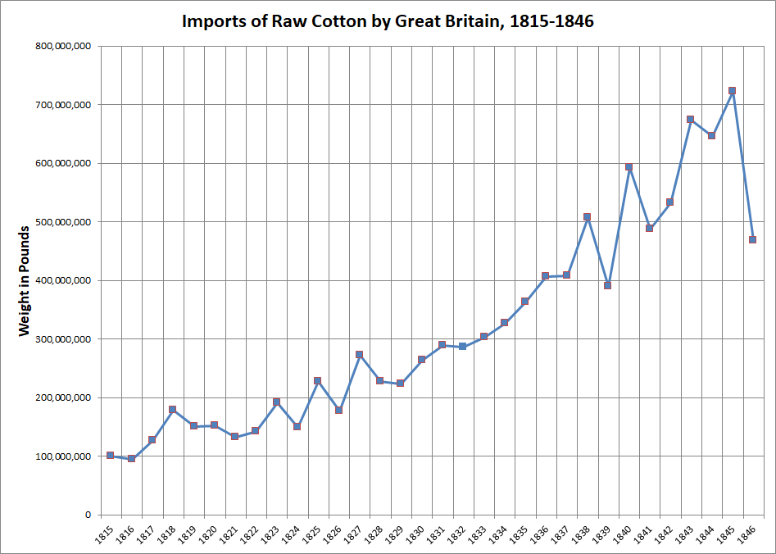

Torget, Andrew J. Seeds of Empire: Cotton, Slavery, and the Transformation of the Texas Borderlands, 1800-1850. Pp. 274. University of North Carolina Press, 2018.

Analysis Questions:
- Using Document C, the graph titled “Imports of Raw Cotton by Great Britain, 1815-1846” explain how this document demonstrates the growth of slavery in Texas.
This graph demonstrates the growth of slavery in Texas because
Document D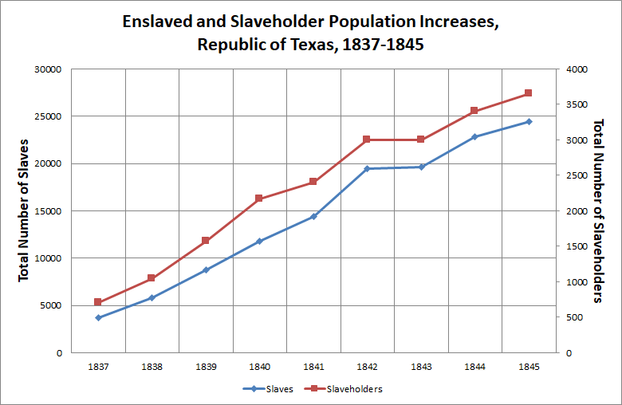

Torget, Andrew J. Seeds of Empire: Cotton, Slavery, and the Transformation of the Texas Borderlands, 1800-1850. Pp. 271. University of North Carolina Press, 2018.

Analysis Questions:

- What conclusions can you draw from the graph in Document D? Please cite textual evidence to support your response.
From this graph I conclude that
- Comparing the information from Document A to Document D, explain how Section 9 contributes to the growth of slavery in Texas. Please reference each of the documents in your response.

Section 9 contributed to the growth of slavery in Texas and Document A shows this by

and Document D shows this by

Document E
Average Annual Price of Cotton, 1845-1846 (Cents or Pence/Pound)
YEAR | NEW ORLEANS (cents) | NEW YORK (cents) | LIVERPOOL (pence)
1815 | 27.3 | 21 | 20.7
1820 | 15.2 | 17 | 11.5
1825 | 11.9 | 18.59 | 10.1
1835 | 8.4 | 10.04 | 6.44
1836 | 15.2 | 17.45 | 9.13
1840 | 13.3 | 16.5 | 8.79
1845 | 9.1 | 8.92 | 5.42
1846 | 6.8 | 5.63 | 3.92

Torget, Andrew J. Seeds of Empire: Cotton, Slavery, and the Transformation of the Texas Borderlands, 1800-1850. Pp. 273. University of North Carolina Press, 2018.

Analysis Questions:
- Using the information from the chart in Document “E,” answer the following questions:
  - How much did the price of cotton decrease in New Orleans from 1815 to 1846?
From 1815 to 1846, the price of cotton decreased by
  - In your opinion, why did the price of cotton decrease instead of increase?
In my opinion, the price of cotton decreased because of

