Events of the Texas Revolution Advanced
Unit 5: The Texas Revolution

Name: |  | Date: |  | Period:

Directions: Use the information in the slideshow to complete your graphic organizer on each significant event of the Texas Revolution.
The Battle of Gonzales

When | Where | What

Why

Outcome

Significance

The Consultation

When | Where | What

Outcome

The Alamo

The Texians Take the Alamo | When | Where

What

The Siege of the Alamo  When | What

Who | 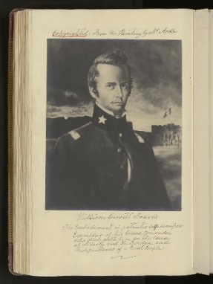 | 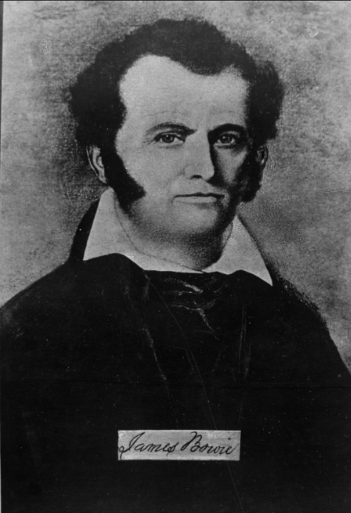 | 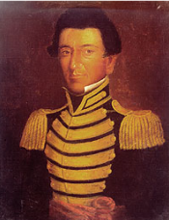

The Battle of the Alamo | When

What

The Constitutional Convention of 1836

When | What

The Goliad Massacre

When | Where | What

The Runaway Scrape

When | What

The Battle of San Jacinto

When | What

The Treaties of Velasco

When | What

Cause and Effect:
Follow the prompts to complete the chart below.

Step 2:  What caused the event you chose? | START HERE:  Step 1  Write the name of ONE event from this lesson in each box below | Step 3  What was one effect of the event you chose?

