Events of the Texas Revolution Foundations
Unit 5: The Texas Revolution

Name: |  | Date: |  | Period:

Directions: Use the information in the slideshow to complete your graphic organizer on each significant event of the Texas Revolution. You will fill in the blanks in some cases, and in others you will circle or highlight the correct information.
The Battle of Gonzales

When (circle one)  Sept. 2 1835  Oct. 2 1835  Nov. 2 1835 | Where (Circle one)  San Antonio  Gonzales  Victoria | What  The _____________________ battle of the Texas Revolution

Why | The Mexican army was ordered to retrieve a _______________ that Mexico had lent the town years earlier. The people _________________ to return the cannon, and a _______________ broke out.

Outcome | The outnumbered Mexican army was forced to _____________________ from Gonzales.

Significance | This battle _____________________ the Texas Revolution

The Consultation

When (Circle one)  Nov. 1835  Nov. 1836  Nov. 1837 | Where (Circle one)  San Antonio  Houston  San Felipe de Austin | What  A Meeting to discuss issues related to possible ______________ with Mexico.

Outcome | Delegates couldn’t agree on whether to fight for independence or a return to the _____________________________ of 1824.  Created a provisional government, an army under _________ ______________________, and a militia under Stephen F. Austin

The Alamo

The Texians Take the Alamo | When (Circle one)  Nov. 1835  Dec. 1835  Jan. 1836 | Where (Circle one)  San Felipe de Austin  Gonzales  San Antonio

What | The Texian ____________________ marched to San Antonio in late October, laid _________________ to the centralist troops at the Alamo under General Cos, driving them __________ of the city in early December 1835.

The Siege of the Alamo  When  Feb 23 – Mar 5 1836 | What  Santa Anna arrived with ___________________ of his army (2,500 troops.)  Texas troops and civilians retreated to the _________________.  Santa Anna began a thirteen-day ______________ of the Alamo

Who | 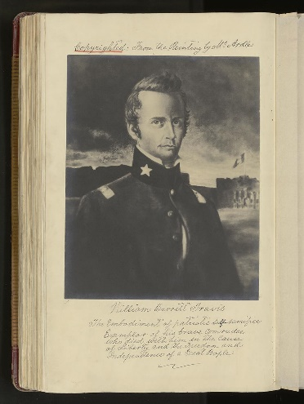  William B. __________________: Commanded the army | 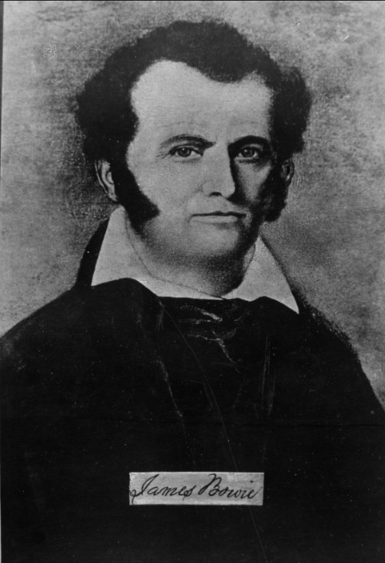  James _____________: Commanded the militia | 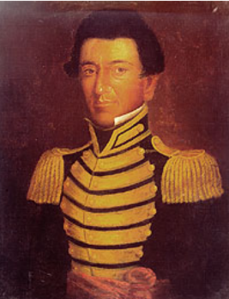  Juan ____________________: A Tejano soldier who acted as a courier for Travis

The Battle of the Alamo | When (Circle one)  Feb. 23, 1836 Mar. 1, 1836 Mar. 6, 1836

What | Santa Anna launched his _______________________ at 1 am  All Texans fighting at the Alamo were ____________________  Santa Anna’s army suffered approximately __________ killed

The Constitutional Convention of 1836

When (Circle one)  March 17 – 30  1836  Feb. 23 – Mar. 6  1836  March 1 – 17  1836 | What  George ______________________ chaired the committee that wrote the Texas Declaration of ____________________________  Wrote the __________________________ of the Republic of Texas  Provisional Government:  _____ 1. David G. Burnet A) Commander of the Army  _____ 2. Lorenzo de Zavala B) President  _____ 3. Sam Houston C) Vice President

The Goliad Massacre

When  (Circle one)  Mar. 27, 1836  Mar. 15, 1836  Mar. 17, 1836 | Where  (Circle TWO)  Goliad  Austin  La Bahía | What  The Texas army under ________________________ surrendered at the Battle of Coleto Creek on March 19  Almost all Texian prisoners were _____________________ by order of Santa Anna

The Runaway Scrape

When (Circle one)  Feb – Mar 1836  Mar – Apr 1836  Apr – May 1836 | What  Texans _____________ east toward Louisiana as Santa Anna’s _______________ pursued the Texas army under Sam Houston.

The Battle of San Jacinto

When (Circle one)  Apr. 21, 1836  Apr. 21, 1835  Apr. 21, 1837 | What  Sam Houston fought Santa Anna’s divided army, _________________________ them in 18 minutes.  Santa Anna was captured and forced to _____________________

The Treaties of Velasco

When (Circle one)  Apr. 17, 1836  May 14, 1836  Jun 25, 1836 | What  Public treaty: Texas was ________________________________ of Mexico, and the southern ______________________ was the Rio Grande.  Private treaty: Santa Anna ___________________________ to get Mexico to recognize Texas independence  (He didn’t carry out his promise)

