Events of the Texas Revolution Grade Level
Unit 5: The Texas Revolution

Name: |  | Date: |  | Period:

Directions: Use the information in the slideshow to complete your graphic organizer on each significant event of the Texas Revolution.
The Battle of Gonzales

When | Where | What  The ___________________________________ of the Texas Revolution

Why | The _____________________________________ was ordered _____________________________________ that Mexico had lent the town years earlier. The people ________________________________________________________________, and a fight broke out.

Outcome | The outnumbered Mexican army was _______________________ __________________________________________________________________

Significance | This battle _____________________________________________________ _________________________________________________________________

The Consultation

When | Where | What  A Meeting to discuss issues related to _____________________________________________

Outcome | Delegates couldn’t agree on whether _______________________ ________________________________or a return to __________________ ______________________________________.  Created a ____________________________________________________, an army under _____________________________________________, and a militia under ___________________________________________.

The Alamo

The Texians Take the Alamo | When | Where

What | The ________________________________ marched to San Antonio in _______________________________, laid siege to _________________ ______________________________________________, driving them out of the city in ___________________________________________________

The Siege of the Alamo  When | What  Santa Anna arrived with ____________________________________ ________________________________________________________________  Texas troops and civilians ___________________________________ ___________________________________________________________________  Santa Anna began _____________________________________________ _________________________________________________________________

Who | 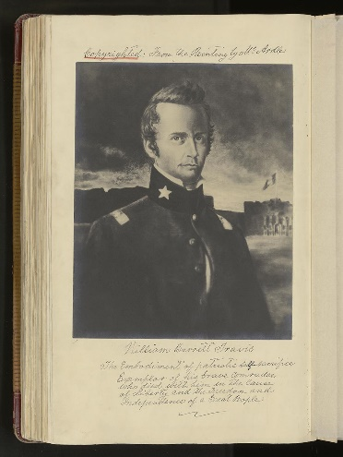  __________________ __________________: Commanded the army | 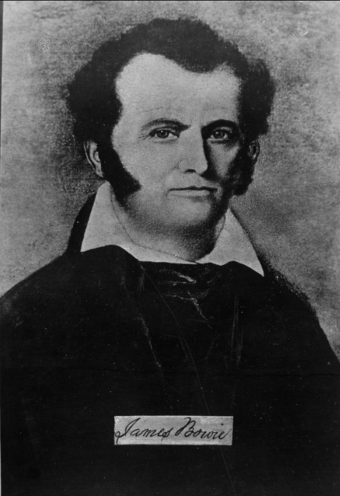  __________________ __________________: Commanded the militia | 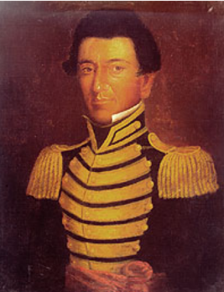  _______________________________: A Tejano soldier who acted as a courier for Travis

The Battle of the Alamo | When

What | Santa Anna launched _________________________________________  _____________________________________________________ were killed  Santa Anna’s army suffered __________________________________ _________________________________________________________________

The Constitutional Convention of 1836

When | What  __________________________________ chaired the committee that wrote the ______________________________________________________  Wrote the ______________________________________________________  Provisional Government:  ____________________________________________: President  ____________________________________________: Vice President  ____________________________________________: Commander of the Army

The Goliad Massacre

When | Where | What  The Texas army under _________________________ ______________________ surrendered at the ______ ___________________________________ on March 19  Almost all Texian prisoners were _____________ ___________________________________________________

The Runaway Scrape

When | What  Texans ____________________________________________________________ as Santa Anna’s army _____________________________________________ ____________________________________________________________________

The Battle of San Jacinto

When | What  _____________________________________ fought Santa Anna’s divided army, _____________________________________________________________  Santa Anna was _________________________________________________

The Treaties of Velasco

When | What  Public treaty: Texas was _________________________________________, and the southern border was ____________________________________  Private treaty: Santa Anna promised to ________________________ _____________________________________________________________________ (He didn’t carry out his promise)

