Warm-up
- Responses will vary
Lesson
The information underlined in bold is what the Foundations students need to fill in. The Grade Level students will have more to fill in. The Advanced students will write all of the notes.
The Battle of Gonzales

When (circle one)  Oct. 2 1835 | Where (Circle one)  Gonzales | What  The first battle of the Texas Revolution

Why | The Mexican army was ordered to retrieve a cannon that Mexico had lent the town years earlier. The people refused to return the cannon, and a fight broke out.

Outcome | The outnumbered Mexican army was forced to retreat from Gonzales.

Significance | This battle started the Texas Revolution

The Consultation

When (Circle one)  Nov. 1835 | Where (Circle one)  San Felipe de Austin | What  A Meeting to discuss issues related to possible war with Mexico.

Outcome | Delegates couldn’t agree on whether to fight for independence or a return to the Constitution of 1824.  Created a provisional government, an army under Sam Houston and a militia under Stephen F. Austin

The Alamo

The Texians Take the Alamo | When (Circle one)  Dec. 1835 | Where (Circle one)  San Antonio

What | The Texian militia marched to San Antonio in late October, laid siege to the centralist troops at the Alamo under General Cos, driving them out of the city in early December 1835.

The Siege of the Alamo  When  Feb 23 – Mar 5 1836 | What  Santa Anna arrived with part of his army (2,500 troops.)  Texas troops and civilians retreated to the Alamo  Santa Anna began a thirteen-day siege of the Alamo

Who | 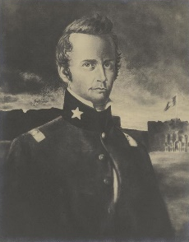  William B. Travis Commanded the army | 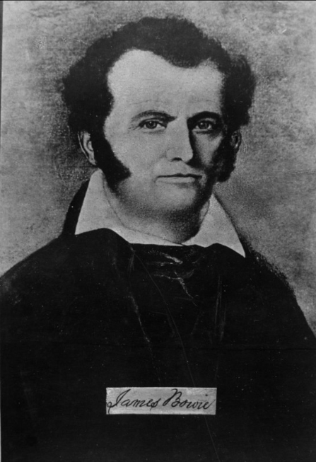  James Bowie Commanded the militia | 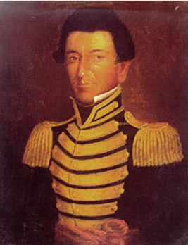  Juan Seguín A Tejano soldier who acted as a courier for Travis

The Battle of the Alamo | When (Circle one)  Mar. 6, 1836

What | Santa Anna launched his attack at 1 am  All Texans fighting at the Alamo were killed  Santa Anna’s army suffered approximately 400 killed

The Constitutional Convention of 1836

When (Circle one)  March 17 – 30  1836  Feb. 23 – Mar. 6  1836  March 1 – 17  1836 | What  George Childress chaired the committee that wrote the Texas Declaration of Independence  Wrote the Constitution of the Republic of Texas  Provisional Government:  __B__ 1. David G. Burnet A) Commander of the Army  __C_ 2. Lorenzo de Zavala B) President  __A_ 3. Sam Houston C) Vice President

The Goliad Massacre

When  (Circle one)  Mar. 27, 1836 | Where  (Circle TWO)  Goliad  La Bahía | What  The Texas army under James Fannin surrendered at the Battle of Coleto Creek on March 19  Almost all Texian prisoners were executed by order of Santa Anna

The Runaway Scrape

When (Circle one)  Mar – Apr 1836 | What  Texans fled east toward Louisiana as Santa Anna’s army pursued the Texas army under Sam Houston.

The Battle of San Jacinto

When (Circle one)  Apr. 21, 1836 | What  Sam Houston fought Santa Anna’s divided army, defeating them in 18 minutes.  Santa Anna was captured and forced to surrender

The Treaties of Velasco

When (Circle one)  May 14, 1836 | What  Public treaty: Texas was independent of Mexico, and the southern border was the Rio Grande.  Private treaty: Santa Anna promised to get Mexico to recognize Texas independence  (He didn’t carry out his promise)

Exit Ticket
- Responses will vary

