The Goliad Massacre Advanced
Extension Lesson with Video
Unit 5: The Texas Revolution

Name: |  | Date: |  | Period:

Directions: You will watch a video about the Goliad Massacre in this lesson. Use this worksheet as a viewing guide to record significant information about each topic covered in the video. Do NOT worry about writing everything exactly as it is stated in the video. Paraphrase and/or summarize the major themes, ideas, or information.
Battle of Goliad

October 10, 1835

James Fannin takes command at Goliad

February 12, 1836

Fannin Receives a Letter from the Alamo Requesting Help

February 25, 1836

After the Fall of the Alamo – Houston Sends Orders to Fannin

March 13 or 14, 1836

José de Urrea Arrives & The Battle of Coleto Creek

March 19, 1836

The Texans are Imprisoned at Goliad

March 19 - 26 1836

The Execution of the Texan Prisoners-of-War

March 27, 1836

- The location of Goliad is shown on the map to the right. Based on the map and the information provided in the video, why was Goliad strategically important during the Texas Revolution? | 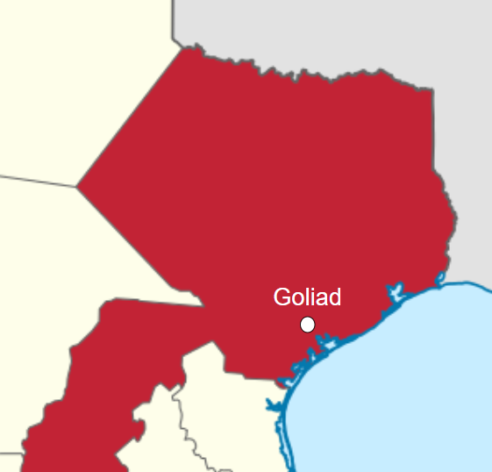

- Describe one significant action James Fannin took as the commander of the troops at Goliad during the Texas Revolution, and explain why he took this action. What is your opinion of this action?

- The Telegraph and Texas Register newspaper printed an article on August 30, 1836 about the Goliad Massacre that stated, “That massacre was a great political blunder. It was expected to drown the revolt in blood – to extinguish aid in terror. On the contrary, it has given life and invincibility to the cause of Texas.”

What do you think the author meant by this statement?

