 Warm-up: Looking Ahead
Unit 5: The Texas Revolution
Name: |  | Date: |  | Period:

- Describe or explain something you notice about the map to the right.  - What questions do you have about the information presented on the map? | 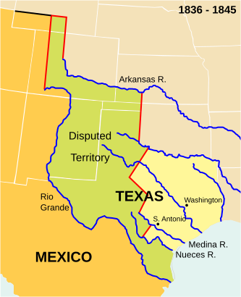

Warm-up: Looking Ahead
Unit 5: The Texas Revolution
Name: |  | Date: |  | Period:

- Describe or explain something you notice about the map to the right.

- What questions do you have about the information presented on the map?


Looking Ahead Exit Ticket

What was one challenge Texas faced after it won its independence in 1836? | How did Texas try to strengthen its position after it won its independence? | What is one thing you predict will happen in the next unit: The Republic of Texas?

Looking Ahead Exit Ticket

What was one challenge Texas faced after it won its independence in 1836? | How did Texas try to strengthen its position after it won its independence? | What is one thing you predict will happen in the next unit: The Republic of Texas?

