 Warm-up: Mind Map Review
Unit 5: The Texas Revolution
Name: |  | Date: |  | Period:

Look at the word bank below. Complete the mind map diagram by putting each term where you think it fits best.

- Cause  - The Texas Revolution  - Texas won its independence  - Centralist takeover of the Mexican government  - Effect | 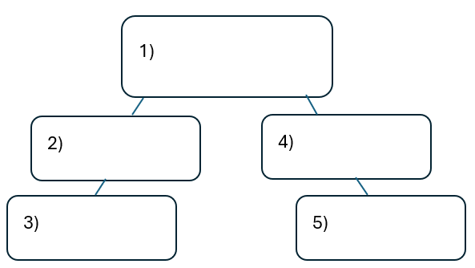

Warm-up: Mind Map Review
Unit 5: The Texas Revolution
Name: |  | Date: |  | Period:

Look at the word bank below. Complete the mind map diagram by putting each term where you think it fits best.

- Cause
- The Texas Revolution
- Texas won its independence
- Centralist takeover of the Mexican government
- Effect


Mind Map Review Exit Ticket

Directions: Complete the sentence by choosing the best answer for each blank from the chart below.

The (1)____________ is primarily characterized by (2)____________

Answer choices for blank (1)  Circle the best answer | Answer choices for blank (2)  Circle the best answer

- federalist rebellion in Mexico  - Texas Revolution  - colonization of Texas  - alliance between Texas and the United States | - The fight for Texas independence from the centralist government of Mexico.  - The organization of the government of the Republic of Texas.  - The Tejano and Anglo attempts at reestablishing the Federal Constitution of 1824.  - Santa Anna’s failure to establish a powerful centralist government in Mexico City.

Mind Map Review Exit Ticket

Directions: Complete the sentence by choosing the best answer for each blank from the chart below.

The (1)____________ is primarily characterized by (2)____________

Answer choices for blank (1)  Circle the best answer | Answer choices for blank (2)  Circle the best answer

- federalist rebellion in Mexico  - Texas Revolution  - Colonization of Texas  - Alliance between Texas and the United States | - The fight for Texas independence from the centralist government of Mexico.  - The organization of the government of the Republic of Texas.  - The Tejano and Anglo attempts at reestablishing the Federal Constitution of 1824.  - Santa Anna’s failure to establish a powerful centralist government in Mexico City.

