Study Guide Foundations
Unit 5: The Texas Revolution

Name: |  | Date: |  | Period:

Part I: Key Terms and Definitions
Circle or highlight the correct term for each definition or description provided in the boxes below.
- (A) Lorenzo de Zavala  (B) George Childress  (C) David G. Burnet | I was one of the delegates at the Constitutional Convention of 1836 who helped write the Declaration of Independence, and I was also chosen to serve as the Vice President in the provisional government of Texas.
- (A) Sam Houston  (B) Juan Seguín  (C) William B. Travis | I was the leader of the regular army forces at the Alamo. I wrote several letters requesting reinforcements, including my famous letter that I signed “Victory or death!” I was killed during the Battle of the Alamo on March 6, 1836.
- (A) Lorenzo de Zavala  (B) James Fannin  (C) George Childress | I served as a delegate to the Constitutional Convention of 1836 where I chaired the committee that wrote the Declaration of Independence.
- (A) Federalists  (B) Centralists  (C) Texians | We are people who supported political power being focused in the hands of a small group of people at the national level in Mexico City. We supported Santa Anna’s overthrow of the government.
- (A) Juan Seguín  (B) William B. Travis  (C) Santa Anna | I was present during the siege of the Alamo, but I left when I served as a courier to deliver one of William B. Travis’ letters requesting help. I went on to fight in the Battle of San Jacinto where I led a Tejano cavalry unit.
- (A) Lorenzo de Zavala  (B) Sam Houston  (C) James Fannin | I led the Texas troops at the Battle of Coleto Creek. We were forced to surrender and held as prisoners of war at mission La Bahía. My men and I were executed during the Goliad Massacre.
- (A) Federalists  (B) Centralists  (C) Anglos | We are people who supported the Mexican Constitution of 1824 that divided political power between the national, or federal, government and the states of Mexico. We were very angry when Santa Anna joined the revolt that overthrew the federalist government.
- (A) David G. Burnet  (B) Sam Houston  (C) Santa Anna | I served as a delegate to the Constitutional Convention of 1836 where I was chosen to serve as the commander of the Texas army during the Texas Revolution.
- (A) Juan Seguín  (B) Lorenzo de Zavala  (C) Santa Anna | I was a popular federalist until I joined a centralist revolt that overthrew the government and concentrated power in the hands of the national government. Many states in Mexico rebelled against these actions and I led my army to these states, including Texas, to subdue these rebellions. The Texans defeated my army at San Jacinto, and I was forced to sign the Treaties of Velasco.

Part II: Timeline of the Revolution
Write the three events from the answer bank in the correct chronological order in the timeline.
The Battle of San Jacinto | The Runaway Scrape | The Siege and Battle of the Alamo

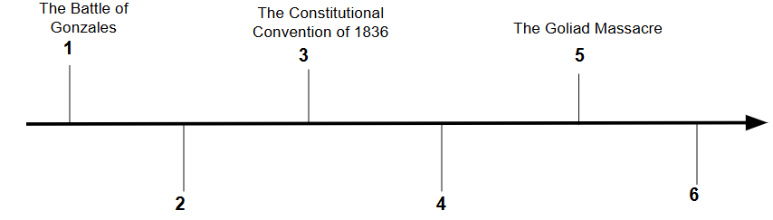

Part III: Matching
The left column contains significant events of the Texas Revolution. The right column provides the effect of each event. Match each cause on the left with its correct effect on the right.

- The Mexican government sent troops to retrieve a cannon lent to the people of Green DeWitt’s colony, however the people refused to return the cannon.
A
- Delegates from Texas communities met at Washington-on-the-Brazos for the Constitutional Convention of 1836.

- When Santa Anna learned of the growing rebellion in Texas in early 1836, he marched his army to San Antonio to subdue the rebellion.
E
- Santa Anna’s troops moved quickly east to attempt to capture the Texas government and defeat Houston’s Texan army.

- Sam Houston’s Texan army defeated Santa Anna’s centralist troops at the Battle of San Jacinto on April 21, 1836.

- As a result of this event, the provisional government of the Republic of Texas was established. They wrote a constitution for this government, and George Childress wrote the Texas Declaration of Independence.

- The soldiers and some citizens fled to the Alamo for safety. They endured a 13-day siege, and all of the defenders at the Alamo were killed in the final battle on March 6, 1836.

- Santa Anna was captured the following day, held as prisoner, and was forced to sign the Treaties of Velasco which ended the war and stated Texas was independent of Mexico.

- This led to the Battle of Gonzales, which began the Texas Revolution.

- Many people in Texas fled east for safety during the Runaway Scrape. Houston’s army marched east to gain more reinforcements and time to train. The Texas government fled for safety and escaped capture.

Part III: Practice Test Questions
Answer the following practice test questions about the Texas Revolution.
- Determine which contribution explains each individual’s significance to the Texas Revolution. Write the letter of each corresponding contribution in the correct box below the name of each person.

  - The Commander-in-Chief of the Army of the Republic of Texas.
  - The primary author of the Texas Declaration of Independence.
  - The Vice President of the provisional government of the Republic of Texas.

George Childress | Sam Houston | Lorenzo de Zavala

- Which of the following newspaper headlines would you have seen on April 22, 1836?
  - The Centralist Army arrives in San Antonio!
  - Thousands of Texans Flee East for Safety!
  - 400 Texian Prisoners of War Executed at Goliad!
  - Santa Anna Surrenders at San Jacinto!

- What were the Treaties of Velasco? Explain the treaties and how the Mexican government responded to their terms.

The Treaties of Velasco were documents that (A) established a trade alliance with Mexico (B) ended the Texas Revolution and granted Texas independence (C) established the provisional government of the Republic of Texas.
The Mexican government responded to the terms of these treaties by (A) refusing to recognize Texas independence (B) ratifying the Texas constitution (C) setting the terms for commerce with Texas. This response was due to the fact that (A) Santa Anna had not signed the treaties willingly (B) trade with Texas was incredibly beneficial (C) the government of Texas was too weak to function properly.

