Road to the Texas Revolution:
Austin Letter to the Fredonia Rebels - Accommodated Summary
Full version located here.

… had you not acted out in such a violent way they would have investigated the behavior and actions of Norris, and if he deserves it, punished him-

You are all mistaken in one way, you think the government does not have force- if you think that this colony will unite in such crazy ideas you are wrong- I know that the Mexican government is powerful and I know that if it were necessary they could march five thousand troops to that district in two months and you would find that every man in this colony able to bear arms would freely and cheerfully join them. Some people even believe that the United States Government would help the rebels… such an idea is too crazy for any reasonable man to think.

What happened with Norris was wrong and the law allows for all officers from the President down to be punished. No individual should have the right to take the power granted by the laws into their own hands because this could lead a government led by mobs and not laws. You can take steps to fix this situation so it turns out right but you have to follow my advice step by step.

First, you need to disband (get rid of) your volunteer company and convince them that this has all been a mistake. Get all of the honest and honorable men and draw up a paper addressed to the Political Chief expressing your surrender and obedience to the Mexican Government. If you do this and help to support and defend the government all will be well and you will get the lands and settlement in the country.

You have been very disrespectful to the government and I have even spoken highly about you to the government, what can I say about you now? The Slave question is now waiting for the Legislature (branch of government that creates the laws) and I fear that the actions you took have jeopardized the chances of these passing in our favor and have made all Americans look bad.

I do not wish any person to submit to oppression, but it is not submitting to oppression to submit to the laws of this country. When we came to this country, we promised to obey the laws of our new country. You are not obeying those laws for you moved in to create a settlement within twenty leagues of the border without the approval of the President.

I will be there with you as I can but I am a citizen of Mexico and an officer and I will sacrifice my life before I will violate my duty and oath of office.

Write me as soon as possible and write frankly what you intend to do and what is the state of things in that country for we have many rumors here—and rumors that I hope are false, although they come very direct from travelers who are daily passing—but I am unwilling to believe that you have all run mad.

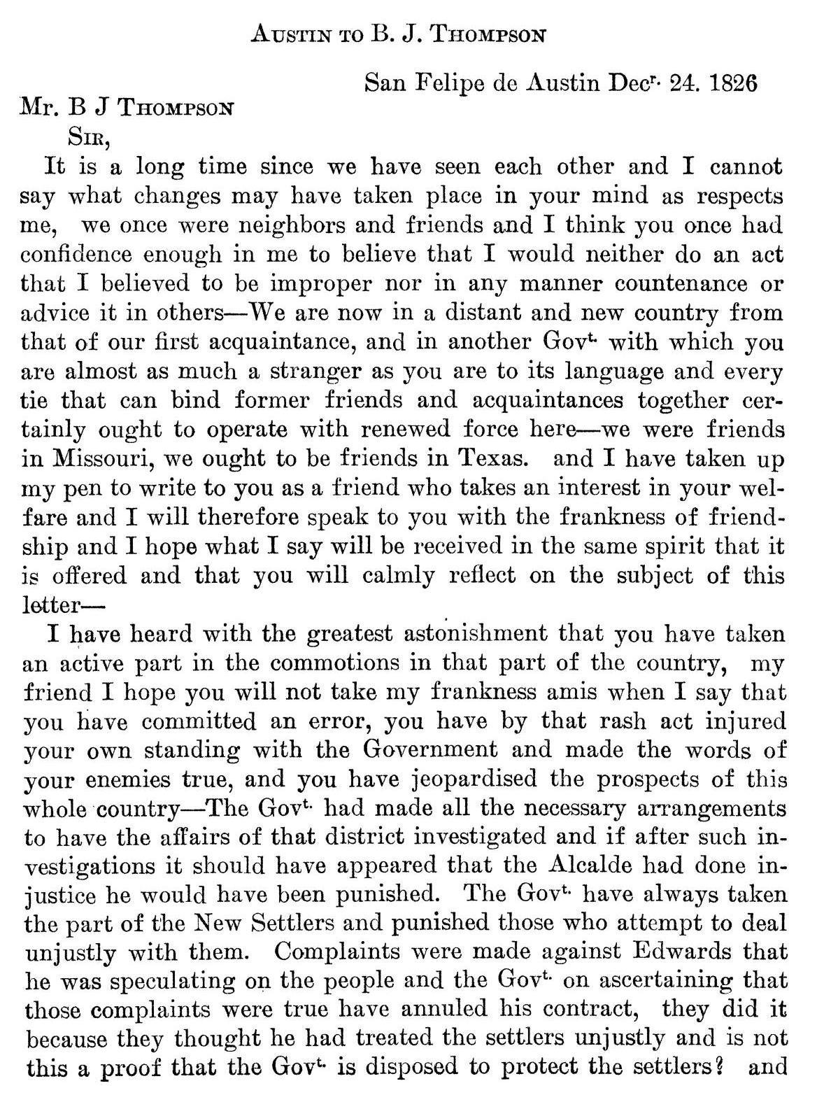
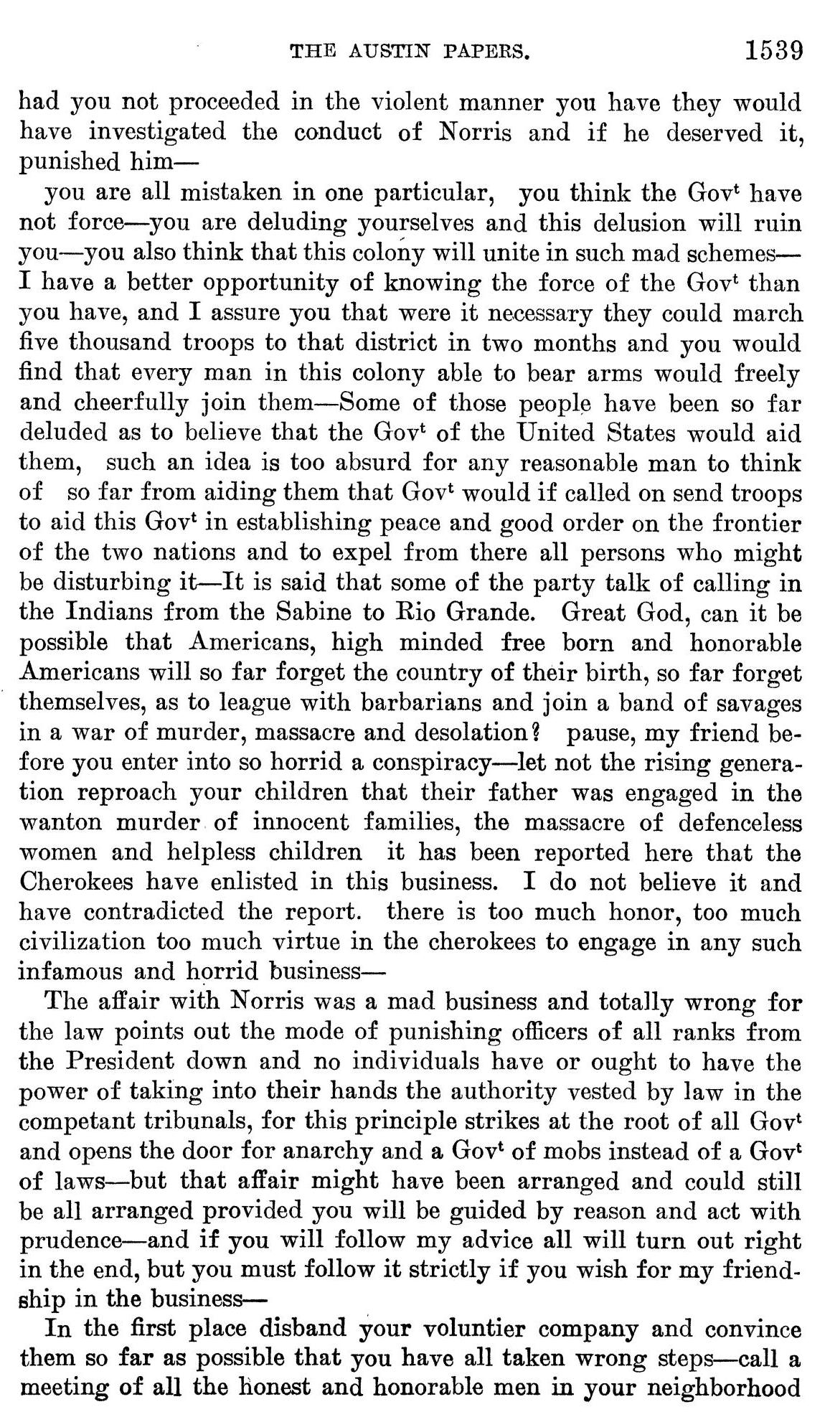
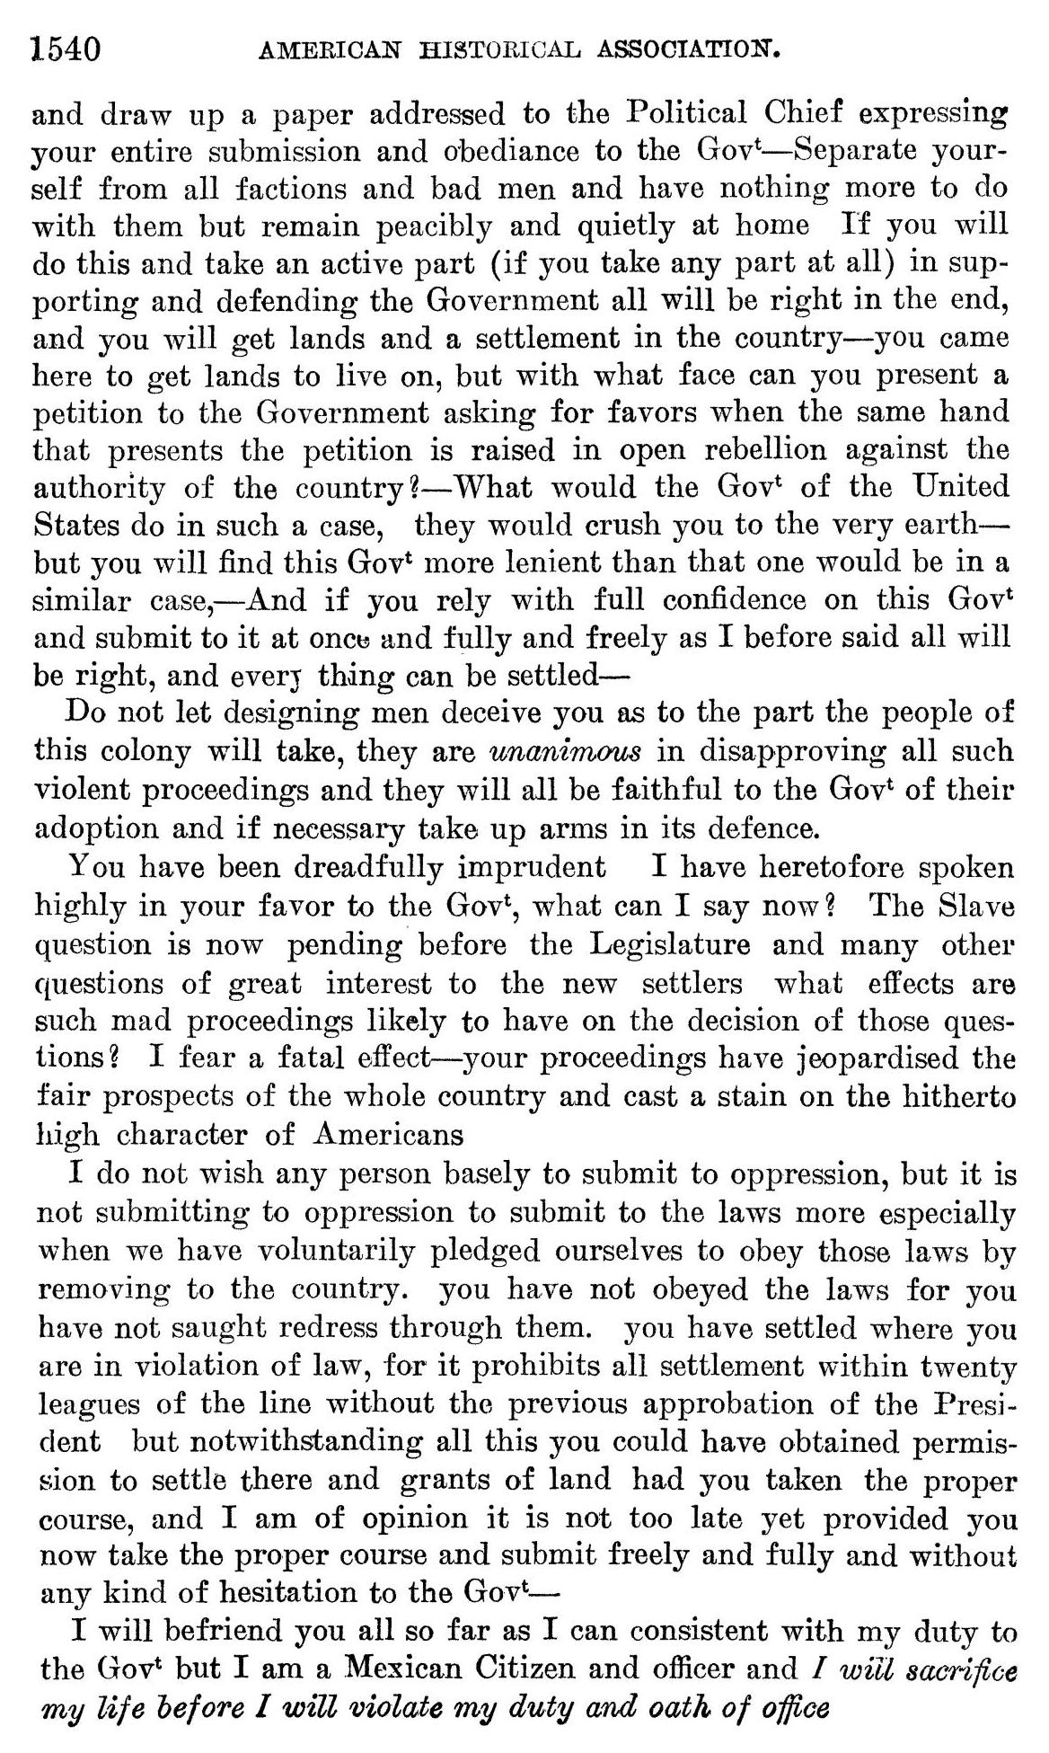
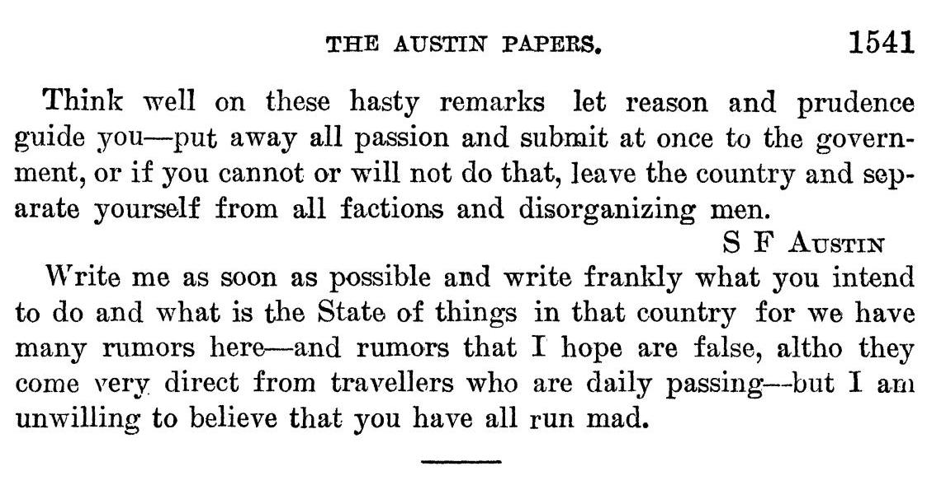
American Historical Association, and Eugene C. Barker. “Annual Report of the American Historical Association for the Year 1919: The Austin Papers in Two Volumes,” Volume 2, Part 2. The Portal to Texas History. United States. Government Printing Office., October 4, 2010. https://texashistory.unt.edu/ark:/67531/metapth121739/.

